Supporting Information

Poly(arylene ether sulfone)s with HEPES Pendants: Synthesis, Thermal and Dielectric studies
S. D. Ganesh¹, M. N. K. Harish², B. J. Madhu³, Husnasarvari Maqbool¹, K. V. Pai ^{1,} *, M. Y. Kariduraganavar⁴
¹Department of Industrial Chemistry, School of Chemical Sciences, Jnana Sahyadri, Kuvempu University, Shankaraghatta - 577 451, Shimoga, Karnataka, INDIA
²PG Department of Chemistry, JSS college of Arts, Commerce & Science, Ooty Road, Mysore-25, Karnataka, INDIA.
³Department of Physics, Government Science College, Chitradurga-577501, Karnataka, INDIA
⁴Department of Chemistry and Center of Excellence in Polymer Science, Karnatak University, Dharwad - 580 003, INDIA

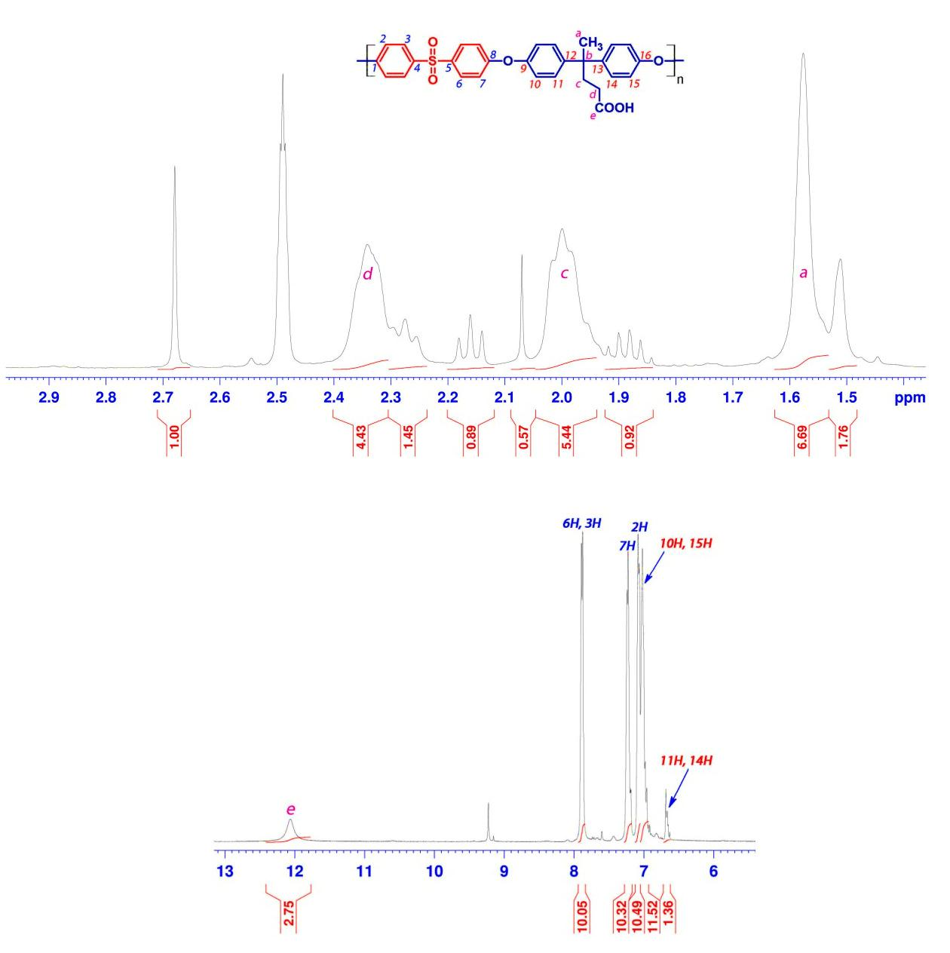
FIGURE 1: ¹H NMR (DMSO-d₆) spectrum of VALPSU Polymer

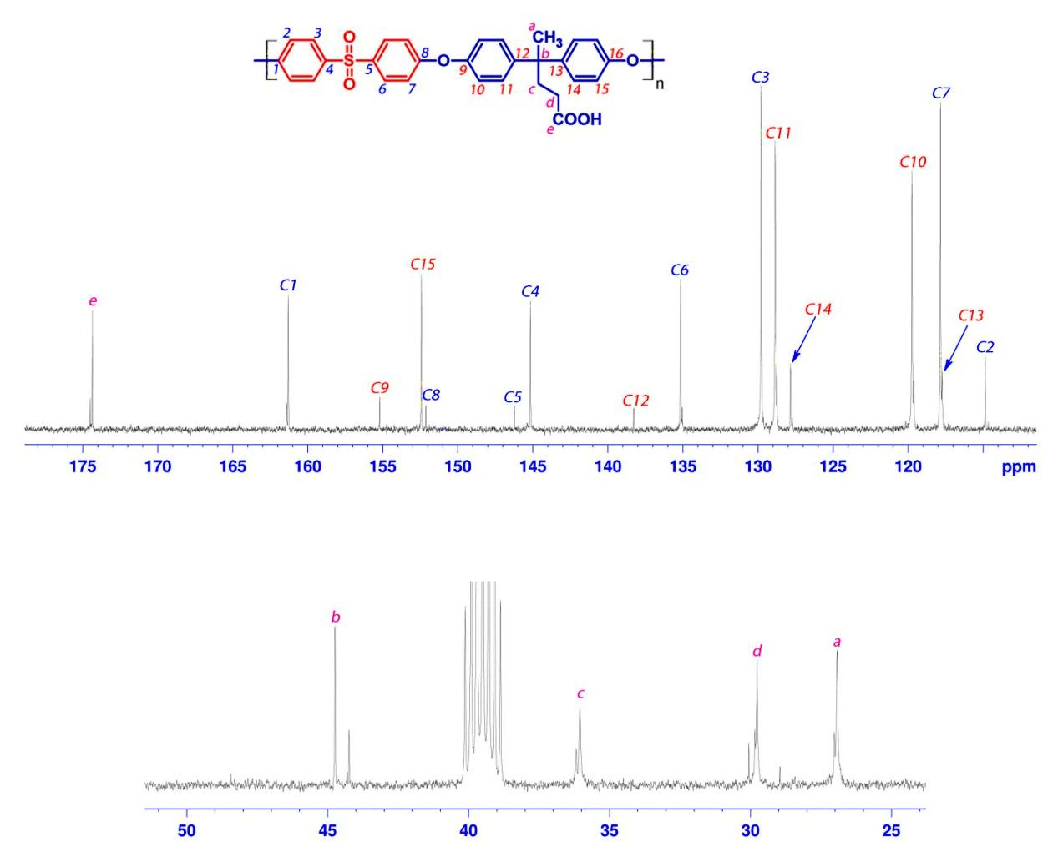

FIGURE 2: ¹³C NMR (DMSO-d₆) spectrum of VALPSU Polymer

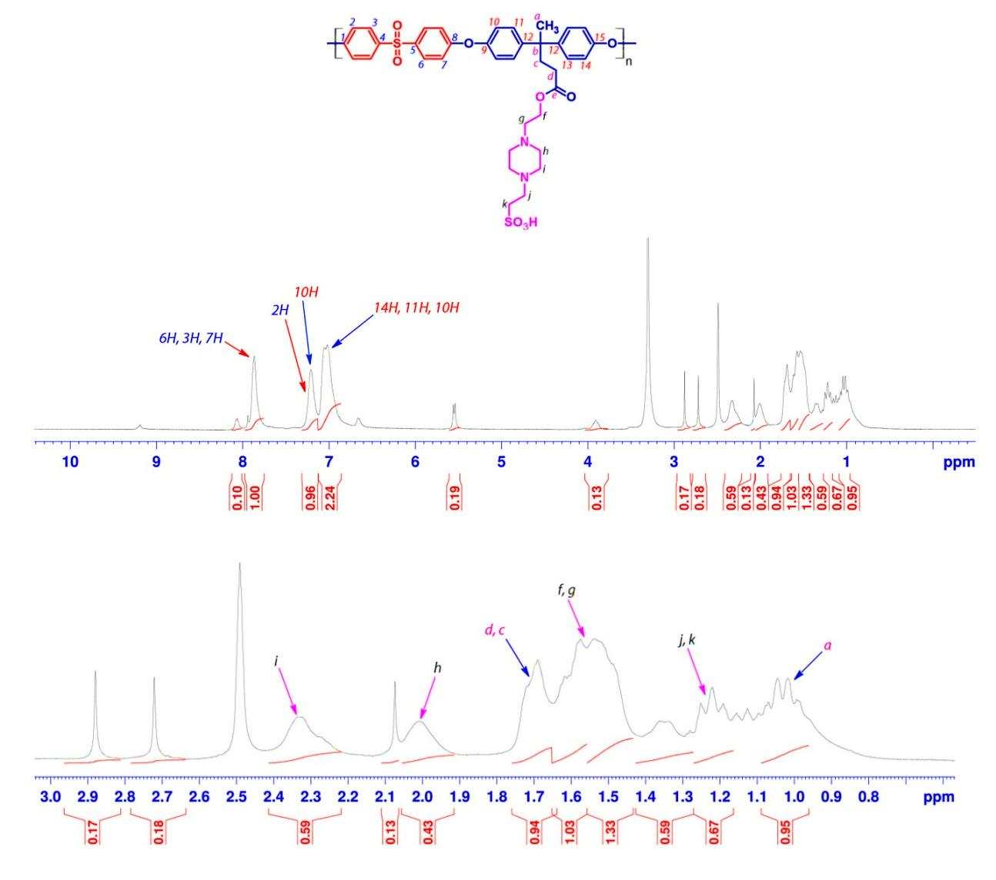
FIGURE 3: ¹H NMR (DMSO-d₆) spectrum of VALPSU-HEP-40 Polymer

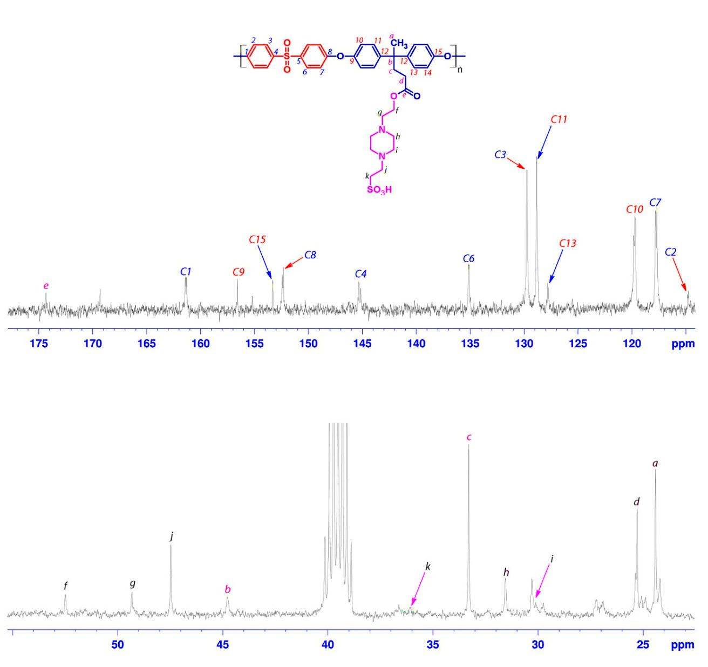

FIGURE 4: ¹³C NMR (DMSO-d₆) spectrum of VALPSU-HEP-40 Polymer

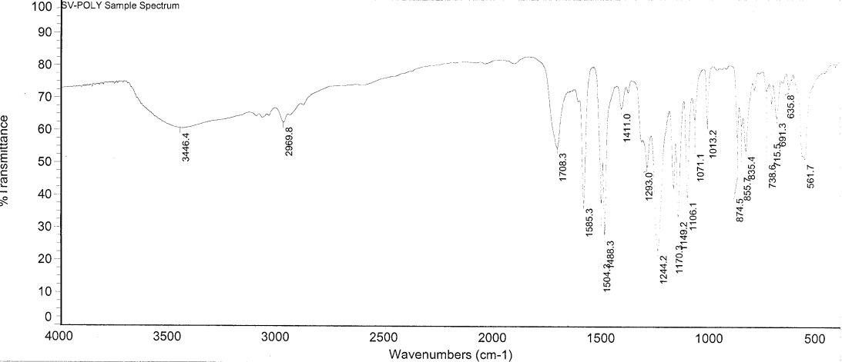

FIGURE 5: FTIR spectrum of VALPSU polymer

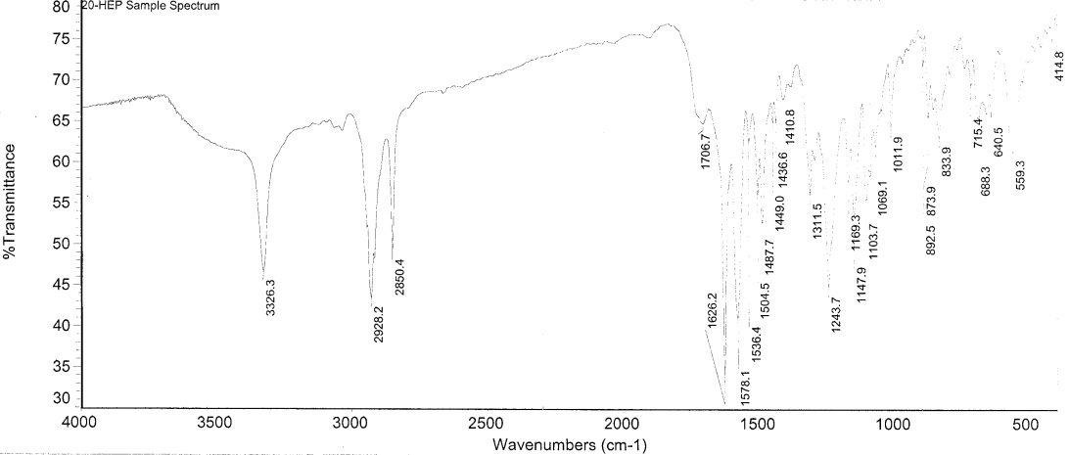

FIGURE 6: FTIR spectrum of VALPSU-HEP-20 polymer

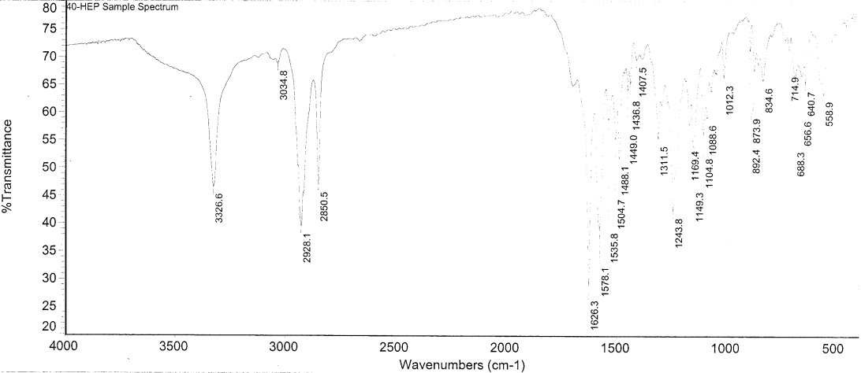

FIGURE 7: FTIR spectrum of VALPSU-HEP-40 polymer

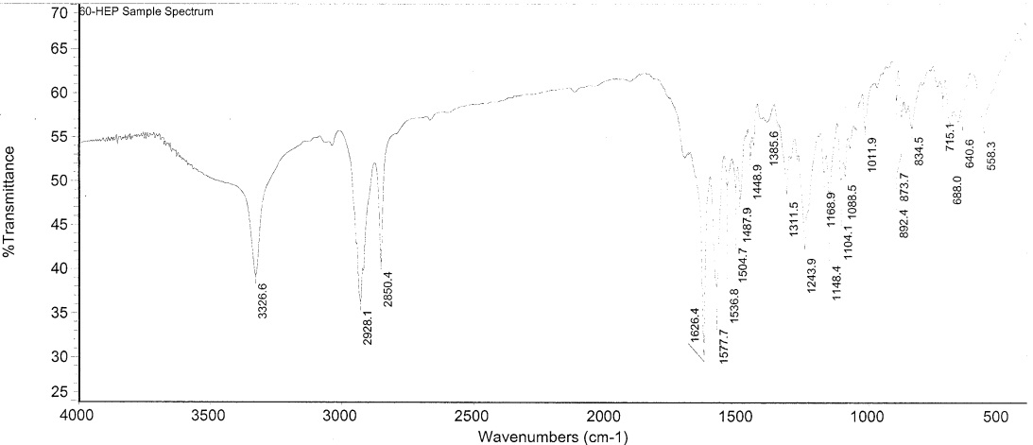

FIGURE 8: FTIR spectrum of VALPSU-HEP-60 polymer

