Supplementary Data
Synthesis and Characterizations of Highly Efficient Nickel Nanocatalysts and Their Use in Degradation of Organic Dyes
A protocol for synthesis of ordered nickel nanostructure arrays with unique morphologies is described. In the present experimental findings a modified hydrazine reduction route has been described for fabrication of stable colloidal dispersions of nickel nanostructures in a lyotropic liquid crystalline medium using Triton X-100 as a nonionic surfactant. Different parameters, such as the concentrations of Ni, hydrazine hydrate and TX-100, were optimized using UV-vis spectrometry. The effects of temperature, pH and stability of Ni NPs were studied by aging the solutions for many days. The characterization studies include scanning electron microscopy (SEM), X-ray diffraction (XRD) and Fourier transform infra red (FTIR) spectroscopy.
Figure S-1

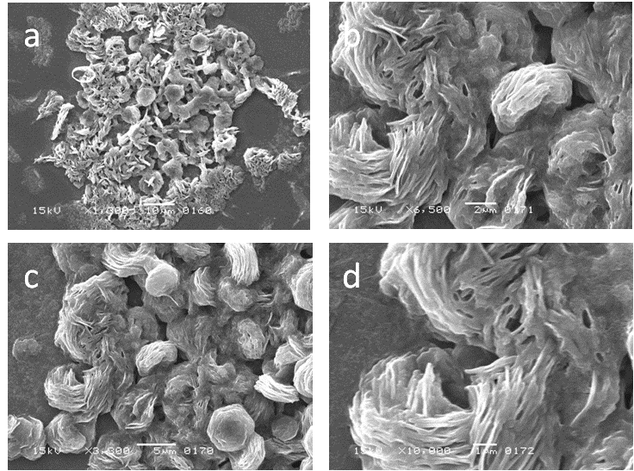

Figure S-1. SEM images of TX-100 stabilized Ni NSs obtained at pH 4.2.
Figure S-2

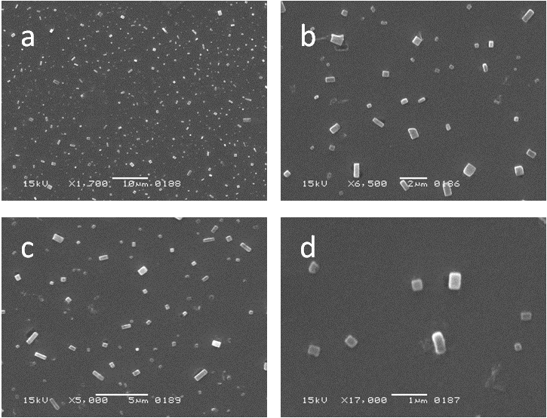

Figure S-2. SEM images of TX-100 stabilized Ni NSs obtained at pH 7.3.
Figure S-3

Figure S-3. UV-vis spectral analysis for catalytic reduction/degradation of a variety of dyes: (a) 0.02 mM EB; (b) 0.02 mM RB; (c) 0.02 mM ECBT; (d) 0.02 mM MB; and (e) mixture of all four dyes, carried out in 4.0 ml of de-ionized water with 0.01 M NaBH₄ without Ni NSs.

