Supplementary Table S1: Protein targeting pathway and antigenic potential of tick p36 proteins
Tick species | NCBI  Accession  No. | Protein Description | Protein targeting |  |  |  | Antigenic potential  Model: Parasite  Threshold: 0.5
 |  |  | Secretory proteins  (Signalp tool) |  | Surface proteins |  | Antigenic score | Remarks
 |  |  | Signal  peptide  presence | Cleavage site | TM Protein (TMHMM tool) | GPI anchored Protein  (PredGPI tool)
D. andersoni | AAF03683.1 | p36* | Yes | 21-22 | 0 | No | 0.5880 | Probable antigen
R. appendiculatus | JAP82151.1 | Da-p36 family member | Yes | 21-22 | 0 | No | 0.5468 | Probable antigen
R. appendiculatus√ | JAP81510.1 | Da-p36 family member | Yes | 20-21 | 0 | No | 0.7258 | Probable antigen
R. appendiculatus | JAP87204.1 | Da-p36 family member | No |  | 0 | No | 0.6137 | Probable antigen
R. appendiculatus√ | JAP86350.1 | Da-p36 family member | No |  | 0 | No | 0.7072 | Probable antigen
A. variegatum | BAD11807.1 | Da-p36 | Yes | 21-22 | 0 | No | 0.5644 | Probable antigen
R. h. haemaphysaloides | ABB90890.1 | Rhh-ISP partial | No |  | 0 | No | 0.4523 | Probable non-antigen
A. sculptum | JAU03129.1 | Hypothetical protein partial | Yes | 13-14 | 0 | No | 0.3102 | Probable non-antigen
R. appendiculatus√ | JAP81944.1 | Da-p36 family member | No |  | 1 | No | 0.7701 | Probable antigen
R. appendiculatus√ | JAP88013.1 | Da-p36 family member partial | No |  | 1 | No | 0.7379 | Probable antigen
A. sculptum | JAU02613.1 | Hypothetical protein partial | No |  | 0 | No | 0.3865 | Probable non-antigen
R. appendiculatus | JAP85022.1 | Da-p36 family member | Yes | 17-18 | 0 | No | 0.5687 | Probable antigen
A. sculptum | JAU02539.1 | Hypothetical protein partial | Yes | 18-19 | 0 | No | 0.5381 | Probable antigen
A. variegatum | DAA34595.1 | Da-p36 like | Yes | 21-22 | 0 | No | 0.5012 | Probable antigen
A. aureolatum | JAT98922.1 | Hypothetical protein partial | No |  | 0 | No | 0.5026 | Probable antigen
A. aureolatum | JAT98921.1 | Hypothetical protein | Yes | 18-19 | 0 | No | 0.4439 | Probable non-antigen

Table S1 cont…..
R. appendiculatus |  | JAP85729.1 | Da-p36 family member |  | No |  | 0 | No | 0.5000 | Probable antigen
R. appendiculatus |  | JAP85564.1 | Da-p36 family member |  | Yes | 22-23 | 0 | No | 0.5569 | Probable antigen
R. appendiculatus |  | JAP82143.1 | Da-p36 family member |  | No |  | 0 | No | 0.3930 | Probable non-antigen
R. appendiculatus |  | JAP86306.1 | Da-p36 family member |  | Yes | 24-25 | 0 | No | 0.5162 | Probable antigen
R. appendiculatus |  | JAP81863.1 | Da-p36 family member |  | No |  | 0 | No | 0.5856 | Probable antigen
A. variegatum |  | DAA34748.1 | Da-p36 like |  | Yes | 21-22 | 0 | No | 0.5733 | Probable antigen
R. appendiculatus |  | JAP78061.1 | Da-p36 family member |  | Yes | 21-22 | 0 | No | 0.3387 | Probable non-antigen
R. appendiculatus |  | JAP86680.1 | Da-p36 family member |  | Yes | 21-22 | 0 | No | 0.5962 | Probable antigen
R. appendiculatus |  | JAP88255.1 | Da-p36 family member |  | No |  | 1 | No | 0.3636 | Probable non-antigen
R. appendiculatus |  | JAP85730.1 | Da-p36 family member |  | No |  | 0 | No | 0.3551 | Probable non-antigen
H. longicornis |  | BAG11660.1 | Isp-p36 |  | Yes | 21-22 | 0 | No | 0.6248 | Probable antigen
R. appendiculatus |  | JAP81735.1 | Da-p36 family member |  | Yes | 21-22 | 0 | No | 0.5229 | Probable antigen
R. appendiculatus |  | JAP86324.1 | Da-p36 family member |  | Yes | 19-20 | 0 | No | 0.5781 | Probable antigen
A. sculptum | JAU02519.1 |  |  | Hypothetical protein partial | No |  | 0 | No | 0.5704 | Probable antigen
A. variegatum | DAA34145.1 |  |  | ISP-p36 partial | Yes | 21-22 | 0 | No | 0.5138 | Probable antigen
R. appendiculatus | JAP81446.1 |  |  | Da-p36 family member | Yes | 21-22 | 0 | No | 0.3690 | Probable non-antigen
R. appendiculatus | JAP86032.1 |  |  | Da-p36 family member | Yes | 21-22 | 0 | No | 0.4766 | Probable non-antigen
R. microplus√ | ADQ19690.1 |  |  | *Bm86 glycoprotein |  |  |  |  | 0.7681 | Probable antigen

Key:
√- Proteins with antigenicty score above 0.7000
*Bm 86 glycoprotein a known anti-tick vaccine antigen from R. microplus used as reference.
- TM (Transmembrane)
- TMHMM (Transmembrane hidden Markov model)
- GPI (Glycosylphosphatidylinositol)

Supplementary Table S2: Verify 3D validation scores of models generated for D. andersoni p36 protein
3-D structure models | Verify 3D Score | Remarks
Model 1 | 49.75% of the residues had an averaged 3D-1D score >= 0.2 | Error
Model 2 | 81.41% of the residues had an averaged 3D-1D score >= 0.2 | Pass
Model 3 | 69.35% of the residues had an averaged 3D-1D score >= 0.2 | Error
Model 4 | 61.81% of the residues had an averaged 3D-1D score >= 0.2 | Error
Model 5 | 57.29% of the residues had an averaged 3D-1D score >= 0.2 | Error
Model 6 | 68.34% of the residues had an averaged 3D-1D score >= 0.2 | Error
Model 7 | 53.27% of the residues had an averaged 3D-1D score >= 0.2 | Error
Model 8 | 61.31% of the residues had an averaged 3D-1D score >= 0.2 | Error
Model 9 | 88.44% of the residues had an averaged 3D-1D score >= 0.2 | Pass
Model 10 | 60.80% of the residues had an averaged 3D-1D score >= 0.2 | Error
Key:
Parameter Monitored: Determines compatibility of an atomic model (3D) with its own amino acid sequence (1D)
Limit: Pass, At least 80% of the amino acids have scored >= 0.2 in the 3D/1D profile

Supplementary Figure S1: D. andersoni p36 protein signal peptide cleavage site location
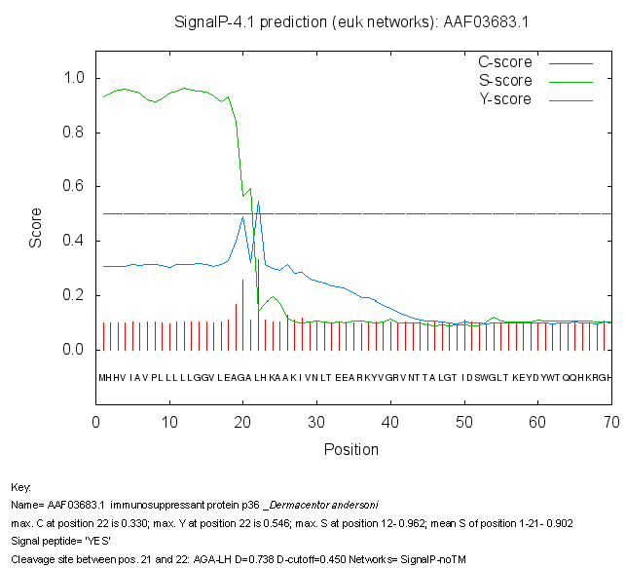

Supplementary Figure S2: Spider² tool secondary structure characterization of D. andersoni p36 protein

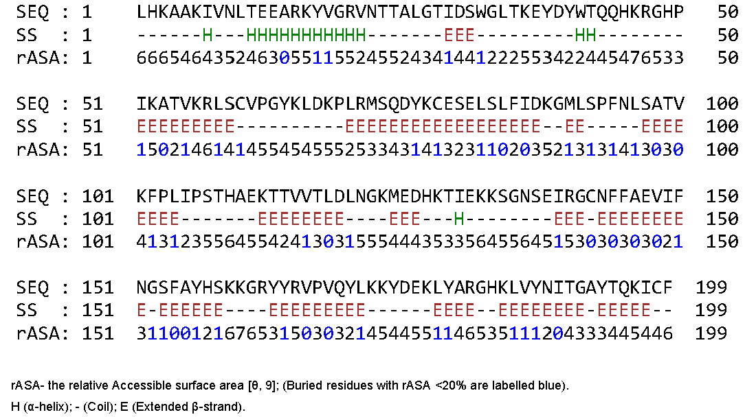
Among 199 residues of D. andersoni p36 protein sequence, 15 are predicted as α-helix and 95 as β-strands. Predicted immunogenic region “74…107” (“QDYKCESELSLFIDKGMLSPFNLSATVKFPLIPS”), has its segments “KG”, “SPFNL” and “IPS” in loop regions.

Supplementary Fig S3: Rampage tool assessment of Ramachandran plot for model 2 of D. andersoni p36 protein
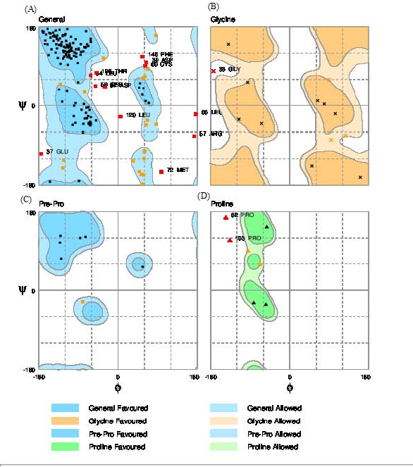
Ramachandran plot showing the distribution of backbone configuration of residue in model 2. (A) All amino acids other than proline and glycine; (B) Glycine residues; (C) Residues preceeding proline in the amino acid sequence; (D) Proline residues.

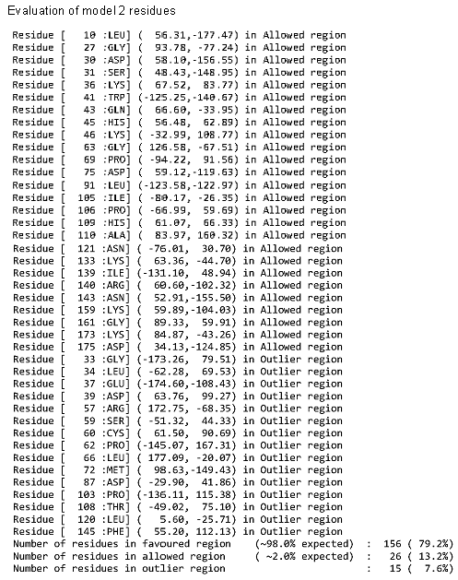
Supplementary Fig S4: Rampage tool assessment of Ramachandran plot for model 9 of D. andersoni p36 protein
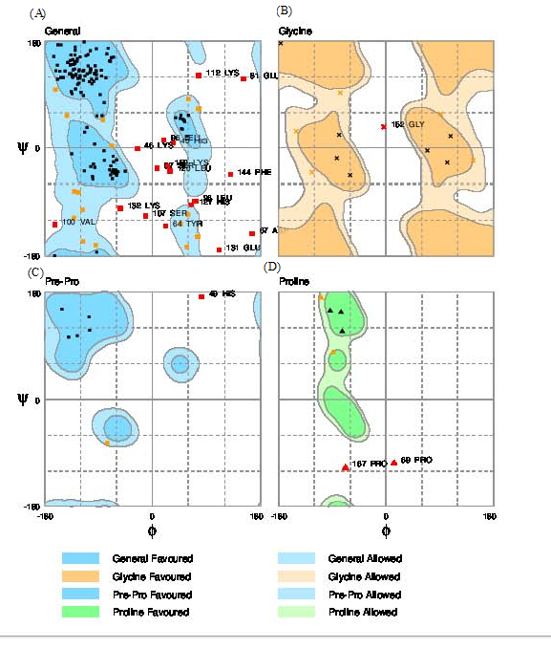
Ramachandran plot showing the distribution of backbone configurations of residue in model 9. (A) All amino acids other than proline and glycine; (B)Glycine residues; (C) Residues preceeding proline in the amino acid sequence; (D) Proline residues.
