Graphical Abstract

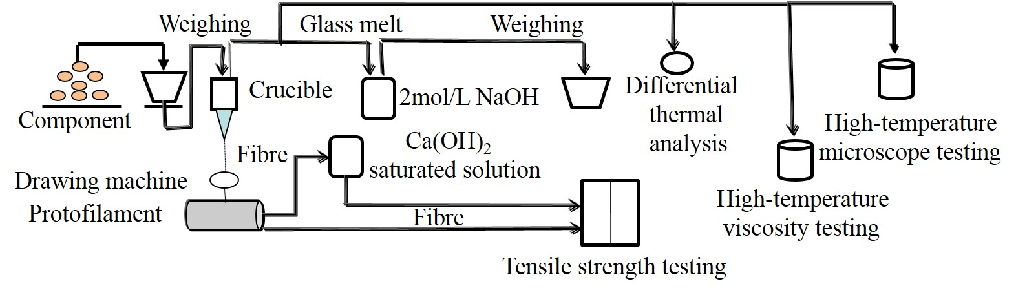

The raw materials were weighed, mixed uniformly, and melted in the home-made platinum crucible to obtain a clarified and homogenized glass melt. The samples were placed in a self-designed drawing crucible for wire drawing, and the sample fibers with required diameters were obtained by adjusting the temperature of the magma, the height of the liquid surface and the speed of the wire drawing machine. The melted glass pieces were crushed and the granules were sieved through a 20-40 mesh sieve to obtain powder samples. Samples with known mass were placed in a conical flask of 2mol/L NaOH solution for 24h and then weighed. Prepared fibers were immersed in Ca(OH)₂ saturated solution and heated at 99±0.2℃ for 4h to weighed. Smelted glass samples were been measured by a differential scanning calorimetry, high-temperature rotational viscometer and high-temperature microscope, respectively.

