G:\Cao hoc\Cao hoc da huong dan\Truong-CH DHTL-2017\TEM-SEM-EDX-Fe3o4-GO-CS\Dang Tuong-BKHN\S1-THP\S1-THP_q985.tif

**Figure 7a.**

**G:\Cao hoc\Cao hoc da huong dan\Truong-CH DHTL-2017\TEM-SEM-EDX-Fe3o4-GO-CS\Dang Tuong-BKHN\S1-THP\S1-THP_q977.tif**

**Figure 7b.**

**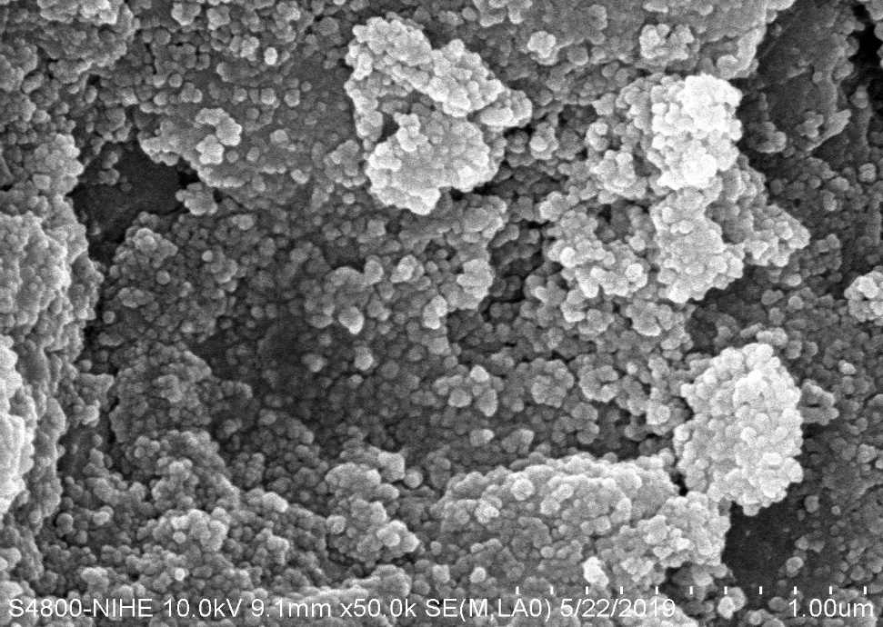**

**Figure 7c.**

**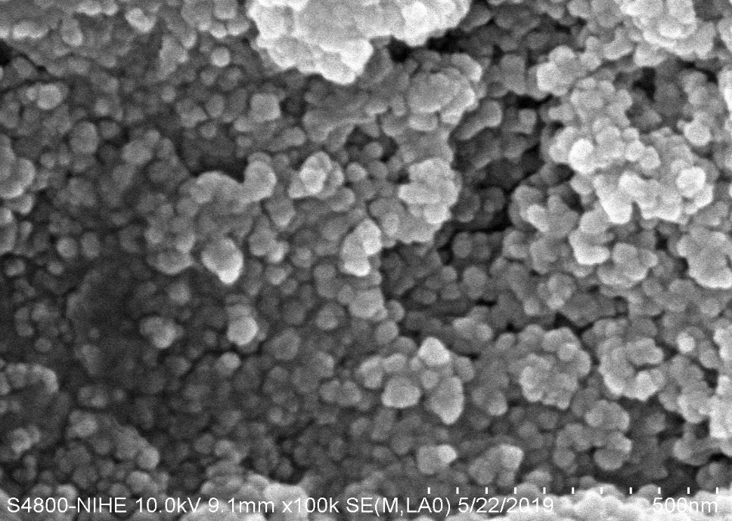**

**Figure 7d.**