 | Overall Population (119)
Age at the diagnosis
<45 | 4\119
>45 | 115\119
Gender
M | 83\119
F | 36\119
Grading
G1 | 20\119
G2 | 66\119
G3 | 33\119
Overall free disease survival | 40\85
Death | 42\85
No follow-up | 37\119
Recurrence | 3\85
Tumor staging
T1-2 | 75\119
T3-4 | 44\119
Lymph Node metastases | 78\119
Distant metastases | 1\119
No metastasis | 40\119
THERAPY
Chem | 29\89
RxT | 60\89
Chem+RxT | 27\89
No Therapy information | 20\119
Primary anatomical Site
Tongue | 71\119
Other sites | 45\119
Lips | 3\119

Supplementary Table 1

 | Overall Population (27)
Age
<50 | 2\27
>50 | 25\27
Gender
M | 15\27
F | 12\27
Grading
G1 | 0\27
G2 | 14\27
G3 | 13\27
Tumor stage
T1-2 | 25\27
T3-4 | 2\27
Smokers | 16\27
Heavy smokers (>20sig) | 12\10
Light smokers (< 19 sig) | 4\10
Drinkers | 17\27
1-2 alcool cups daily assumption | 12\17
3-4 alcool cups daily assumption | 5\17
Fruits/Vegetables
Moderate | 19\27
Hight | 8\27

Supplementary Table 2

SPARC
Tumor Expression
SPARC Stromal  Expression | Negative | Positive
Negative | 15 | 0
Positive | 28 | 59
Pearson  Chi-square | ,000
Supplementary Table 3

 | Grading |  |  | Anatomical site |  | Deep Invasion |  | T |  |  | N |  |  | Age |  | SEX
SPARC Superficial  Tumour Expression | 1 | 2 | 3 | Tongue | Other | < 10mm | > 10mm | T1\2 |  | >T2 | 0 | 1 | 2 | <50 | >51 | F | M
0 | 10 | 23 | 7 | 18 | 22 | 18 | 22 | 23 |  | 17 | 19 | 7 | 14 | 2 | 40 | 11 | 29
1 | 4 | 15 | 5 | 11 | 12 | 6 | 18 | 15 |  | 9 | 13 | 7 | 4 | 2 | 27 | 6 | 18
2 | 3 | 12 | 10 | 10 | 14 | 12 | 13 | 16 |  | 9 | 11 | 6 | 8 | 1 | 30 | 4 | 21
Pearson Chi-square | ,258 |  |  | ,91 |  | ,191 |  | ,853 |  |  | ,552 |  |  | ,368 |  | ,559

Supplementary Table 4

 | Grading |  |  | Anatomical site |  | Deep Invasion |  | T |  | N |  |  | Age |  | SEX
SPARC Superficial  Stromal  Expression | 1 | 2 | 3 | Tongue | Other | < 10mm | > 10mm | T1\2 | >T2 | 0 | 1 | 2 | <50 | >51 | F | M
0 | 3 | 5 | 4 | 7 | 5 | 7 | 5 | 6 | 6 | 7 | 2 | 3 | 2 | 13 | 5 | 7
1 | 12 | 21 | 9 | 17 | 23 | 13 | 29 | 24 | 18 | 17 | 10 | 15 | 2 | 42 | 9 | 33
2 | 2 | 25 | 10 | 16 | 21 | 16 | 21 | 25 | 12 | 19 | 8 | 10 | 1 | 42 | 8 | 29
Pearson Chi-square | ,087 |  |  | ,604 |  | ,191 |  | ,46 |  | ,552 |  |  | ,368 |  | ,31

Supplementary Table 5

 | Grading |  |  | Anatomical site |  | Ki 67 expression |  | T |  | Age |  | SEX
SPARC  tumoral Expression | 1 | 2 | 3 | Tongue | Other | low | high | T1\2 | >T2 | <50 | >51 | M | F
Negative | 0 | 7 | 2 | 5 | 4 | 1 | 6 | 8 | 1 | 1 | 8 | 6 | 3
Positive | 0 | 6 | 10 | 7 | 9 | 5 | 9 | 14 | 1 | 2 | 14 | 8 | 8
Pearson Chi-square | ,053 |  |  | ,57 |  | ,30 |  | ,7 |  | ,91 |  | ,4

 | Fruits and Vegetables  consumption |  |  | Smokers |  | Alcohol consumption
SPARC  Stromal Expression | No | Low | High | light | Hevvy | No | low | high
Negative | 0 | 7 | 2 | 4 | 1 | 2 | 6 | 1
Positive | 1 | 9 | 5 | 0 | 11 | 6 | 6 | 4
Pearson Chi-square | ,43 |  |  | ,001 |  | ,37

Supplementary Table 6

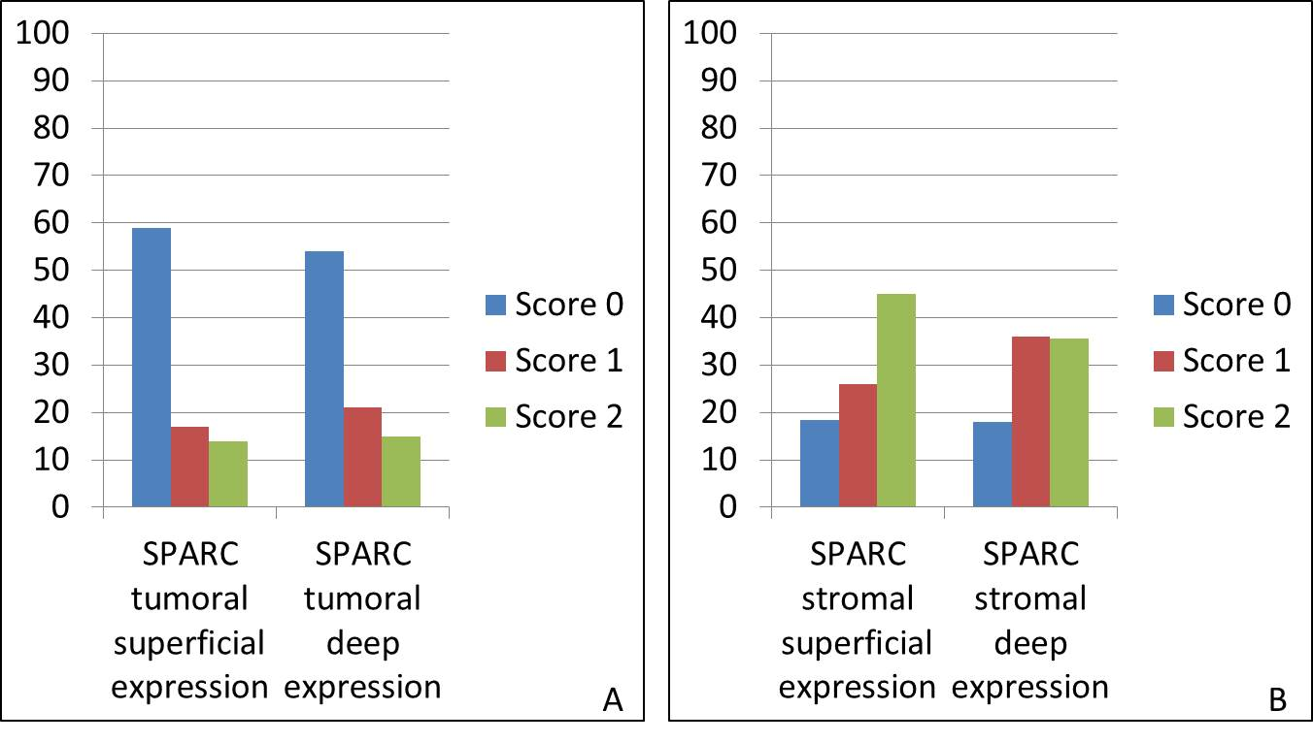Supplementary Figure 1

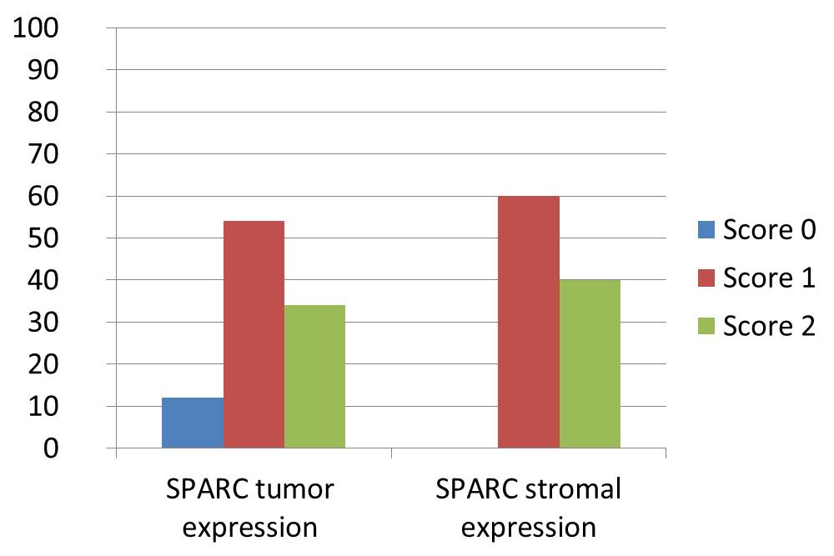Supplementary Figure 2

