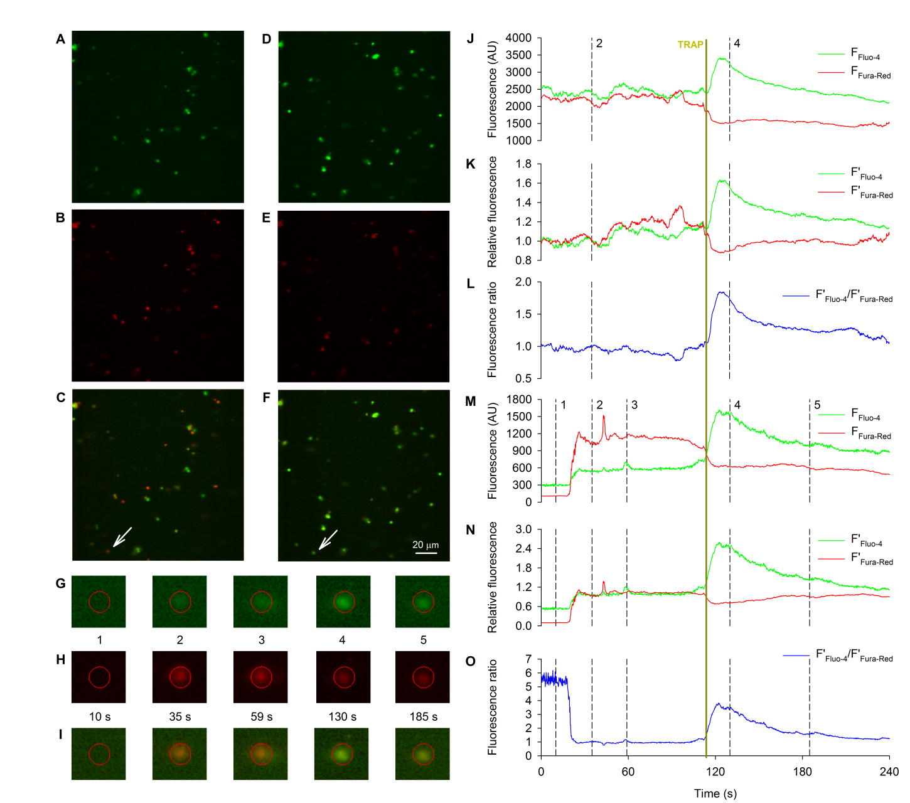
Supplementary figure 1. Ratiometric measurement of platelet intracellular Ca²⁺ levels by high-speed confocal microscopy. A, B, C: Fluo-4 (A), Fura-Red (B) and composite (C) fluorescence images showing the signal levels of non-activated platelets. D, E, F: Fluo-4 (D), Fura-Red (E) and composite (F) fluorescence images showing the signal levels of platelets 20 seconds after activation by TRAP. Panels A-F have the same scaling. Arrows on panels C and F point to the platelet shown on panels G, H and I. G, H, I: Excerpts of Fluo-4 (G), Fura-Red (H) and composite (I) fluorescence images showing the evolution of signal levels at the location of a stationary platelet. The red circle (diameter: 5.9 µm) denotes the ROI where the fluorescence levels were measured. Excerpt 1: the area before the arrival of any platelets with characteristic low fluorescence levels and high relative noise levels. Excerpt 2: baseline fluorescence of the platelet. Excerpt 3: only the fluorescence level of one of the channels is affected by another platelet floating into the ROI. Excerpt 4: a real calcium transient results in an increase of the Fluo-4 fluorescence and a decrease in the Fura-Red fluorescence. Excerpt 5: in the relaxation phase of the transient Fluo-4 fluorescence decreases while Fura-Red fluorescence increases relatively to its corrected background level.J: Original fluorescence values measured on all non-background pixels of the whole field of view on the Fluo-4 (F_{Fluo-4}, green) and Fura-Red (F_{Fura-Red}, red) channels. K: Relative fluorescence values for the Fluo-4 (F’_{Fluo-4}, green) and Fura-Red (F’_{Fura-Red}, red) channels calculated from the original fluorescence values measured on all non-background pixels of the whole field of view by normalization to the corrected background fluorescence level. L: Fluorescence ratio (F’_{Fluo-4}/F’_{Fura-Red}, blue) values corresponding to the intracellular Ca²⁺ level of all platelets in the field of view are calculated by dividing the relative fluorescence value for the Fluo-4 channel by that of the Fura-Red channel at every time point. Dashed lines on panels J, K and L correspond to panels A, B and C (2) and D, E and F (4). M: Original fluorescence values measured in the selected ROI on the Fluo-4 (F_{Fluo-4}, green) and Fura-Red (F_{Fura-Red}, red) channels. N: Relative fluorescence values for the Fluo-4 (F’_{Fluo-4}, green) and Fura-Red (F’_{Fura-Red}, red) channels calculated from the original fluorescence values by normalization to the corrected background fluorescence level. O: Fluorescence ratio (F’_{Fluo-4}/F’_{Fura-Red}, blue) values corresponding to the intracellular Ca²⁺ level in the platelet are calculated by dividing the relative fluorescence value for the Fluo-4 channel by that of the Fura-Red channel at every time point. Dashed lines on panels M, N and O correspond to images on panels G, H and I. The solid yellow line across panels J-O corresponds to the activation of platelets by TRAP.

