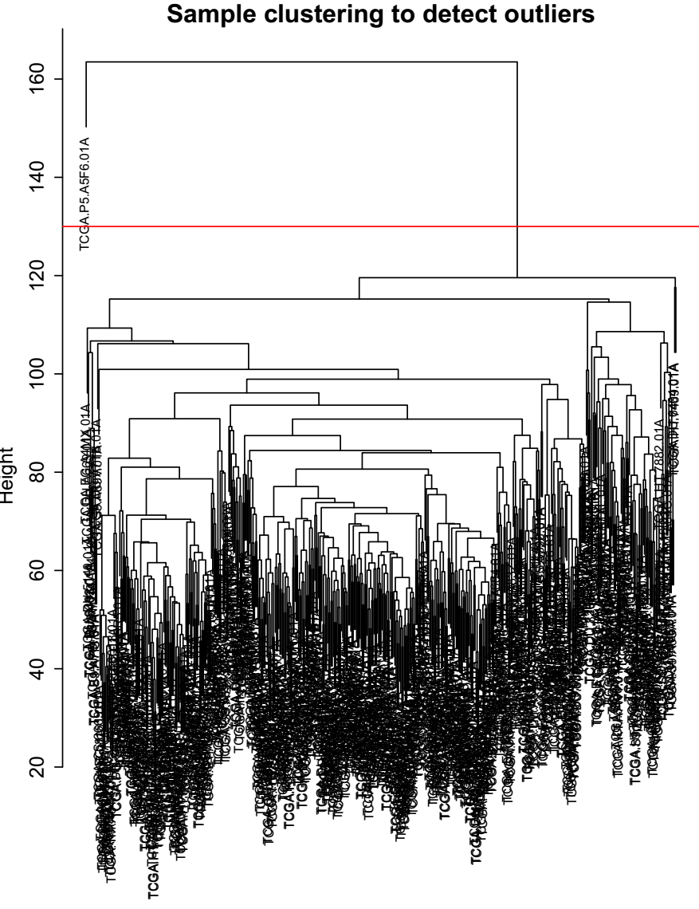

Figure S1: Sample clustering to detect outliers in the TCGA LGG RNA-seq cohort
The TCGA LGG RNA-seq cohort result showed that samples in TCGA LGG RNA-seq can be clustered into different subgroups.
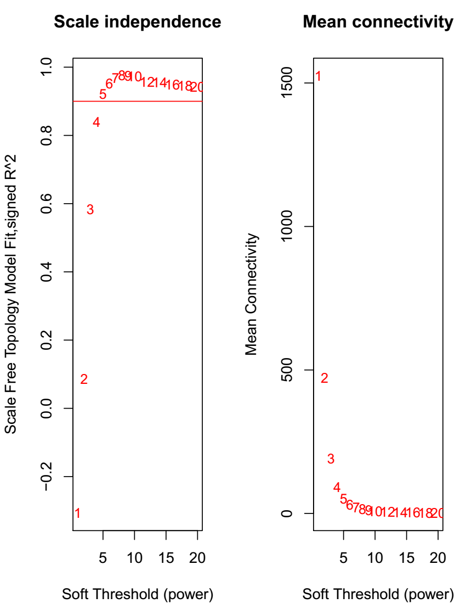

FigureS2: Scale independence and Mean connectivity of TCGA LGG RNA-seq cohort
The relationship between Scale independence and soft threshold, as well as mean connectivity and soft threshold showed the cluster pattern of TCGA LGG RNA-seq cohort samples. Correlation coefficient should be at least 0.9. The power of 5 was interpreted as a soft-threshold of the correlation matrix.

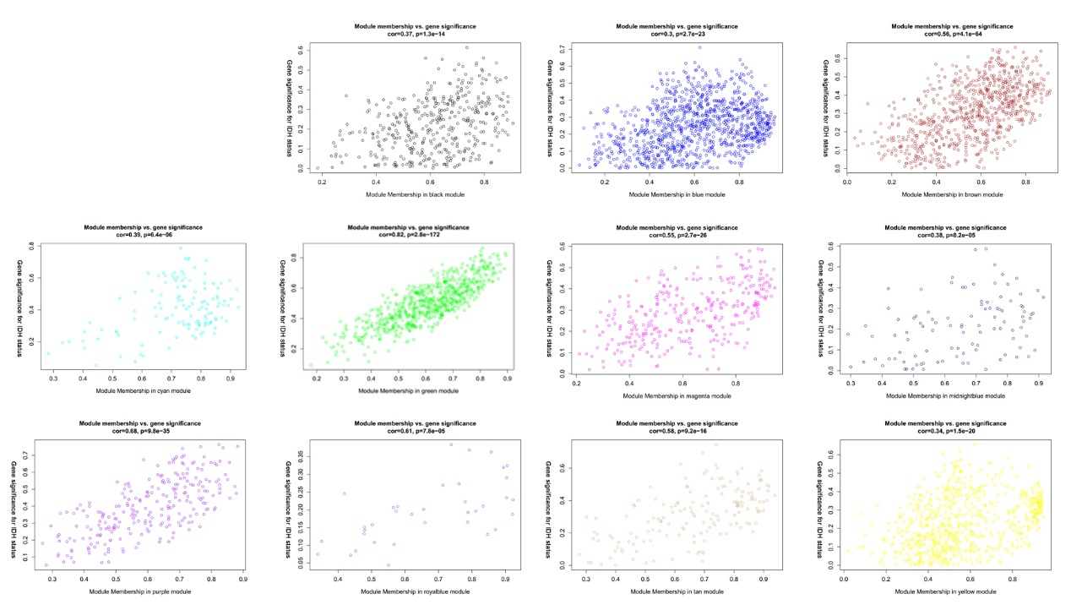
Figure S3: Correlation between different module genes and IDH status.

