Supplementary Material
The safety of laparoscopic cholecystectomy in day surgery unit comparing with that in the inpatient unit: a systematic review and meta-analysis
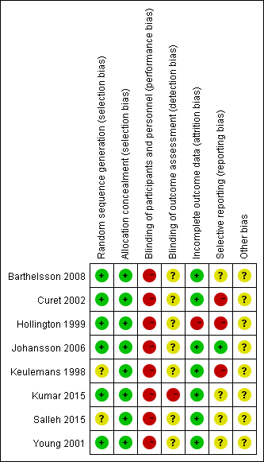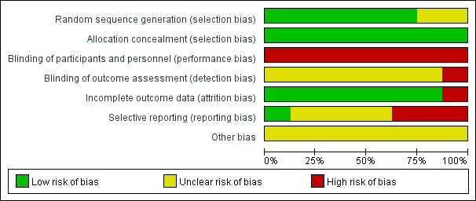
Figure s1. Risk of bias summary and risk of bias graph.
Supplementary S2. Search strategy for The safety of laparoscopic cholecystectomy in day surgery unit comparing with that in the inpatient unit: a systematic review and meta-analysis.
Search strategy were developed following the five “PICOS” components.
PICOS-LC in day surgery unit vs. LC in the inpatient unit
P | population: patients with benign diseases of gallbladder underwent LC
I | intervention: laparoscopic cholecystectomy (LC)
C | comparison: day surgery unit vs. inpatient unit
O | outcomes: Post-operative complications, post-operative nausea and vomiting (PONV) and visual analogue score (VAS), hospital stay, time to normal activity, patients’ satisfaction, readmission and cost.
S | study design: retrospective or prospective studies or randomized control trials

Embase.com 594
('cholecystectomy'/exp OR (cholecystectom* OR (gallbladder* NEAR/3 (remov* OR resection*))):ab,ti) AND ('ambulatory surgery'/exp OR 'ambulatory care'/de OR outpatient/de OR 'outpatient department'/de OR 'outpatient care'/de OR (ambulatory OR outpatient* OR ((day) NEXT/1 (surger* OR case OR stay OR care OR hospital*)) OR same-day OR polyclinic* OR poly-clinic*):ab,ti) AND ('hospitalization'/exp OR 'hospital admission'/exp OR 'length of stay'/exp OR 'hospital patient'/exp OR 'hospital discharge'/de OR (hospitali* OR overnight* OR over-night* OR ((length OR hospital OR long OR short*) NEAR/3 stay) OR admission* OR admitted* OR inpatient* OR in-patient* OR routine OR discharge*):ab,ti) NOT ('case report'/de OR [Conference Abstract]/lim OR [Editorial]/lim OR [Erratum]/lim OR [Letter]/lim OR [Note]/lim OR 'case report':ti) AND [English]/lim NOT ([animals]/lim NOT [humans]/lim)
Medline Ovid 498
(exp Cholecystectomy/ OR (cholecystectom* OR (gallbladder* ADJ3 (remov* OR resection*))).ab,ti.) AND (Ambulatory Surgical Procedures/ OR Ambulatory Care/ OR Outpatients/ OR Ambulatory Care Facilities/ OR Outpatient Clinics, Hospital/ OR (ambulatory OR outpatient* OR ((day) ADJ (surger* OR case OR stay OR care OR hospital*)) OR same-day OR polyclinic* OR poly-clinic*).ab,ti.) AND (Hospitalization/ OR Length of Stay/ OR Inpatients/ OR (hospitali* OR overnight* OR over-night* OR ((length OR hospital OR long OR short*) ADJ3 stay) OR admission* OR admitted* OR inpatient* OR in-patient* OR routine OR discharge*).ab,ti.) NOT (case reports/ OR (news OR congres* OR abstract* OR book* OR chapter* OR dissertation abstract* OR letter* OR note OR editorial).pt. OR case report.ti.) AND english.la. NOT (exp animals/ NOT humans/)
Web of science 442
TS=(((cholecystectom* OR (gallbladder* NEAR/2 (remov* OR resection*)))) AND ((ambulatory OR outpatient* OR "day surger*" OR "day case" OR "day stay" OR "day care" OR "day hospital*" OR "same-day" OR polyclinic* OR poly-clinic*)) AND ((hospitali* OR overnight* OR over-night* OR ((length OR hospital OR long OR short*) NEAR/2 stay) OR admission* OR admitted* OR inpatient* OR in-patient* OR routine ORdischarge*))) AND DT=(article) AND LA=(english)
Cochrane CENTRAL 125
((cholecystectom* OR (gallbladder* NEAR/3 (remov* OR resection*))):ab,ti) AND ((ambulatory OR outpatient* OR ((day) NEXT/1 (surger* OR case OR stay OR care OR hospital*)) OR same next day OR polyclinic* OR poly next clinic*):ab,ti) AND ((hospitali* OR overnight* OR over next night* OR ((length OR hospital OR long OR short*) NEAR/3 stay) OR admission* OR admitted* OR inpatient* OR in next patient* OR routine OR discharge*):ab,ti)
Google scholar
cholecystectomy|"gallbladder removal|resection" ambulatory|outpatient|"day surgery|case|stay|care|hospital"|"same-day"|polyclinic hospitalization|overnight|admission|inpatient|discharge

