Supplementary Figure 1. A retroperitoneal tumor that entered the inferior vena cava and reached the right atrium via the left renal vein. A, the retroperitoneal tumor enters the inferior vena cava to the right atrium via the left renal vein. B, right atrial tumor. C, the arrow indicates the left renal vein.
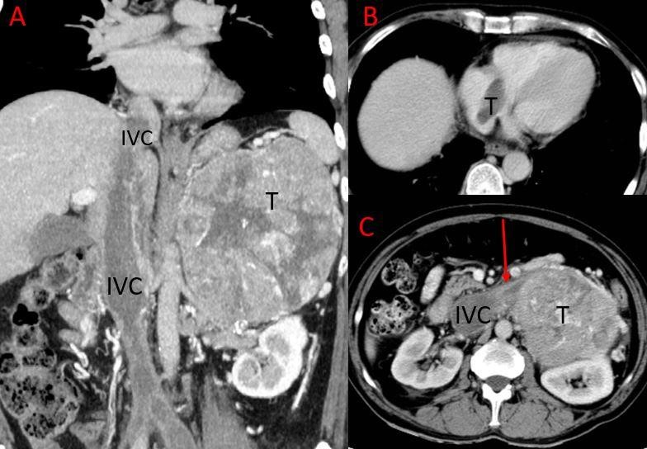

Supplementary Table 1 Changes in cardiac function before and after surgery and immunohistochemistry results of tumor in the inferior vena cava/ right atrium

Case Heart function class（NYHA） Desmin SMA ER PR

Pre-operation | Post-operation
1 I | I | + | +
2 II | I | + | + | + | +
3 III | I | + | + | ++ | ++
4 III | II | + | + | +++ | +++
5 III | II | + | + | + | +
6 IV | Death | + | + | + | -
7 II | I
SMA, smooth muscle actin; ER, oestrogen receptor; PR, progesterone receptor; NYHA, New York Heart Association

