Supplementary Figure 1 (a) Capillary Electrophoresis of NPM1 mutation in AML samples. Fluorescent PCR product analysis of exon 12 showed one wild type NPM1 peak at 198 bp and additional peak at 202 bp in patients with NPM1 mutation (b) Sequence electropherogram showing the NPM1 mutation: Direct sequencing of PCR product from normal and NPM1 mutant samples was done. Reverse PCR primer was used as a sequencing primer. The boxed tetranucleotides shown in the mutant sequence are the 4bp inserted between nucleotide 960 and 961 from the transcription start site
(a)
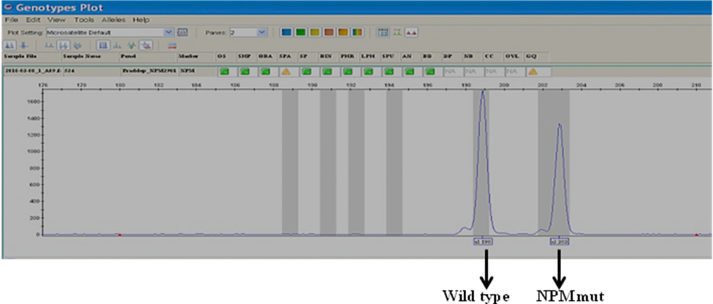

(b)
T C T G

Wild Sequence Mutant Sequence (4 bp Insert)

