SUPPLEMENTARY

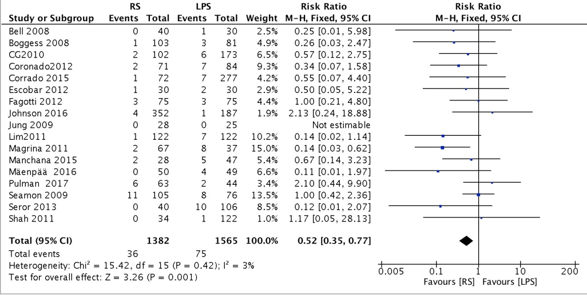
Figure S1 Forest plot of intraoperative complications between the RS and LPS groups.
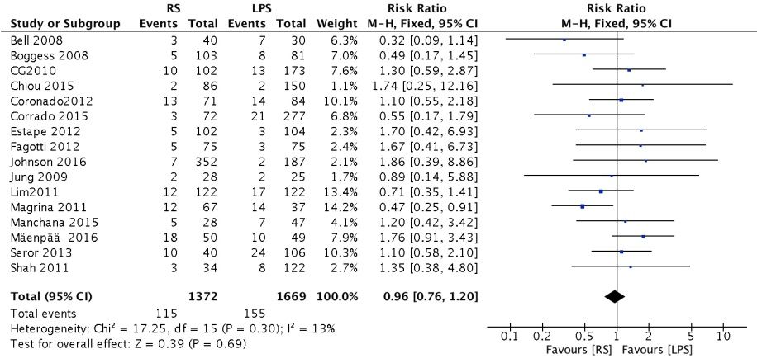
Figure S2 Forest plot of postoperative complications between the RS and LPS groups.
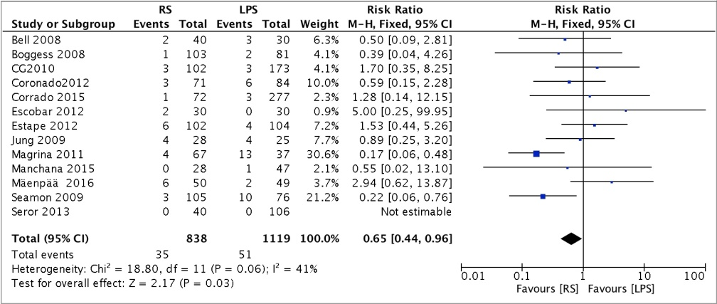
Figure S3 Forest plot of blood transfusion between the RS and LPS groups.
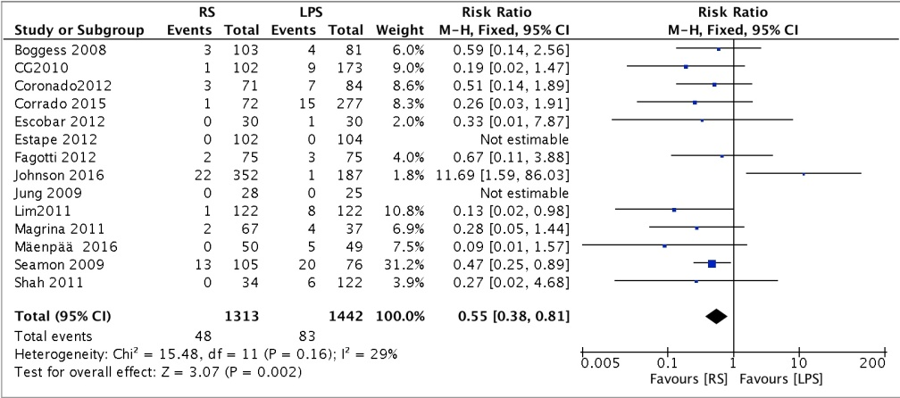
Figure S4 Forest plot of conversion between the RS and LPS groups.
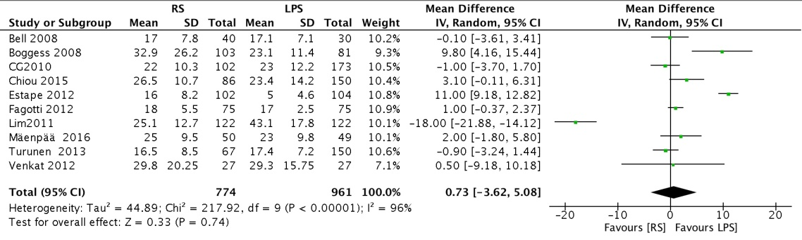
Figure S5 Forest plot of TLNH between the RS and LPS groups.
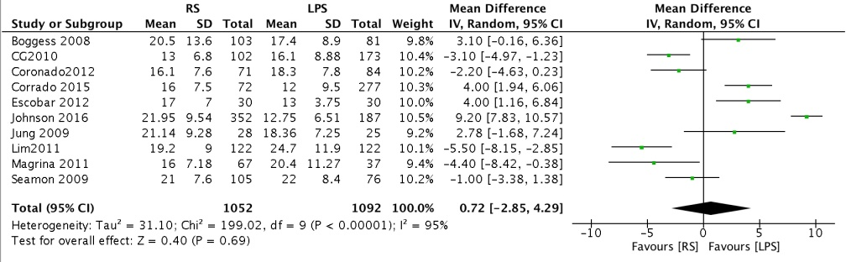
Figure S6 Forest plot of the number of PLNH between the RS and LPS groups.
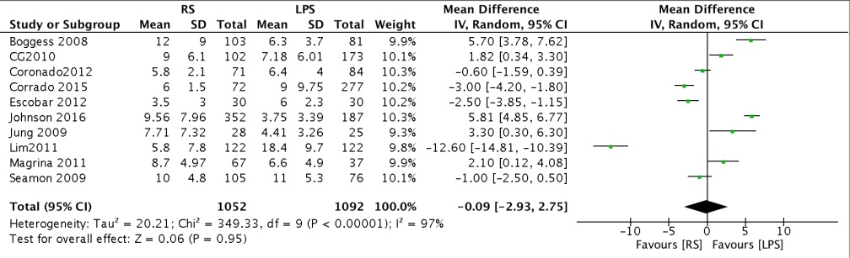
Figure S7 Forest plot of the number of PALNH between the RS and LPS groups.
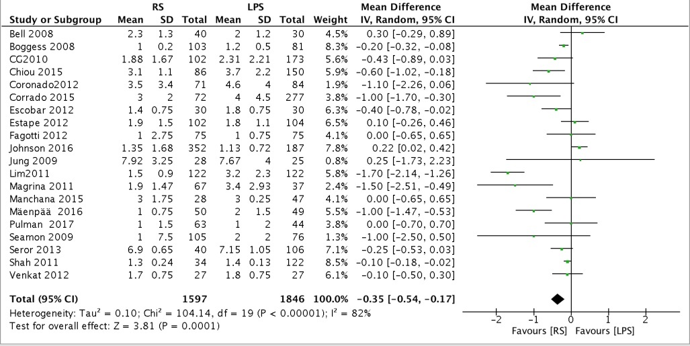
Figure S8 Forest plot of hospital stay between the RS and LPS groups.
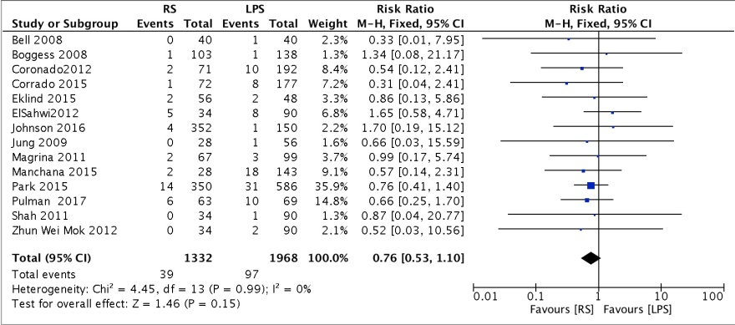
Figure S9 Forest plot of intraoperative complications between the RS and LT groups

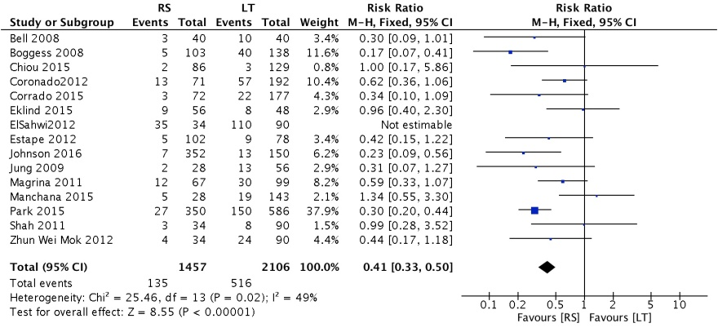
Figure S10 Forest plot of postoperative complications between the RS and LT groups.
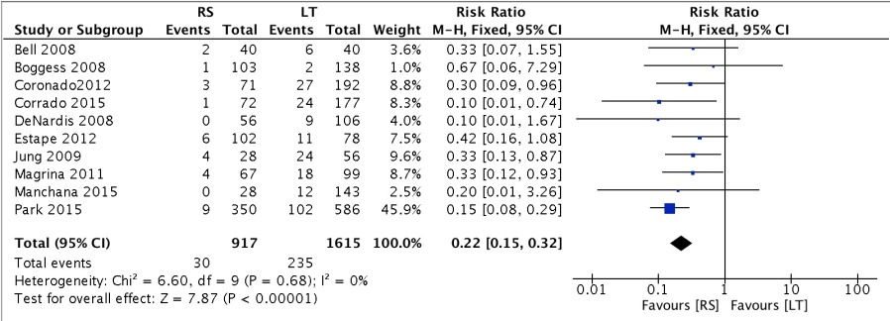
Figure S11 Forest plot of blood transfusion between the RS and LT groups.
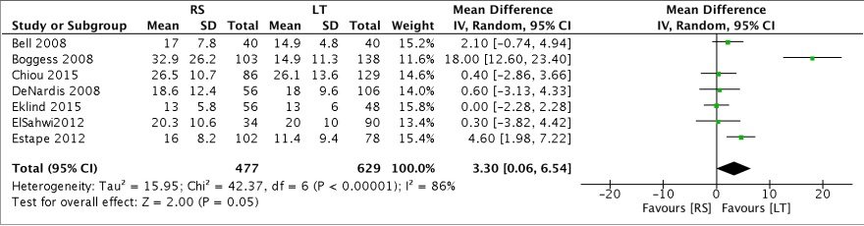
Figure S12 Forest plot of TLNH between the RS and LT groups.
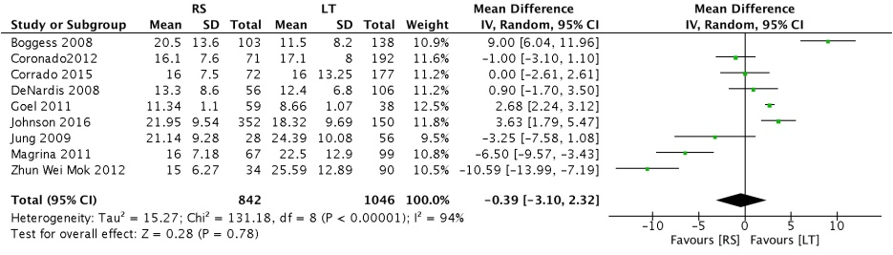
Figure S13 Forest plot of the number of PLNH between the RS and LT groups.
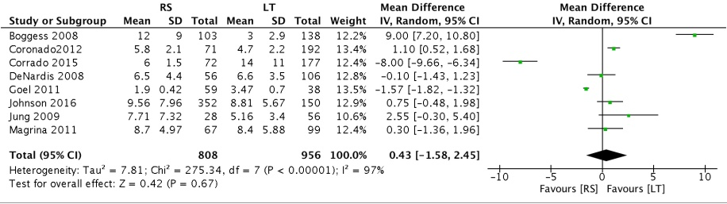
Figure S14 Forest plot of the number of PALNH between the RS and LT groups.
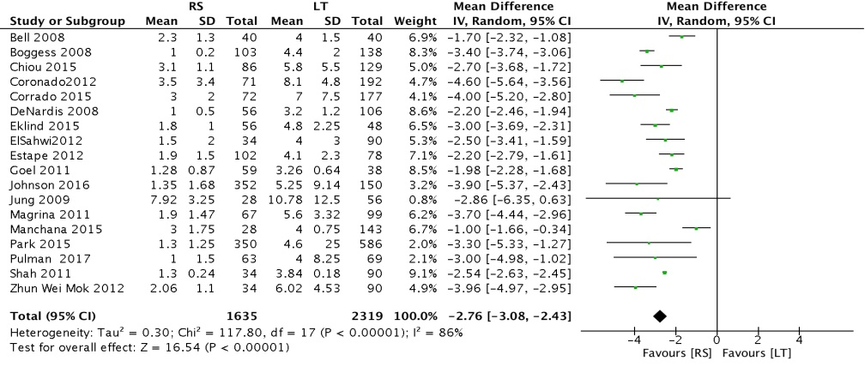
Figure S15 Forest plot of hospital stay between the RS and LT groups.
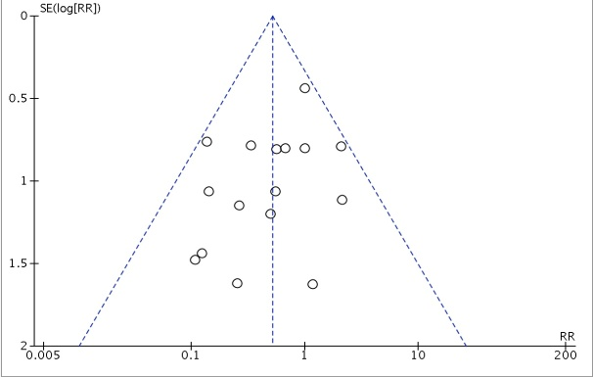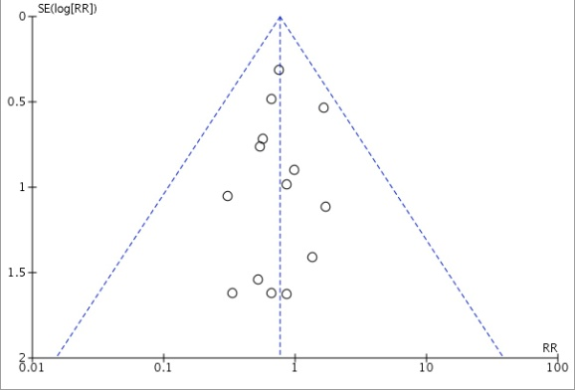
- (b)
Figure S16-a Funnel plots for intraoperative complications of RS vs. LPS.
S16-b Funnel plots for intraoperative complications of RS vs. LT

Criteria |  | Brief description of how the criteria were handled in the meta-analysis
Reporting of background should include
√ | Problem definition | Diabetes mellitus is a condition that could affect one’s risk of active tuberculosis disease. Diabetes prevalence is on the rise, while tuberculosis burden remains stagnant. The potential public health impact of diabetes on TB remains to be summarized quantitatively.
√ | Hypothesis statement | Diabetes increases the risk of active tuberculosis.
√ | Description of study outcomes | Active tuberculosis disease
√ | Type of exposure or intervention used | Diabetes mellitus
√ | Type of study designs used | We included case-control studies, prospective cohort studies, cross-sectional studies, comparisons of study populations with age standardization; We excluded studies of reverse association.
√ | Study population | We placed no restriction.
Reporting of search strategy should include
√ | Qualifications of searchers | The credentials of the two investigators CJ and MM are indicated in the author list.
√ | Search strategy, including time period included in the synthesis and keywords | PubMed from 1965 – March 2007  EMBASE from 1974 – March 2007  See Box 1 in the article
√ | Databases and registries searched | PubMed and EMBASE
√ | Search software used, name and version, including special features | We did not employ a search software. EndNote was used to merge retrieved citations and eliminate duplications
√ | Use of hand searching | We hand-searched bibliographies of retrieved papers for additional references,
√ | List of citations located and those excluded, including justifications | Details of the literature search process are outlined in the flow chart. The citation list is available upon request
√ | Method of addressing articles published in languages other than English | We placed no restrictions on language; local scientists fluent in the original language of the article were contacted for translation
√ | Method of handling abstracts and unpublished studies | We had contacted a few authors for unpublished studies on the association.
√ | Description of any contact with authors | We contacted authors who had conducted multivariate analysis with diabetes as a covariate, but had not reported relative risk for diabetes.
Reporting of methods should include
√ | Description of relevance or appropriateness of studies assembled for assessing the hypothesis to be tested | Detailed inclusion and exclusion criteria were described in the methods section.
√ | Rationale for the selection and coding of data | Data extracted from each of the studies were relevant to the population characteristics, study design, exposure, outcome, and possible effect modifiers of the association.
√ | Assessment of confounding | Restricted the analysis to age-adjusted estimates only. Conducted sensitivity analyses by eliminating studies that had not adjusted for possible confounders such as sex, race, smoking, alcohol, immunosuppressive drugs, and socioeconomic status.
√ | Assessment of study quality, including blinding of quality assessors; stratification or regression on possible predictors of study results | Sensitivity analyses by several quality indicators such as timing of diabetes assessment relative to tuberculosis, method of diabetes and tuberculosis diagnosis, control selection, adjustment factors, potential duplicate data, use of convenience samples.
√ | Assessment of heterogeneity | Heterogeneity of the studies were explored within two types of study designs using Cochrane’s Q test of heterogeneity and I² statistic that provides the relative amount of variance of the summary effect due to the between-study heterogeneity.
√ | Description of statistical methods in sufficient detail to be replicated | Description of methods of meta-analyses, sensitivity analyses, meta-regression and assessment of publication bias are detailed in the methods.
√ | Provision of appropriate tables and graphics | We included 1 box detailing the terms used for database search, 1 flow chart,1 summary table, 1 forest plot of all studies, 1 forest plot to examine effect modification by age, 1 table of sensitivity analyses.
Reporting of results should include
√ | Graph summarizing individual study estimates and overall estimate | Figure 2
√ | Table giving descriptive information for each study included | Table 1
√ | Results of sensitivity testing | Table 2
√ | Indication of statistical uncertainty of findings | 95% confidence intervals were presented with all summary estimates, I² values and results of sensitivity analyses
Reporting of discussion should include
√ | Quantitative assessment of bias | Sensitivity analyses indicate heterogeneity in strengths of the association due to most common biases in observational studies.
√ | Justification for exclusion | We excluded studies that had not adjusted for or were standardized by age, a potential confounder, and used different exposure or outcome assessment for the comparison groups. Those studies that were excluded also indicate positive association, as noted in the discussion.
√ | Assessment of quality of included studies | We discussed the results of the sensitivity analyses, and potential reasons for the observed heterogeneity.
Reporting of conclusions should include
√ | Consideration of alternative explanations for observed results | We discussed that potential unmeasured confounders such as other chronic diseases may have caused residual confounding, but the measured factors that are correlated with such confounders would have mitigated the bias.  We noted that the variations in the strengths of association may be due to true population differences, or to differences in quality of studies.
√ | Generalization of the conclusions | The calculation of attributable risk percent from the relative risk and the population attributable risk percent given a realistic estimate of the prevalence of diabetes indicates diabetes has a substantial impact on TB burden. We noted the lack of studies in Africa.
√ | Guidelines for future research | We recommend future studies on the effect of duration and severity of diabetes on TB risk.
√ | Disclosure of funding source | No separate funding was necessary for the undertaking of this systematic review.

Figure S17 MOOSE Checklist

Table S1 NOS score of the study

项目 | Selection  （4 ※） |  |  |  | Comparability  （2 ※） | Outcome  （3 ※）
Study | Representativeness of the exposed cohort  （※） | Selection of the non exposed cohort  （※） | Ascertainment  of exposure （※） | Demonstration that outcome of interest was not present at start of study  （※） | Comparability of cohorts on the basis of the design or analysis （※※） | Assessment of outcome  （※） | Was follow-up long enough for outcomes to occur  （※） | Adequacy of follow up of cohorts（※）
Bell 2008 | ※ | ※ | ※ | ※ | ※ | ※ | ※ | ※
Boggess 2008 | ※ | ※ | ※ | ※ |  | ※ | ※ | ※
Coronado2012 | ※ | ※ | ※ | ※ |  | ※ | ※ | ※
Chiou 2015 | ※ | ※ | ※ | ※ | ※※ | ※ | ※ | ※
CG 2010 | ※ | ※ | ※ | ※ | ※ | ※ | ※ | ※
Corrado 2015 | ※ | ※ | ※ | ※ | ※※ | ※ | ※ | ※
Estape 2012 | ※ | ※ | ※ | ※ | ※※ | ※ | ※ | ※
Escobar 2012 | ※ | ※ | ※ | ※ | ※ | ※ | ※ | ※
Fagotti 2012 | ※ | ※ | ※ | ※ | ※ | ※ | ※ | ※
JUNG 2009 | ※ | ※ | ※ | ※ | ※ | ※ | ※ | ※
Johnson 2016 | ※ | ※ | ※ | ※ | ※ | ※ | ※ | ※
Lim2010 | ※ | ※ | ※ | ※ | ※※ | ※ | ※ | ※
Manchana 2015 | ※ | ※ | ※ | ※ |  | ※ | ※ | ※
Magrina 2011 | ※ | ※ | ※ | ※ | ※ | ※ | ※ | ※
Pulman 2017 | ※ | ※ | ※ | ※ |  | ※ | ※ | ※
Seamon 2009 | ※ | ※ | ※ | ※ | ※ | ※ | ※ | ※
Seror 2013 | ※ | ※ | ※ | ※ | ※ | ※ | ※ | ※
Shah 2011 | ※ | ※ | ※ | ※ |  | ※ | ※ | ※
Turunen 2013 | ※ | ※ | ※ | ※ | ※※ | ※ | ※ | ※
Venkat 2012 | ※ | ※ | ※ | ※ | ※※ | ※ | ※ | ※
DeNardis 2008 | ※ | ※ | ※ | ※ |  | ※ | ※ | ※
ElSahwi2012 | ※ | ※ | ※ | ※ | ※ | ※ | ※ | ※
Eklind 2015 | ※ | ※ | ※ | ※ | ※※ | ※ | ※ | ※
Goel 2011 | ※ | ※ | ※ | ※ | ※ | ※ | ※ | ※
Park 2015 | ※ | ※ | ※ | ※ |  | ※ | ※ | ※
Zhun Wei Mok 2012 | ※ | ※ | ※ | ※ | ※ | ※ | ※ | ※

