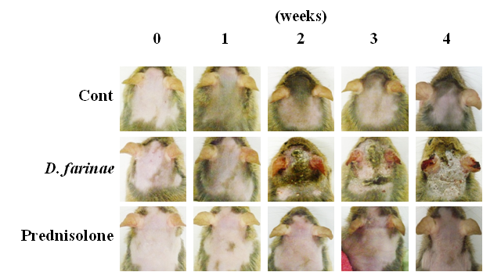

F_{IGURE} 1S: Histological changes of treated backs and ears in NC/Nga mice. Representative features and histological changes following consecutive administration of prednisolone to Dermatophagoides farinae-induced AD-like lesions on the back and ears. The images show the back and ears 4 weeks after sensitization.

