Supplementary Information

1. Histology images with H&E staining in model group at various time points (Fig S1).
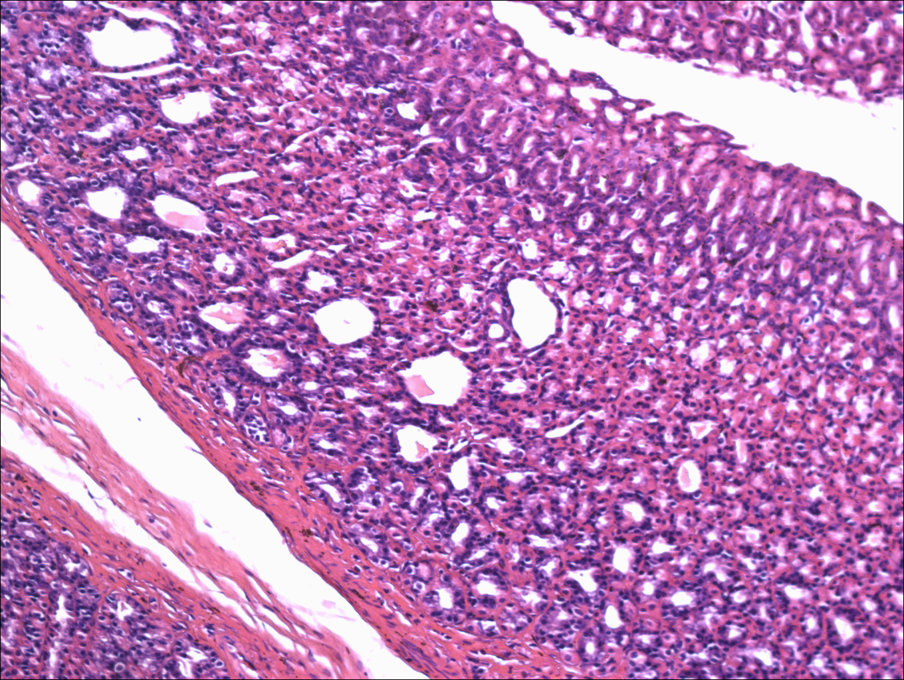 | 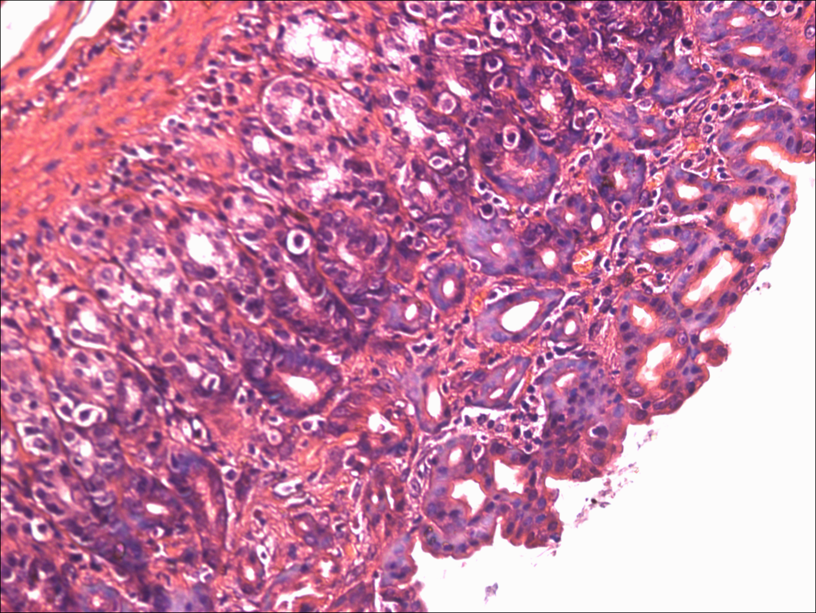 | 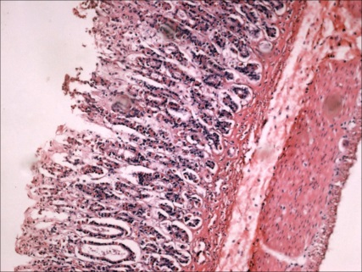
(A) | (B) | (C)
Fig S1. Histology images in model group at various time points. (A) At the end of week 8th, histological observation showed cystic dilation and irregular arrangement of gastric glands without obvious atrophy. (B) At the end of week 12th, histological observation showed inflammatory infiltration, cystic dilation, irregular arrangement and reduction of gastric glands in rats with CAG. (C) After 2 months withdraw of MNNG, inflammatory infiltration, cystic dilation and reduction of gastric glands still remained in model group. H&E staining, ×100.

2. 2^{-ΔCt} values of miR-155, miR-21 and miR-146a from different groups (Fig S2).
Fig S2. 2^{-ΔCt} values of miR-155, miR-21 and miR-146a from different groups. (A), (B) and (C) represented 2-^{ΔCt} values of miR-155, miR-21 and miR-146a respectively. *P<0.05, **P<0.001.

3. Proposed mechanisms of therapeutic effect of acupuncture through NF-κB-miR-155/-21/-146a signaling (Fig S3).
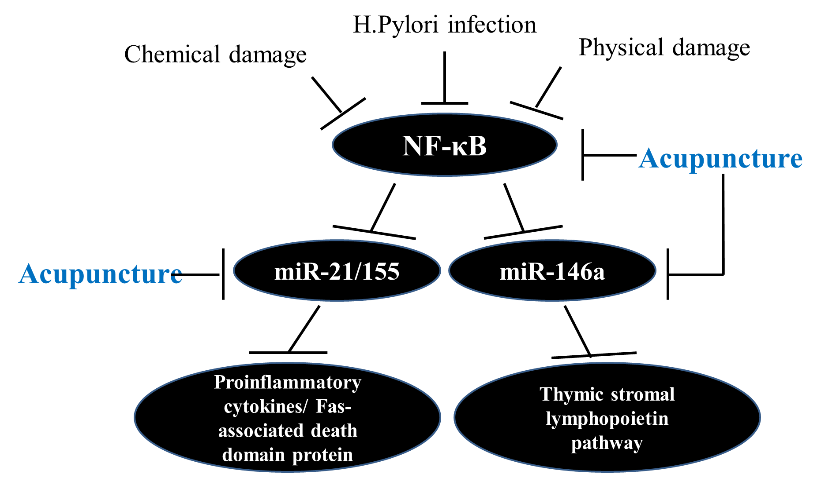
Fig S3. Proposed mechanisms of therapeutic effect of acupuncture through NF-κB-miR-155/-21/-146a signaling.

