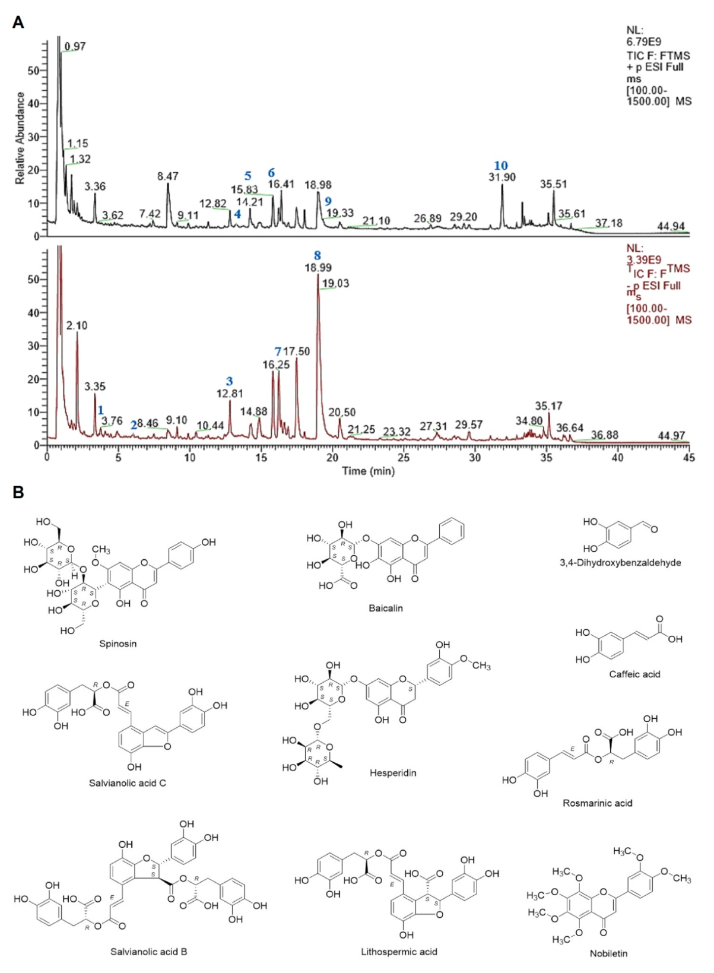
Supplementary Fig. A: UHPLC-MS fingerprint chromatogram of CHB-II-F. B: Chemical structure of the identified active ingredients of CHB-II-F. 3,4-Dihydroxybenzaldehyde (1), caffeic acid (2), spinosin (3), baicalin (4), salvianolic acid C (5), hesperidin (6), rosmarinic acid (7), salvianolic acid B (8), lithospermic acid (9) and nobiletin (10).

