Heteroatom Chemistry
Computational Studies of 4-formylpyridinethiosemicarbazone, Structural and Biological studies of its Ni(II) and Cu(II) complexes
Mydhili P. Sripathi, ¹ Sireesha Berely, ¹ Venkata Ramana Reddy Chittireddy²
¹ Department of Chemistry, Nizam College, Osmania University, Hyderabad, India
² Department of Chemistry, Jawaharlal Nehru Technological University Hyderabad, Hyderabad, India

E-mail: vrr9@jntuh.ac.in

Supplementary Material

Figures
Thione Thiol-1 Thiol-2
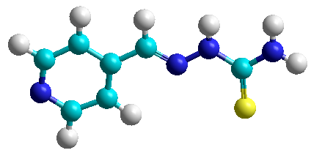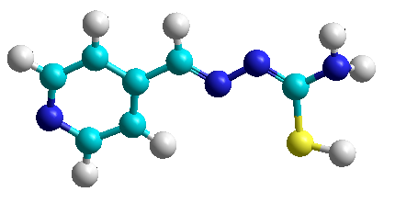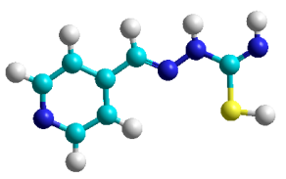
Optimized Geometry
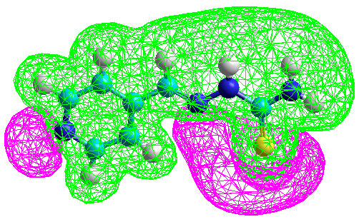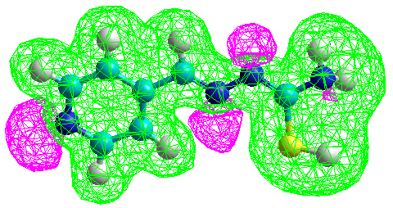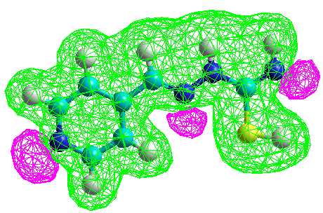
Electrostatic Potential
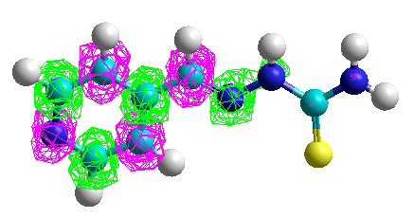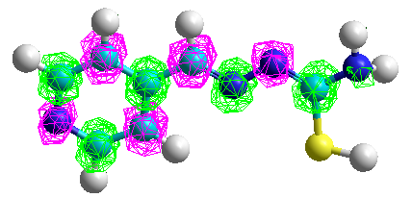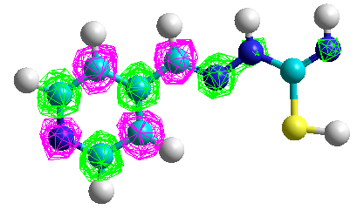
Total Spin Density
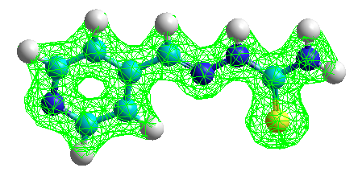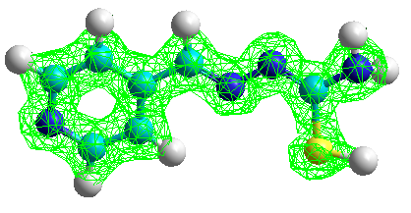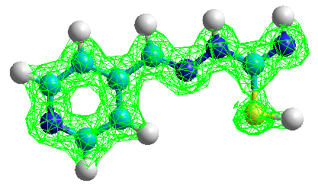
Total Charge Density
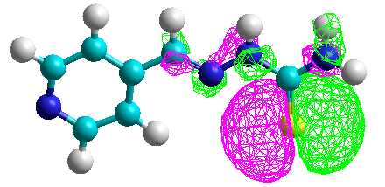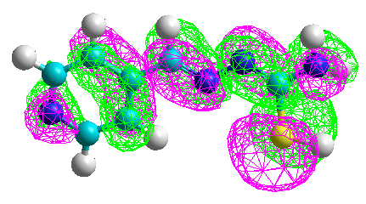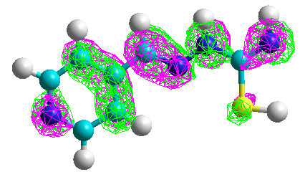
Highest Occupied Molecular Orbital
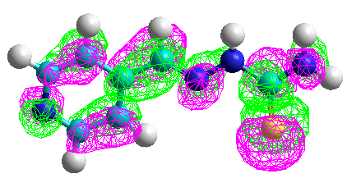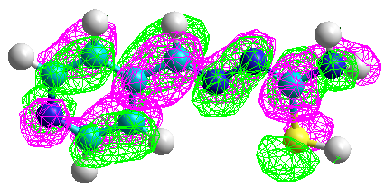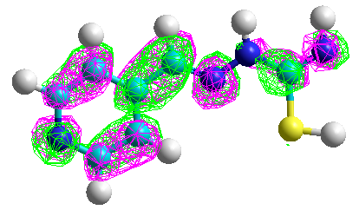
Lowest Unoccupied Molecular Orbital
Figure S1. Molecular Graphs of H4FPT (L)
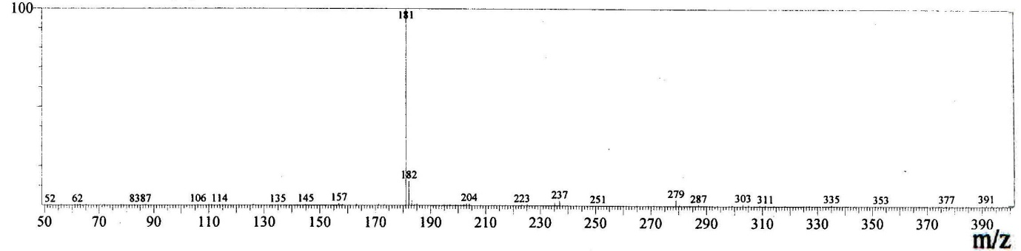
a. H4FPT (L)
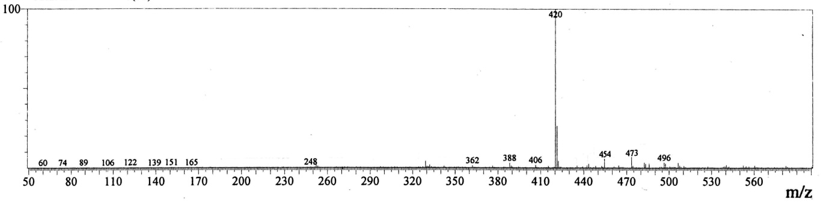
b. Ni(II) complex
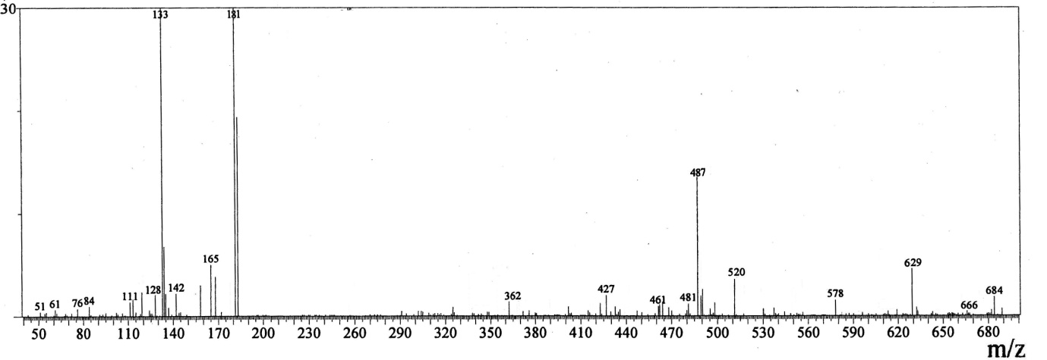
c. Cu(II) complex
Figure S2. Mass spectra of H4FPT, Ni(II) and Cu(II) complexes

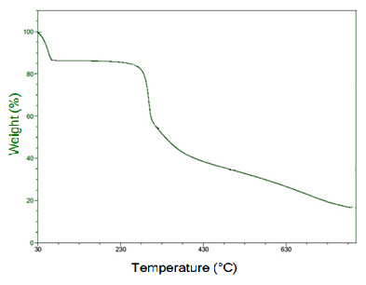
a. Ni(II) complex
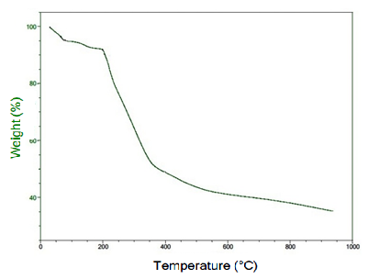
b. Cu(II) complex
Figure S3. Thermograms of Ni(II) and Cu(II) complexes
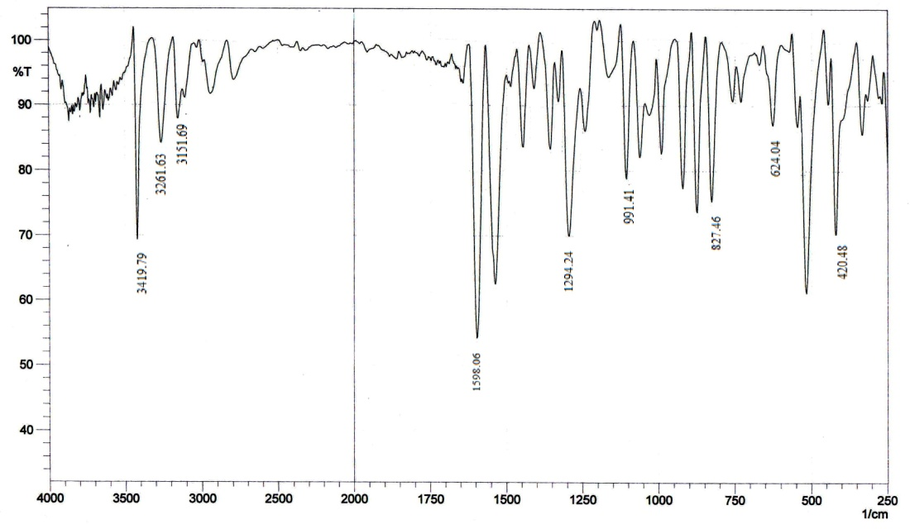
a. H4FPT (L)
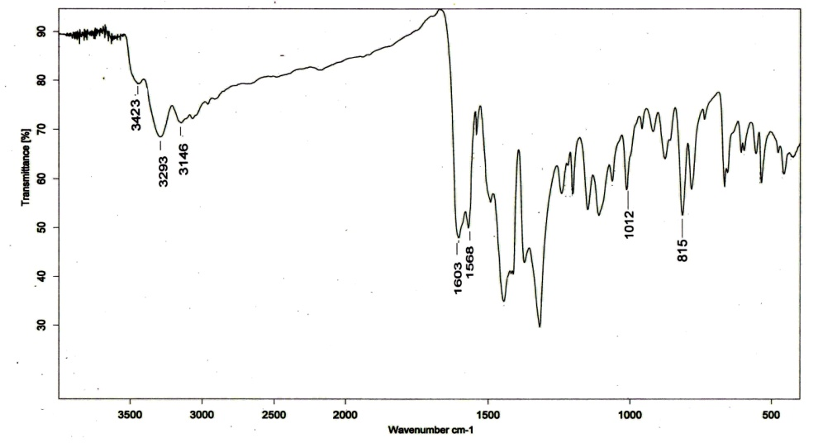
b. Ni(II) complex

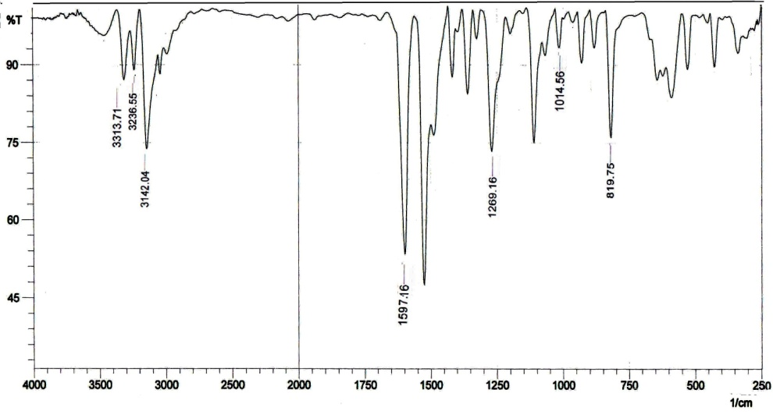
c. Cu(II) complex
Figure S4. IR Spectra of H4FPT, Ni(II) and Cu(II) complexes
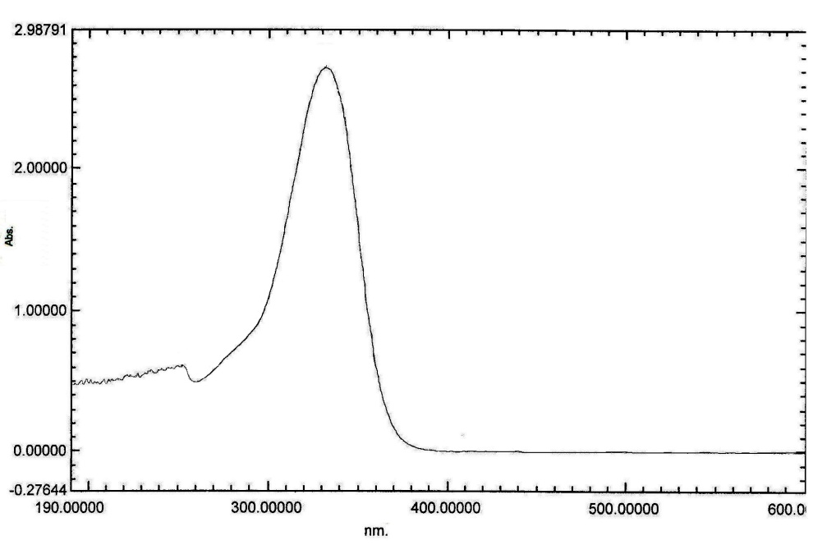
a. H4FPT (L)
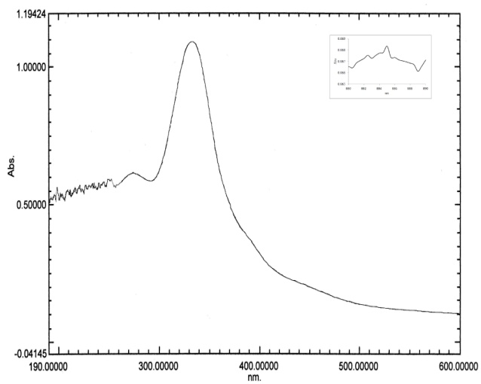
b. Ni(II) complex
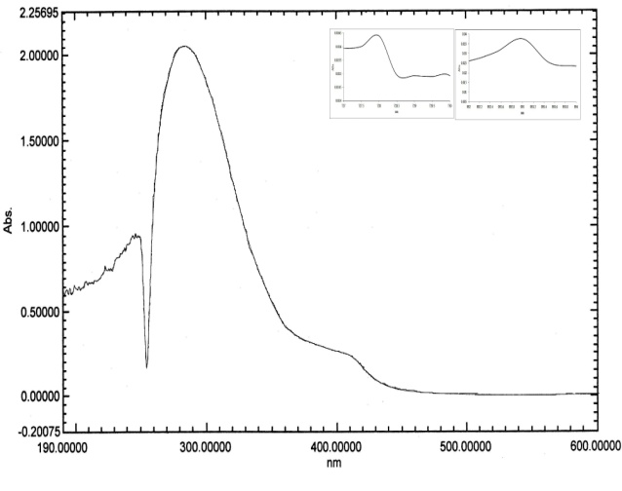
c. Cu(II) complex
Figure S5. UV-Visible Spectra of H4FPT, Ni(II) and Cu(II) complexes

Figure S6. ESR spectra of Cu(II) complex
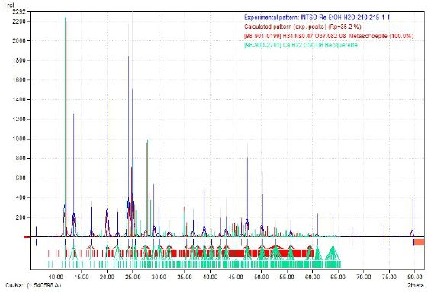
a. H4FPT (L)
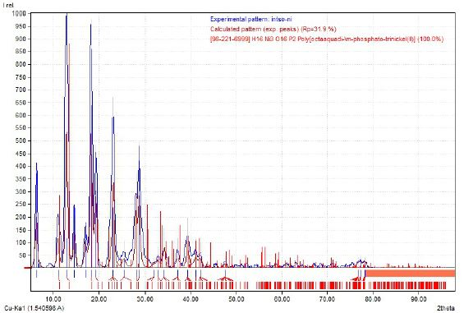
b. Ni(II) complex
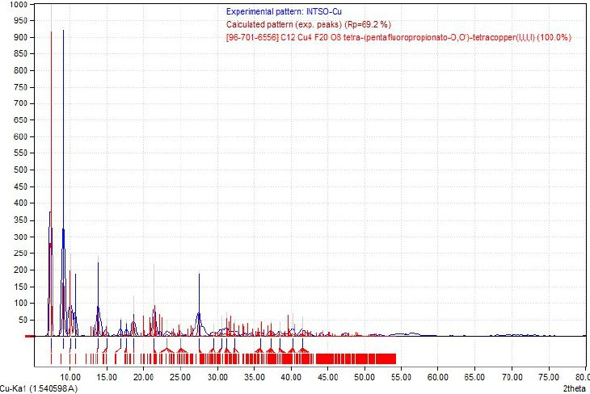
c. Cu(II) complex
Figure S7. Powder XRD of H4FPT, Ni(II) and Cu(II) complexes

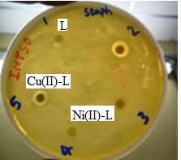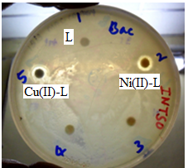
a) S.aureus b) B.subtilis

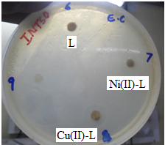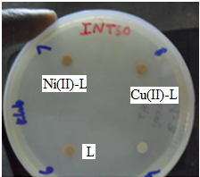
c) E.coli d) K.pneumoniae
Figure S8. Antibacterial activity of H4FPT (L) and its Ni(II) and Cu(II) complexes
with zone of inhibition in mm

Table S1: Data showing decrease in fluorescence emission with increase in concentration of the Ni(II)- H4FPTcomplex

Concentration of the complex x10⁻⁶ M | % increase in Concentration | Intensity of emission | % decrease in Intensity
0.78 | 96.85 | 81.88 | 1.78
1.55 | 47.74 | 80.43 | 1.25
2.29 | 31.35 | 79.42 | 3.81
3.01 | 23.14 | 76.39 | 1.79
3.70 | 18.25 | 75.03 | 1.08
4.38 | 14.98 | 74.22 | 1.35
5.04 | 12.67 | 73.22 | 1.20
5.67 | 10.93 | 70.14 | 3.10
6.29 | 9.58 | 70.04 | 0.08

Table S2: Data showing decrease in fluorescence emission with increase in concentration of the Cu(II)- H4FPTcomplex

Concentration of the complex x10-6 M | Increase in % Concentration | Intensity of emission | Decrease in % Intensity
0.78 | 96.85 | 77.12 | 0.26
1.55 | 47.74 | 76.92 | 2.03
2.29 | 31.35 | 75.35 | 2.35
3.01 | 23.14 | 73.58 | 1.68
3.70 | 18.25 | 72.34 | 1.23
4.38 | 14.98 | 71.46 | 2.69
5.04 | 12.67 | 69.53 | 1.16
5.67 | 10.93 | 68.74 | 1.14
6.29 | 9.58 | 67.94 | 1.96

