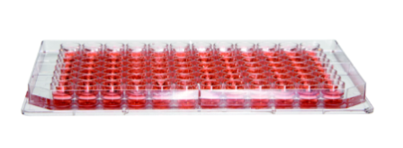
Media prepared with pre-mixed DMEM

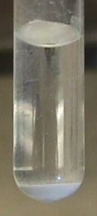
QELBY powder powder
Cells were seeded in a 96 well plate at a density of 1x10₅ cells/well.
Allowed to adhere for 3 hours.

Treated with LPS 10 ㎍/㎖
(lipopolysaccharid)

30 ㎖ of DMEM + 0.3 g of QELBY powder

Allowed to stand for 2 days at 4 ℃ after strong agitation for 5 min.
.

Suspended layer was added in different amount to each well,
0, 50, 100, 200 μg/ml

Incubated at 37 °C and 5 % CO₂ for 24 hours.

10 µl of CCK-8 solution were added to each well and incubated further for 2 hours.

Absorbance was measured by ELISA reader at 450 nm wavelength

SFig 1. Block diagram showing the cell culture process using a medium prepared by mixing with the suspended layer from the pre-mixed DMEM with the QELBY powder for the measurement of cell viability.
Absorbance was measured by ELISA reader at 450 nm wavelength

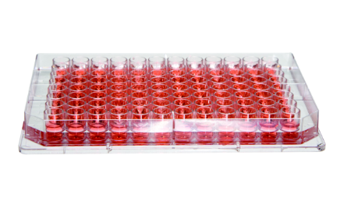
Phagocytic activity measurement
QELBY powder
Cells were seeded in a 96 well plate at a density of 1x10₅ cells/well.
Allowed to adhere for 3 hours.

Treated with LPS 10 ㎍/㎖
(lipopolysaccharid)
10㎖ of DMEM+
0.1g of QELBY powder

Allowd to stand for 2 days after strong
agitation (5 min).
Different amount of suspended layer was added to each well,
0, 50, 100, 200 μg/ml
Absorbance was measured by ELISA reader at 550 nm wavelength

Incubated at 37 °C in humidified 5 % CO₂ for 24 hours.

100 µl of 0.075 % aseptic neutral red solution was added and incubated further for 1 hour.

Plate was washed 3 times with PBS
and a mixture of 100 % ethanol and 99.9 % acetic acid (1:1 v/v) was added to 150 ㎕ of cell lysate.

Absorbance was measured by ELISA reader at 550 nm wavelength

SFig. 2 Block diagram showing the cell culture process using a medium prepared by mixing with the suspended layer from the pre-mixed DMEM with the QELBY powder for the measurement of phagocytic activity.

Natural Killer cell activity measurement
Target cell (YAC-1) was seeded in a 96 well plate at a density of 5x10₃cells/well and allowed to adhere for 3 hrs.

Target cell and Effector cell were mixed at a ratio (v/o) of;
Effector : Target = 10 : 1
Effector cell was prepared by isolation of spleen cell from a mouse.
Different amount of suspended layer was added to fresh RPMI 1640 media, 0, 50, 100, 200 μg/㎖

10 ㎖ of RPMI 1640 + 0.1 g of QELBY powder

Allowed to stand for 2 days after strong agitation (5 min).

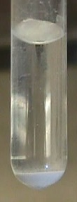
Qelby powder

Incubated in RPMI 1640 media for 24 hours.

CCK-8 assay for cytotoxicity measurement against YAC-1 cell.

Absorbance was measured by ELISA reader at 450 nm wavelength

SFig. 3. Block diagram showing the cell culture process using a medium prepared by mixing with the suspended layer from the pre-mixed RPMI 1640 with the QELBY powder for the measurement of natural killer cell activity.

Media prepared with non-contact treated water
Dulbeco’s Modified Eagle’s Media (powder)

50 mℓ of DW in a conical tube was put in QELBY powder for 2 days.

Exposed water was used for the preparation of culture media by mixing with DMEM

Cells were seeded in a 96 well plate at a density of 1x10₅cells/well.
Allowed to adhere for 3 hours.

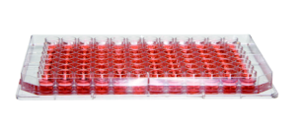

Treated with LPS 10 ㎍/㎖ (lipopolysaccharid)

Incubated at 37 °C with 5 % CO₂ for 24 hours.

10 µl of CCK-8 solution was added to each well and incubated further for 2 hours.

Absorbance was measured by ELISA reader at 450 nm wavelength

SFig 4. Block diagram showing the cell culture process using a medium prepared with the deionized water treated in a non-contact manner for the measurement of cell viability.

Absorbance was measured by ELISA reader at 450 nm wavelength

