Supplementary: 1000 genome phase 1 ensemble human genome population studies

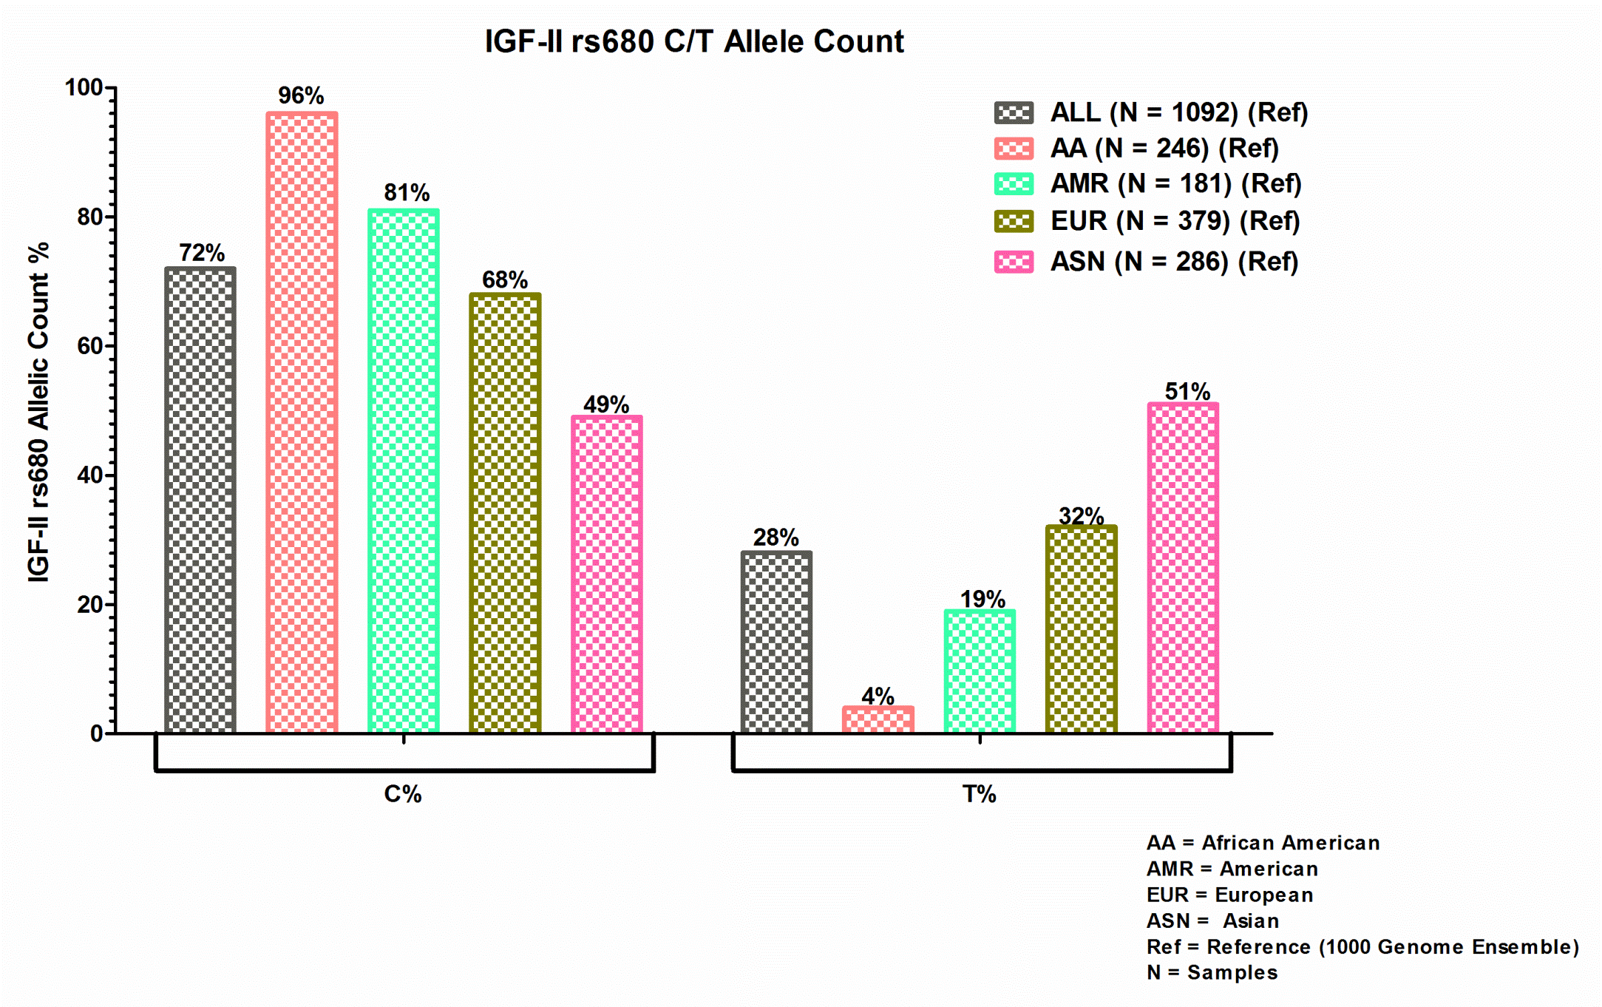
S. Figure 1
Analysis include total reference samples All (N = 1092), African American (AA) (N=246), American (AMR) (N=181), European (EUR) (N= 379), Asian (ASN) (N= 286). C/T IGF-II rs680 allelic count information is obtained from the 1000 genome phase 1 ensemble human genome population studies. Bar graph shows the representation information of the allelic count % for IGF-II rs680 observed among men and women population across different ethnic groups.

Supplementary: Limited Breast Sample Analysis of IGF-II rs680 in Different Ethnic Groups

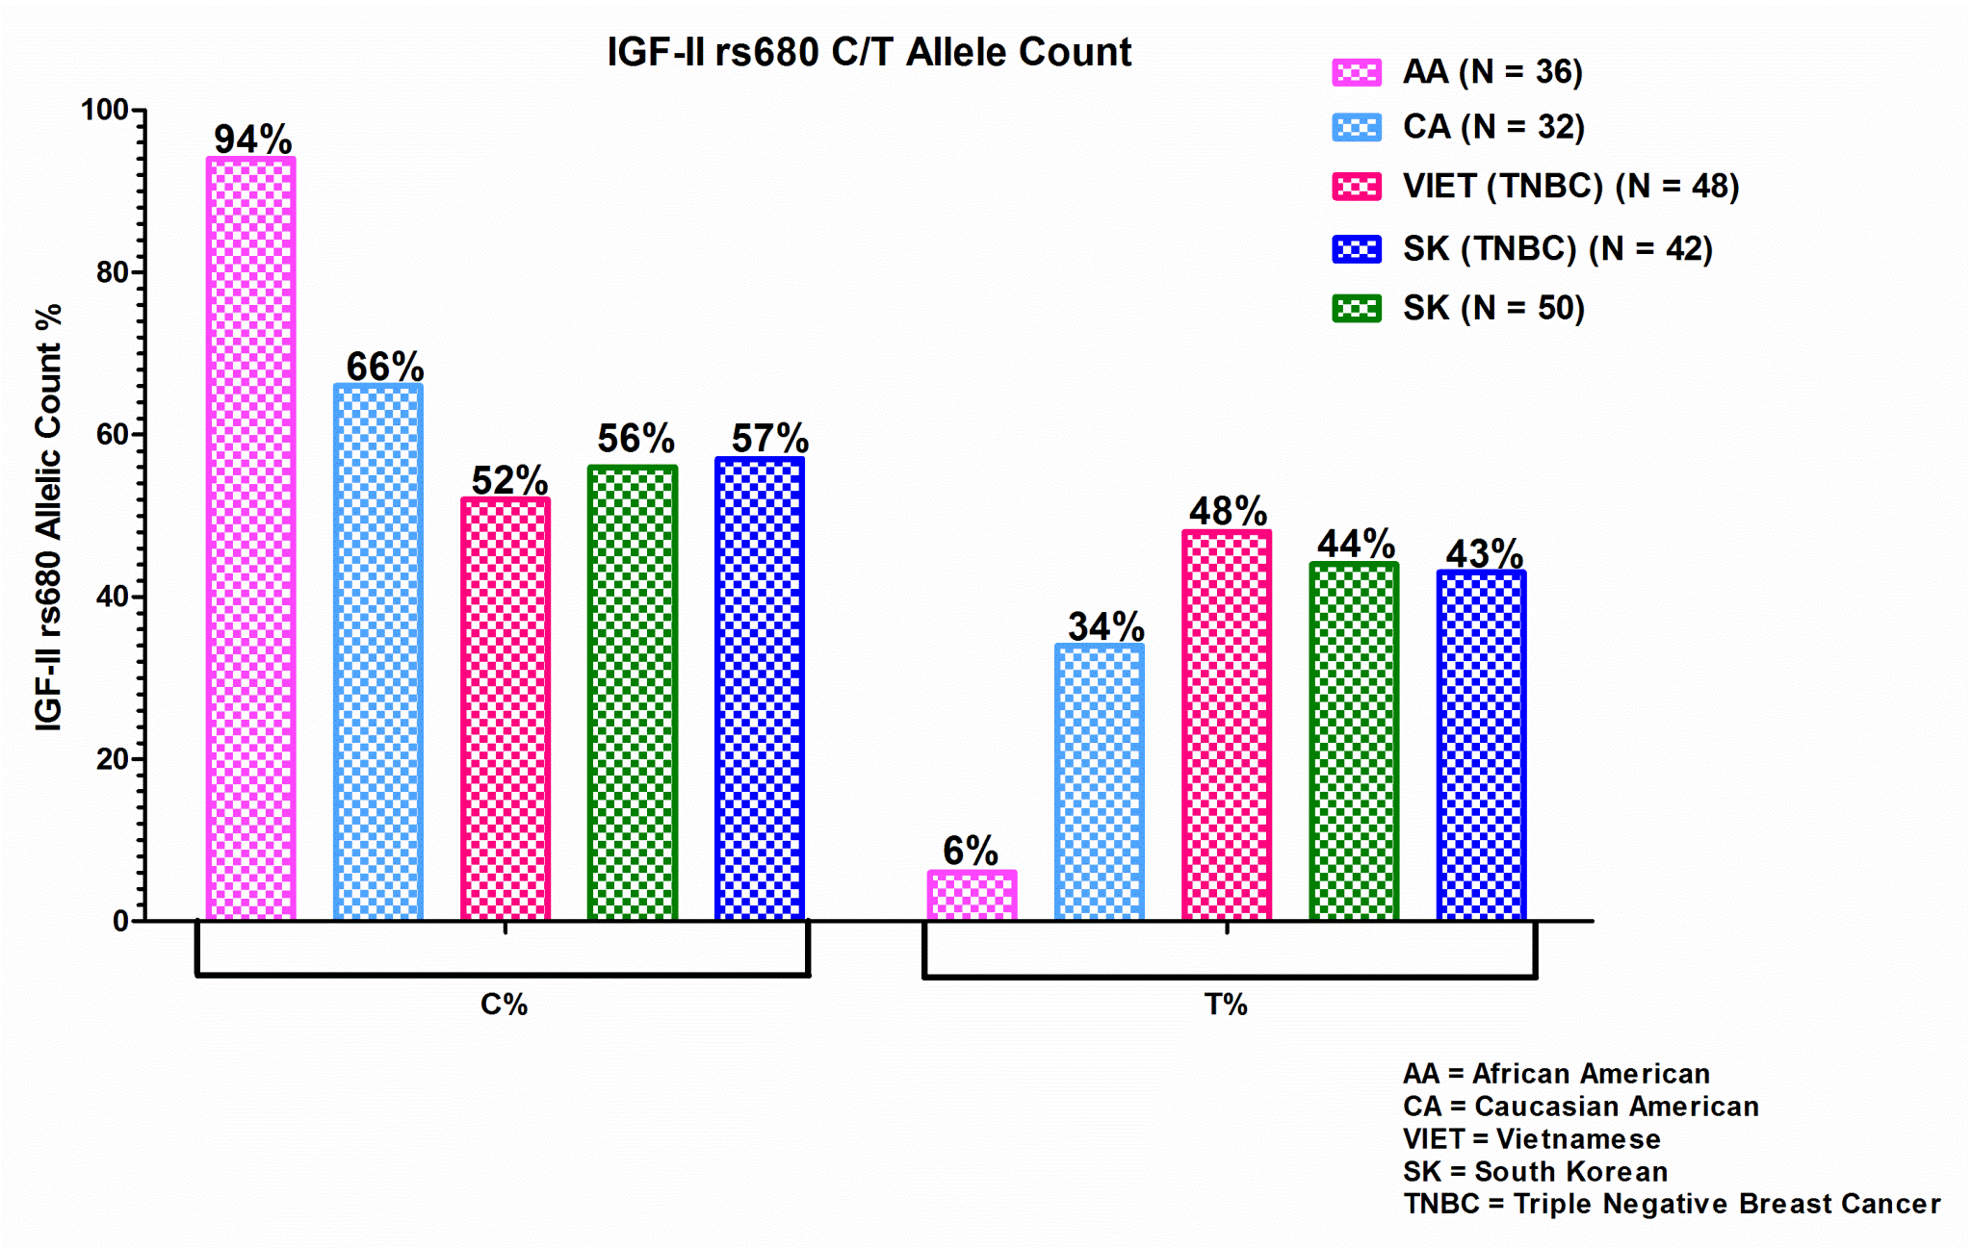
S. Figure 2
Analysis include experimental samples African American (AA) (N=36), Caucasian American (CA) (N=32), Vietnamese (VIET) (N=48) TNBC, South Korean (SK) (N= 50), South Korean (SK) (N= 42) TNBC. C/T IGF-II rs680 allelic count information are calculated as per the 1000 genome phase 1 ensemble human genome rs680 SNP variation studies. Bar graph shows the representation of the allelic count information % for IGF-II rs680 SNP observed in breast cancer and adjacent normal samples from women of different ethnic groups analyzed in our breast cancer laboratory.

