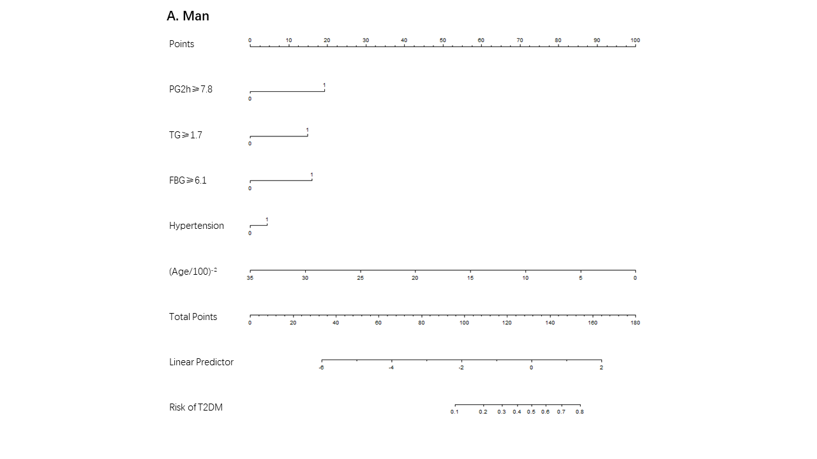
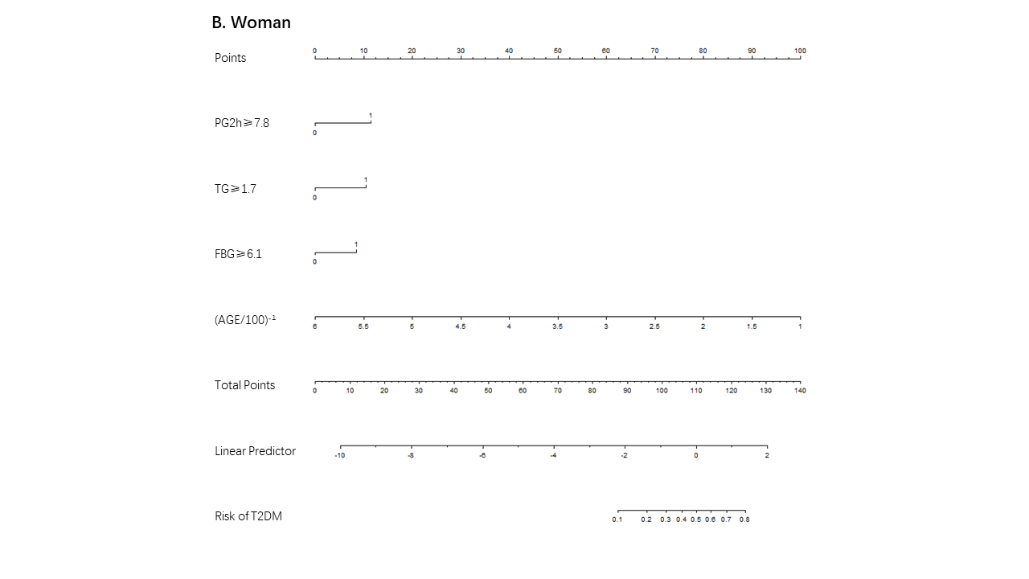
Fig.S1 The nomogram to estimate the risk of T2DM using part of the components of MetS (MFP model). To use the nomogram, find the position of each variable on the corresponding axis, draw a line to the points axis for the number of points, add the points from all of the variables, and draw a line from the total points axis to determine the T2DM probabilities in 3 years at the lower line of the nomogram.

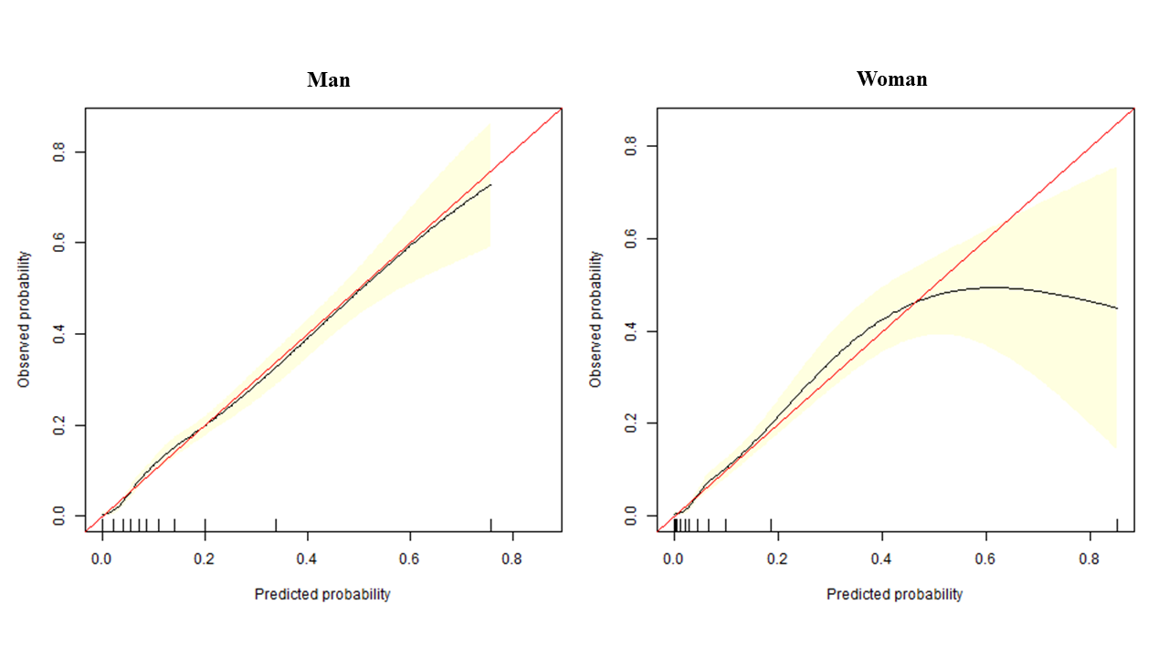
Fig.S2 Calibration curves of the MFP model nomogram (Bootstrap resampling times = 500) On the calibration curve, x-axis is nomogram-predicted probability of incident T2DM in 3 years, and y-axis is observed incident T2DM in 3 years.
The red line represents a perfect prediction by an ideal model. The black line represents the performance of the nomogram, of which a closer fit to the diagonal dotted line represents a better prediction. The pink area is the 95%CI of the calibration curve.

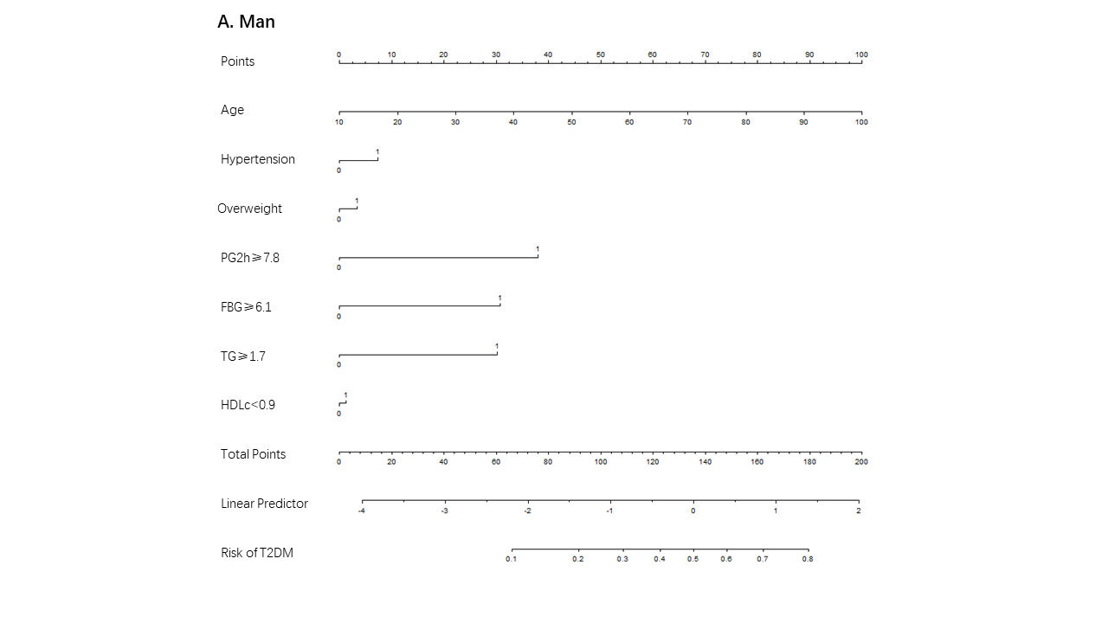
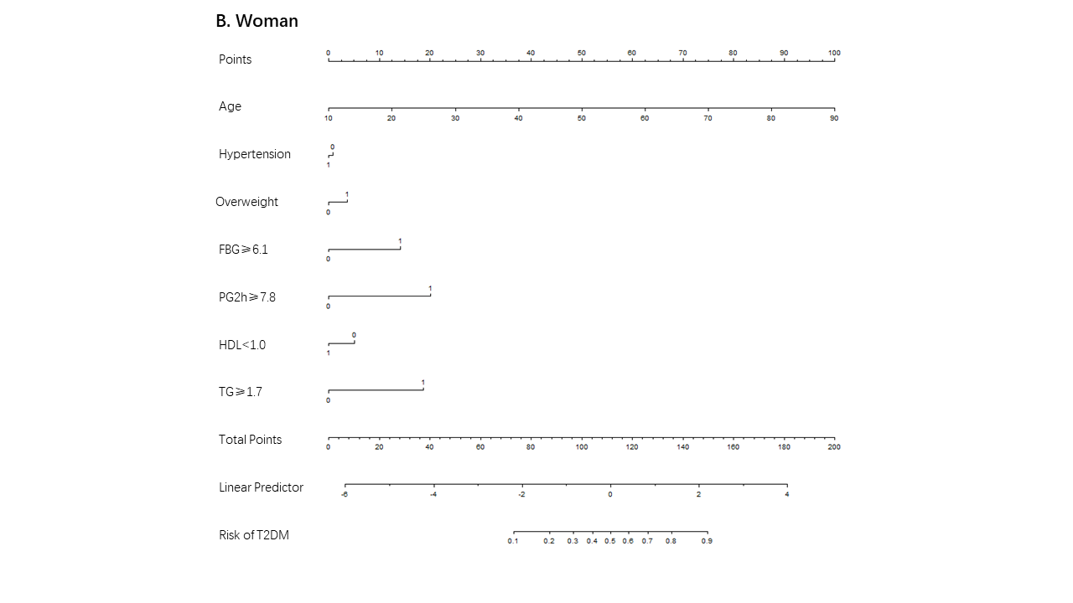
Fig.S3 The nomogram to estimate the risk of T2DM using all of the components of MetS (Full model). To use the nomogram, find the position of each variable on the corresponding axis, draw a line to the points axis for the number of points, add the points from all of the variables, and draw a line from the total points axis to determine the T2DM probabilities in 3 years at the lower line of the nomogram.

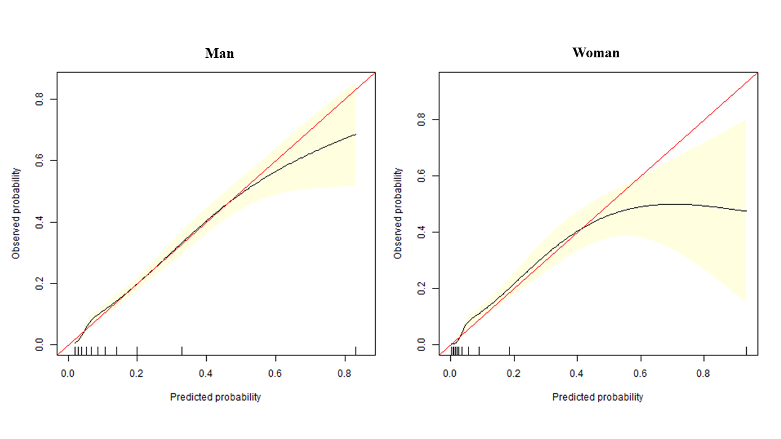
Fig.S4 Calibration curves of the Full model nomogram (Bootstrap resampling times = 500) On the calibration curve, x-axis is nomogram-predicted probability of incident T2DM in 3 years, and y-axis is observed incident T2DM in 3 years.
The red line represents a perfect prediction by an ideal model. The black line represents the performance of the nomogram, of which a closer fit to the diagonal dotted line represents a better prediction. The pink area is the 95%CI of the calibration curve.

