Supplementary Information
Table S1. Other individuals used to compare our results with. The different species/populations all have their own demographic history and thus their own interpretation of results and the comparison.
Species | Description
Sus verrucosus | Javan warty pig, lives in Indonesia (Java), this sample is from inbred zoo animal, originated from very small source population.
Sus barbatus | Bearded pig, lives in Indonesia and Malaysia, probably large outbred population present.
Sus celebensis | Sulawesi warty pig, lives in Indonesia (Sulawesi), probably large outbred population present.
Sus scrofa – Asian domestic | Domestic breed (Meishan) originated from Asian wild boar, limited population size.
Sus scrofa – Asian wild | Asian wild boar, large outbred population for long time, these samples are from North and South China. Sample from Japan experienced very severe bottleneck but recovered.
Sus scrofa – European domestic | Domestic breed (Large White) originated from European wild boar but admixed with Chinese domestic breeds.
Sus scrofa – European wild | European wild boar, originated from Asian wild boars, experienced severe bottleneck, currently fragmented population.

Table S2. Cross-validation errors for all possible K-values in the Admixture analyses. K = 6 had the lowest cross-validation error. We used K = 2 because of prior knowledge on the origin of the samples.
K-value | Cross-validation error
1 | 1.35
2 | 1.44
3 | 1.93
4 | 1.36
5 | 0.60
6 | 0.41

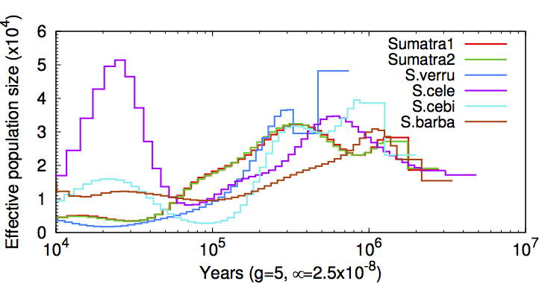
Figure S1. Estimated effective population size of other Sus species based individual genomes, generation time (i.e. 5 years) and mutation rate (2.5*10⁻⁸) from 10.000 (left) to 1.000.000 (right) years ago (Frantz et al. 2013). All species experienced a bottleneck to some extent around 100.000 years ago. Sumatra1 and Sumatra 2 are wild boar populations (Sus scrofa) from Sumatra.

Figure S2. Total coverage as proportion of the genome of all ROHs (left of dotted line) and of ROHs per length category (right of dotted line).
Figure S3. Total coverage as proportion of the genome of all ROHs (left of dotted line) and of ROHs per length category (right of dotted line). Counter to what logic predicts, not all individuals have the largest proportion of the genome covered by the longest ROHs. Many short ROHs are a sign of severe inbreeding in the past. Species description in Table S1. WB29U14 = Wild Boar South China, WB30U08 = Wild Boar North China, WB20U02 = Wild Boar Japan.
Figure S4. Proportion of bins (10kb) per category of SNPs per bin. On average 12 SNPs per bin were found in Sus cebifrons, 23 SNPs per bin were found on average in the other individuals (Table 2).

Table S3. Assessment of shared and island-specific variation. SNPs in coding regions only. Fixed differences between Sus cebifrons and Sus scrofa were excluded. The vast majority of the SNPs is shared between islands, and only a very small portion may be specific.
 | Shared | Panay  (N = 5) | Negros  (N = 2) | Total | Fraction island specific variation
All | 3969361 | 457741 | 251910 | 4679012 | 0.152
Synonymous | 19565 | 2150 | 1190 | 22905 | 0.146
Non-synonymous tolerated | 10081 | 918 | 533 | 11532 | 0.126
Non-synonymous not-tolerated | 3370 | 343 | 171 | 3884 | 0.132

Tabls S4. Number of variants in homozygous (Hom) or heterozygous (Het) state, per category (All, synonymous, non-synonymous tolerated and non-synonymous not-tolerated). The ratio represents the Het/Hom ratio. This ratio is increased in not-tolerated variants, suggesting some degree of purging has taken place.
 | All_variants |  |  | Synonymous_variants |  |  | Non-synonymous Tolerated_variants |  |  | Non-synonymous Not-tolerated_variants
 | Hom | Het | Ratio | Hom | Het | Ratio | Hom | Het | Ratio | Hom | Het | Ratio
02M01 | 3067603 | 1611409 | 0.525 | 14157 | 8748 | 0.618 | 6808 | 4724 | 0.694 | 2258 | 1626 | 0.720
02M02 | 3141793 | 1537219 | 0.489 | 14492 | 8413 | 0.581 | 6926 | 4606 | 0.665 | 2277 | 1607 | 0.706
01F01 | 2847575 | 1831437 | 0.643 | 13350 | 9555 | 0.716 | 6425 | 5107 | 0.795 | 2076 | 1808 | 0.871
Kb14130 | 2836079 | 1842933 | 0.650 | 13403 | 9502 | 0.709 | 6357 | 5175 | 0.814 | 2057 | 1827 | 0.888
Kb16508 | 2633978 | 2045034 | 0.776 | 12265 | 10640 | 0.868 | 5849 | 5683 | 0.972 | 1911 | 1973 | 1.032
Kb16637 | 2635637 | 2043375 | 0.775 | 12440 | 10465 | 0.841 | 5893 | 5639 | 0.957 | 1923 | 1961 | 1.020
Kb17528 | 2829669 | 1849343 | 0.654 | 13239 | 9666 | 0.730 | 6227 | 5305 | 0.852 | 1986 | 1898 | 0.956

