Supplementary Material

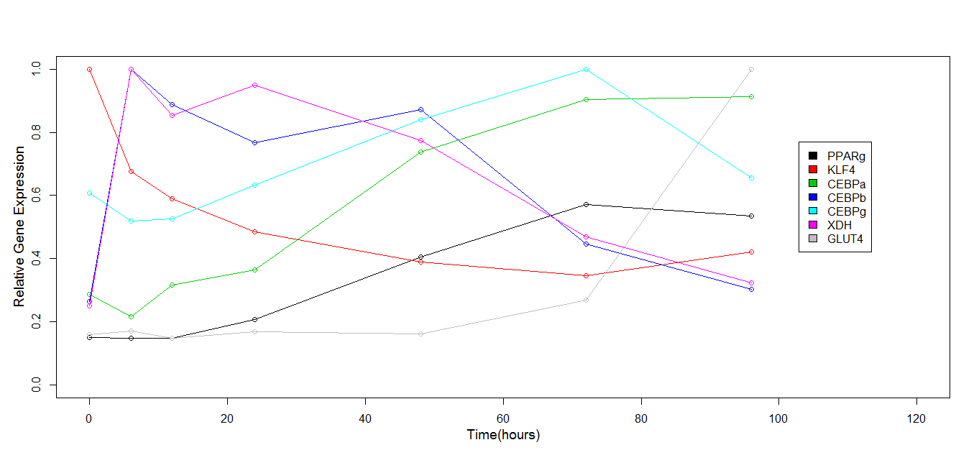
Supplementary Fig. S1. Gene expression data in Figure 4a magnified between 0 and 100 hours.

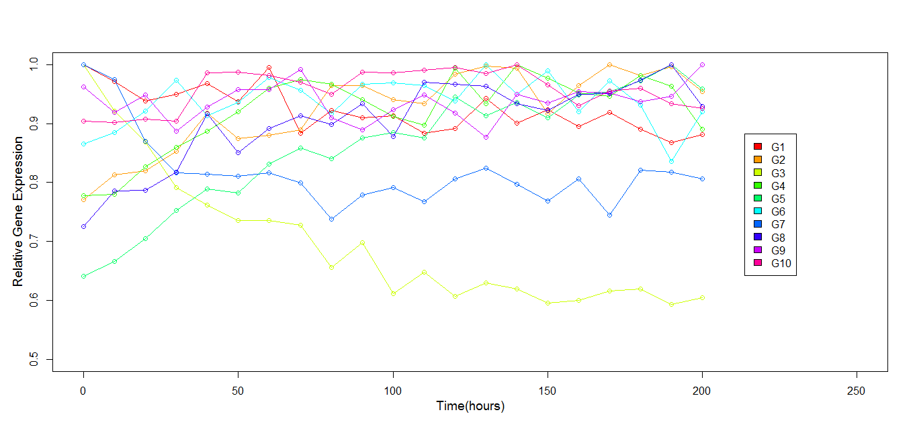
Supplementary Fig. S2. DREAM3 Time Series gene expression data. Data was obtained by perturbing a 10-gene network (Figure 8a) and collecting the activity of genes for 21 time points in 10 hour intervals. The data was normalized such that maximum possible gene activity was 1.

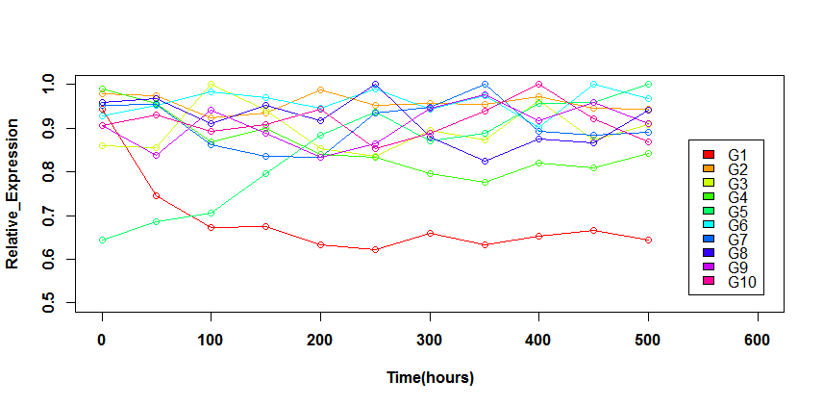
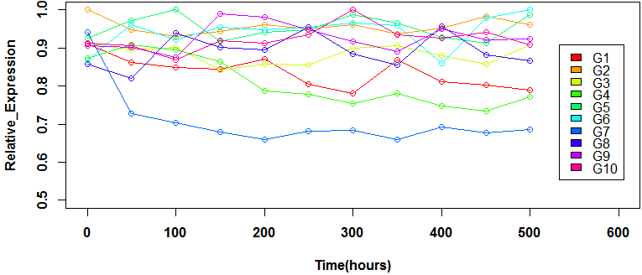
Supplementary Fig. S3. DREAM4 Time Series gene expression data. The top and bottom panels represent data obtained by perturbing a 10-gene network (Sup Table S5) by two separate perturbations and collecting the activity of genes for the next 10 time points in 50 hour intervals. The data was normalized such that maximum possible gene activity was 1.

Supplementary Table S1. Correlation matrix of 7 genes in the adipogenesis network estimated from Time Series expression data (Figure 4a)
 | PPARg | KLF4 | CEBPa | CEBPb | CEBPg | XDH | GLUT4
PPARg |  | 0.53 | 0.87 | 0.30 | 0.85 | 0.32 | 0.75
KLF4 |  |  | 0.63 | 0.27 | 0.72 | 0.37 | 0.42
CEBPa |  |  |  | 0.13 | 0.88 | 0.17 | 0.67
CEBPb |  |  |  |  | 0.07 | 0.88 | 0.05
CEBPg |  |  |  |  |  | 0.03 | 0.63
XDH |  |  |  |  |  |  | 0.05
GLUT4

Supplementary Table S2. Correlation matrix generated for the 10 genes within the DREAM3 network based on Time Series expression data shown in Supplementary Figure S2.
 | G1 | G2 | G3 | G4 | G5 | G6 | G7 | G8 | G9 | G10
G1 |  | 0.56 | 0.71 | 0.50 | 0.76 | 0.1 | 0.43 | 0.72 | 0.19 | 0.27
G2 |  |  | 0.71 | 0.61 | 0.85 | 0.17 | 0.4 | 0.85 | 0.24 | 0.41
G3 |  |  |  | 0.62 | 0.91 | 0.15 | 0.45 | 0.74 | 0.02 | 0.24
G4 |  |  |  |  | 0.63 | 0.25 | 0.44 | 0.60 | 0.01 | 0.49
G5 |  |  |  |  |  | 0.1 | 0.32 | 0.86 | 0.05 | 0.23
G6 |  |  |  |  |  |  | 0.36 | 0.12 | 0.24 | 0.42
G7 |  |  |  |  |  |  |  | 0.3 | 0.06 | 0.49
G8 |  |  |  |  |  |  |  |  | 0.11 | 0.42
G9 |  |  |  |  |  |  |  |  |  | 0.12
G10

Supplementary Table S3. Complete list of gene windows selected by MANI arranged according to their average degrees of correlation between genes within windows. The windows chosen for network inference are highlighted in bold. A, B and C are names of genes within a generic three gene window.
Window # | A | B | C | Average Correlation
1 | G5 | G8 | G2 | 0.85
2 | G3 | G5 | G8 | 0.84
3 | G3 | G5 | G2 | 0.82
4 | G3 | G5 | G1 | 0.79
5 | G5 | G8 | G1 | 0.78
6 | G8 | G2 | G3 | 0.76
7 | G2 | G5 | G1 | 0.72
8 | G8 | G3 | G1 | 0.72
9 | G3 | G4 | G5 | 0.72
10 | G2 | G1 | G8 | 0.71
11 | G5 | G8 | G4 | 0.7
12 | G2 | G4 | G5 | 0.7
13 | G8 | G4 | G2 | 0.69
14 | G3 | G1 | G2 | 0.66
15 | G8 | G3 | G4 | 0.65
16 | G3 | G2 | G4 | 0.65
17 | G7 | G3 | G5 | 0.56
18 | G2 | G8 | G10 | 0.56
19 | G3 | G1 | G7 | 0.53
20 | G2 | G7 | G5 | 0.52
21 | G2 | G7 | G8 | 0.52
22 | G2 | G4 | G10 | 0.50
23 | G8 | G4 | G10 | 0.50
24 | G3 | G4 | G7 | 0.50
25 | G7 | G8 | G3 | 0.49
26 | G7 | G8 | G5 | 0.49
27 | G2 | G1 | G7 | 0.46
28 | G3 | G10 | G8 | 0.46
29 | G3 | G10 | G5 | 0.46
30 | G2 | G10 | G7 | 0.43
31 | G7 | G8 | G10 | 0.40
32 | G7 | G3 | G10 | 0.39
33 | G7 | G3 | G6 | 0.32
34 | G2 | G7 | G6 | 0.31
35 | G3 | G10 | G6 | 0.27
36 | G7 | G8 | G6 | 0.26
37 | G10 | G5 | G9 | 0.13

Supplementary Table S4. Kinetic parameters of regulation estimated for the MANI inferred DREAM3 network (Figure 8b)
Parameters | Mean +/- Standard Error  (hr⁻¹) | Parameters | Mean +/- Standard Error  (hr⁻¹)
U₁ | 0.12 ± 0.03 | F | 7.64 ± 1.1
k₁ | 0.12 ± 0.03 | k₁₁ | -2.15 ± 0.51
k₂ | 2.44 ± 0.71 | k₁₂ | -3.0 ± 0.02
k₃ | 0.92 ± 0.67 | k₁₃ | 2.27 ± 0.81
k₄ | 1.43 ± 0.39 | G | -6.1 ± 0.37
k₅ | 0.93 ± 0.68 | k₁₄ | 0.07 ± 0.01
D | 1.00 ± 0.32 | k₁₅ | 0.05 ± 0.01
E | 0 | H | 0
U₂ | 0.10 ± 0.04 | k₁₆ | 3.66 ± 1.96
k₆ | 0.3 ± 0.07 | k₁₇ | -4.06 ± 2.08
U₃ | 0.24 ± 0.06 | k₁₈ | 0.42 ± 0.33
k₈ | 0.11 ± 0.05 | I | -0.83 ± 0.44
k₇ | 3.78 ± 1.24 | k₁₉ | 0.04 ± 0.02
k₉ | 6.85 ± 2.26 | k₂₀ | 0.19 ± 0.39
k₁₀ | 2.81 ± 0.11 | J | -0.15 ± 0.36

Supplementary Table S5. Gene regulatory relationships in the 10 gene DREAM4 network. The gene in the first column has regulatory control over gene in the second column.
Gene 1 | Gene 2
G1 | G2
G1 | G3
G1 | G4
G1 | G5
G3 | G4
G3 | G7
G4 | G3
G6 | G2
G7 | G3
G7 | G4
G8 | G2
G8 | G6
G9 | G10
G10 | G3
G10 | G4

Derivation of Likelihood (L) for mathematical models of gene regulation
For any gene regulatory relationship X in Figure 2, estimation of posterior probability in Bayesian theory is proportional to the product of likelihood and prior probability. Applying that principle,

P (X/Gene Expression Data) α P(Gene Expression Data/ X) P(X)

Therefore, Likelihood (L) of obtaining gene expression from regulatory relationship X is given by P(Gene Expression Data/X). Though we illustrate below how to estimate L for a parallel regulatory relationship between genes within a module, it can be applied to other relationships in Figure 2 as well.

Based on parallel regulatory relationship shown in Figure 3, K is a vector of regulatory parameters [U, k₁, k₂, k₃, k₄, k₅, D, E] and G is a matrix composed of Time Series gene expression data of genes A, B and C. Therefore,

L= P(Gene Expression Data/ X) = P(G/X)
L = P(G/X)= P(G/K)=P(A,B,C/K)=P(A/U, k₁). P(B/U, k₁, k_{2,} k₄, D). P(C/U, k₁, k_{3,} k₅, E)
= P(ε_{A}/U, k₁). P(ε_{B}/U, k₁, k_{2,} k₄, D). P(ε_{c}/U, k₁, k_{3,} k₅, E), (1) where ε_{A}, ε_{B} and ε_{C} are random variables representing errors in fits of genes A, B and C.

The error variables (ε_{A}, ε_{B} and ε_{C}) followed a normal distribution, that is, ε_{i} ~ N(0,$τ$_{i}), where $τ$_{i} represents the standard deviation of the error distribution. Therefore, applying error distribution in the equation for L (equation #1), we get
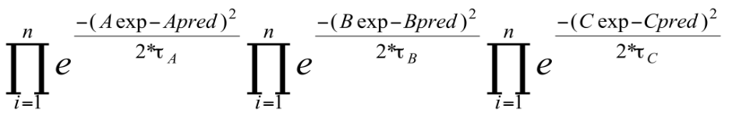
L = (2)

Where A_{exp}, B_{exp}, C_{exp} are the observed values of expression of genes A, B and C respectively while A_{pred}, B_{pred} and C_{pred} are their predicted values by the model representing the regulatory relationship and n is the number of time points in the gene expression data.

Simplifying equation #2, we get
-ln L = (SSE_{A}/ $τ$_{A}+ SSE_{B}/$τ$_{B} + SSE_{C}/ $τ$_{C})/2, where SSE is sum of square of errors of fit (3)

