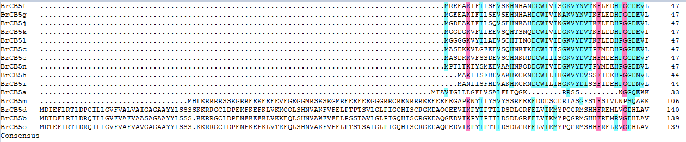
Motif 1

Motif 2
Motif 3
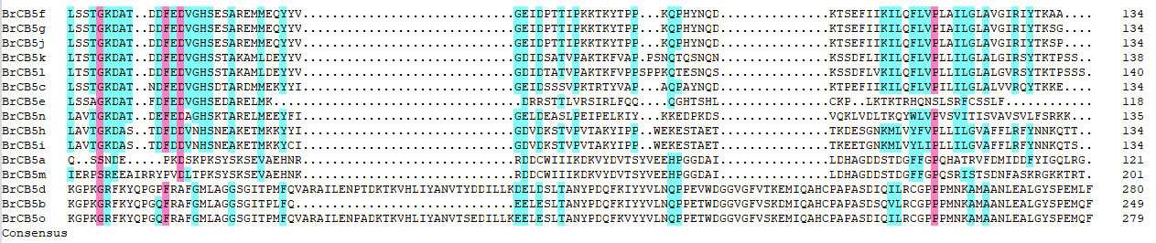

Supplementary file 3. Figure S3. Multiple sequence alignment of the protein sequences of BrCB5s. The sequences were aligned using the DNAMAN software, in which red, blue colors indicated the similarity was above 75%, 50%, respectively. Motif 1, 2, 3 were marked artificially according to the results of MEME, which were shown in supplementary figure S1 (C).

