FIGURE LEGENDS (SUPPLEMENTAL FIGURES)

Fig. S1. Confirmation of mutations in S. aureus. The mutants were verified by PCR. Primers P1 and P2 were used for the verification of mutation in the msrA1 gene (lanes 1, 2, 9, 10), P3 and P4 for mutation in the msrB (lanes 3, 4, 11, 12), P5 and P6 for mutation in the msrA1-msrB (lanes 5, 6, 13, 14), and P7 and P8 for mutation in the sigB gene (lanes 7, 8, 15, 16), respectively. A larger amplicon (even numbered lanes) was observed when genomic DNA from mutant bacteria was used as template due to insertion of larger antibiotic cassettes in the coding regions compared to smaller amplicons when wild type genomic DNA was used a template (odd numbered lanes).

Figure S2. Confirmation of presence of mecA. The presence/absence of the mecA gene in the various strains was investigated by PCR using primers P9 and P10. The mecA gene was present in the wild-type COL (lane 1) and its isogenic msrA1 (lane 2), msrB (lane 3), msrA1-msrB (lane 4), and sigB (lane 5) mutants but absent in the wild-type SH1000 (lane 6) and its isogenic msrA1 (lane 7), msrB (lane 8), msrA1-msrB (lane 9), and sigB (lane 10) mutants.

Fig. S3. Confirmation of msrA1/msrB promoter-lacZ integration into S. aureus. A forward primer (P11) internal to the msrA1/msrB promoter and a backward primer (P12) internal to the lacZ gene were used in the PCR verification of this integration into wild-type (lanes 1 & 6) and isogenic msrA1 (lanes 2 & 7), msrB (lanes 3 & 8), msrA1- msrB (lanes 4 & 9), and sigB (lanes 5 & 10) mutants.

Fig. S1

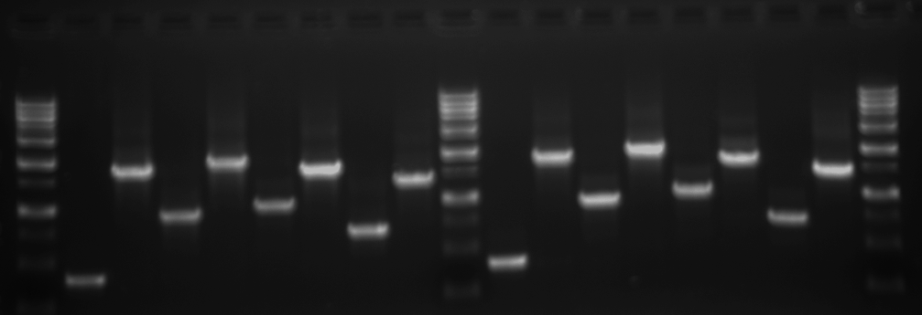
M
2
3
4
5
6
7
8
M
9
10
11
12
13
14
15
16
M
1
8000
3000
2000
1500
1000
750
500
COL
SH1000

Fig. S2

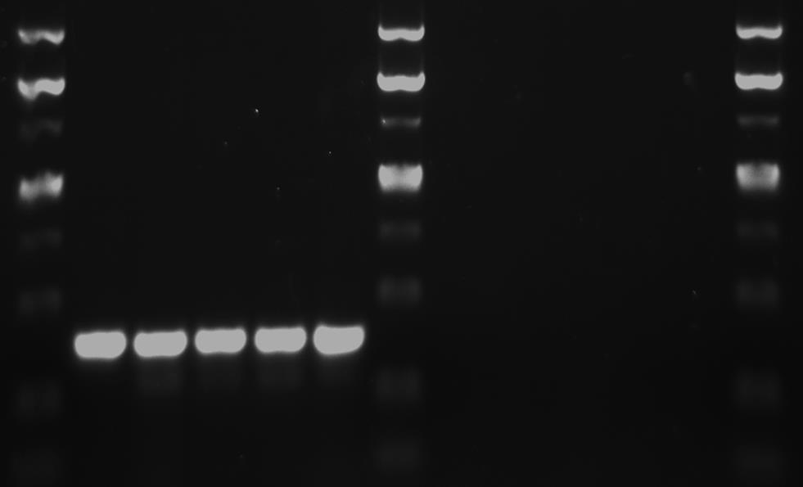
M
2
3
4
5
6
7
8
M
9
10
M
1
4000
3000
2000
1500
1000
500
250
COL
SH1000

Fig. S3

M
2
3
4
5
M
6
7
8
9
10
M
1
8000
3000
2000
1500
1000
COL
SH1000

