D1
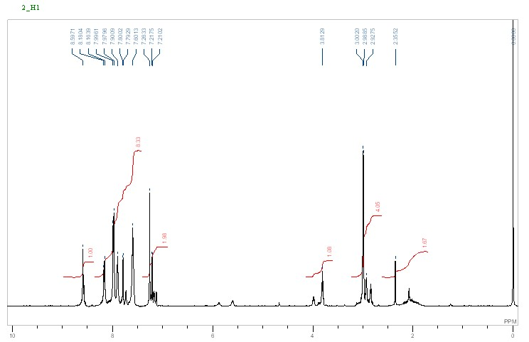

(E)-2-Cyano-3-(5-(5-(naphthalen-2-yl)-1,3,4-oxadiazol-2-yl)thiophen-2-yl)acrylic acid [D1]
¹H NMR (DMSO): δ 7.40.7.55 (m, 3H), 7.80 (d, J = 7.8 Hz, 1H), 7.90 (d, J = 5.5 Hz, 1H), 7.95-8.15 (m, 3H), 8.20 (d, J = 5.5Hz, 1H), 8.60 (s, IH); IR (KBr): υ 3417.9, 3060, 2247.2, 1675.8, 1587.9 cm⁻¹. ESI-MS: m/z: 373 [M⁺].

D2
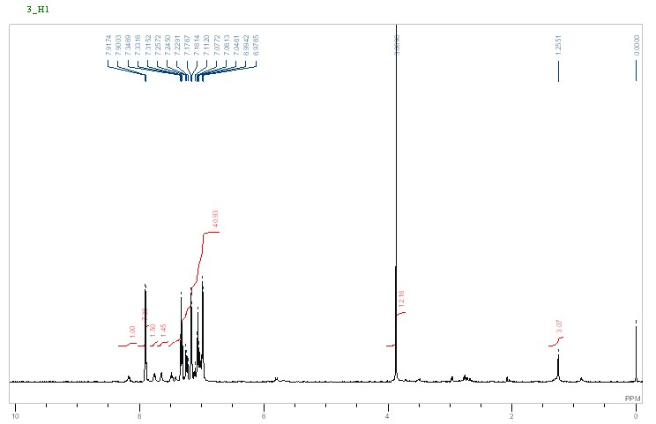

(E)-3-(5-(5-([1,1'-Biphenyl]-4-yl)-1,3,4-oxadiazol-2-yl)thiophen-2-yl)-2-cyanoacrylic acid [D2]
¹H NMR (DMSO): δ 7.40 (dd, J = 8.0, 2.1 Hz, 2H), 7.45 (t, J = 8.0 Hz, 2H), 7.65 (d, J = 8.0 Hz, 2H), 7.80 (d, J = 8.1 Hz, 2H), 7.83 (J = 5.6 Hz, 1H), 7.90 (J = 5.6 Hz, 1H), 8.20 (d, J = 8.1 Hz, 2H). 8.25 (s, 1H). IR (KBr): υ 3420, 3058, 2248, 1670, 1590 cm⁻¹; ESI-MS: m/z: 399 [M⁺].

D3
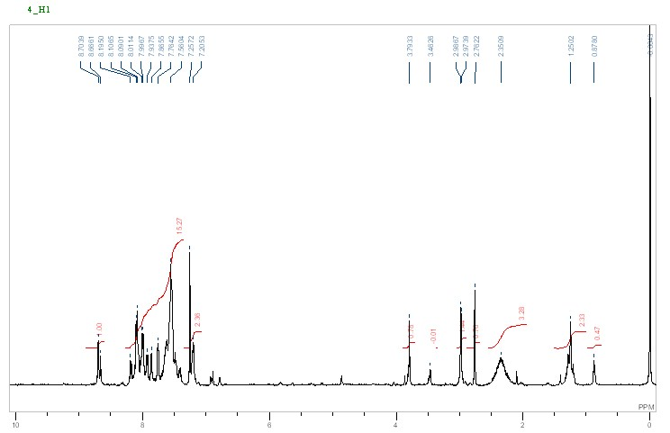

E)-3-(5-(5-(Anthracen-9-yl)-1,3,4-oxadiazol-2-yl)thiophen-2-yl)-2-cyanoacrylic acid [D3]
IR (KBr): υ 3415.6, 3060, 2249.2, 1675.8, 1587.9 cm⁻¹. ESI-MS: m/z: 423 [M⁺].

D4

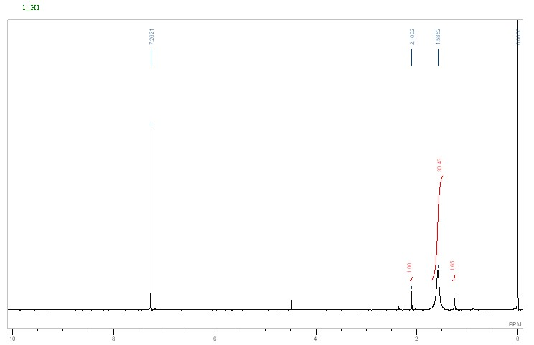

(E)-2-Cyano-3-(5-(5-(4-(diphenylamino)phenyl)-1,3,4-oxadiazol-2-yl)thiophen-2-yl)acrylic acid [D4]
¹H NMR(DMSO): δ 6.9-7.60 (m, 14H),7.80 (s, 1H), 8.0 (d, J = 8.0 Hz, 2H), 8.20 (d, J = 8.0 Hz, 2H). IR (KBr): υ 3347.1, 3060, 2248.2, 1675.8, 1587.9 cm⁻¹; ESI-MS: m/z: 490 [M⁺].

(

