Calculation of Reynolds number (Re)

Calculation formula for Re was Re=ρvd/μ. Where, ρ, v, d and μ were the gas density, velocity, viscosity coefficient respectively, d was the equivalent diameter. For Ar, the ρ and μ were 1.169g/cm³ and 18.448μPa•s respectively. The diameter (d) was 0.15cm. The velocity (v) was 0.019-0.038m/s based on the gas flow rate (v=Q/S, Q was 20-40L/min, and S was obtained based on the diameter of 15cm). Then the calculated Re was about 203-406. In addition, the velocity based on the simulation of Eq.1 was no more than and 0.058m/s (as shown in Fig. S1), and the Re was about 609. Both the above Re values indicated a typical laminar flow pattern in the reactor.

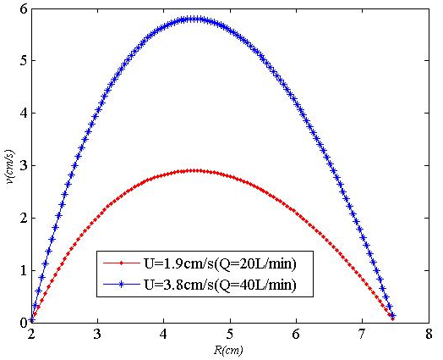
Fig. S1 The simulated gas flow velocity by Eq.1

