Electronic Supplementary Information
S1

Fig. S1 The FTIR-ATR spectra of PPy obtained from solution containing 1 mM monomer and 0.1 M LiClO₄

S2
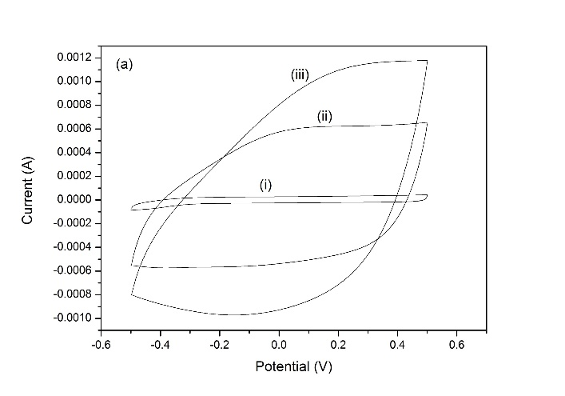
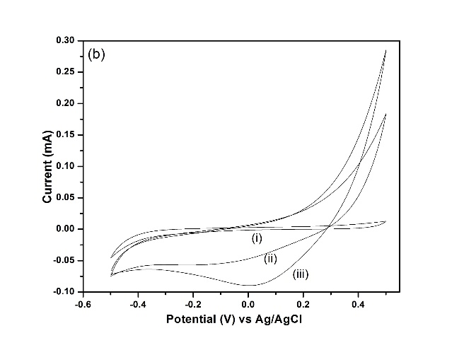
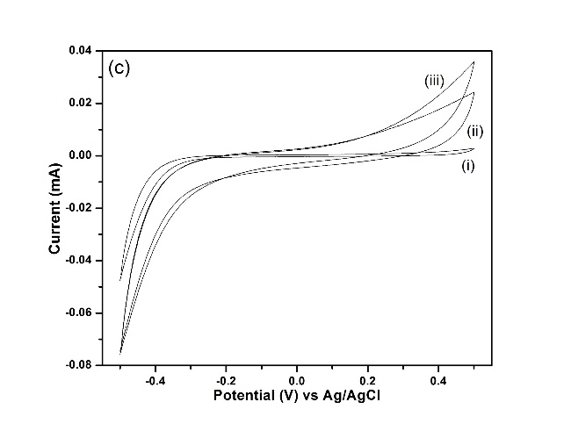

Fig. S2 The CVs for the (a) PEDOT, (b) PANI and (c) PPy films electropolymerized at 1.0 V for all monomer concentration recorded in 0.1 M potassium chloride (KCl) solution at the scan rate of 100 mV/s

