Fig. S2 without labels.
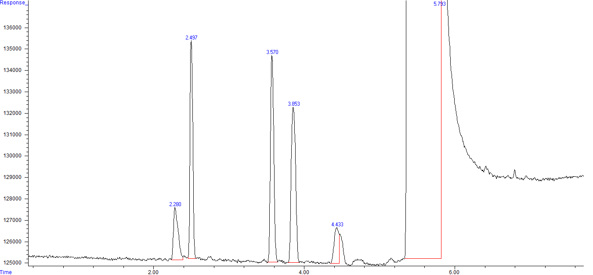

Fig. S2 with labels.
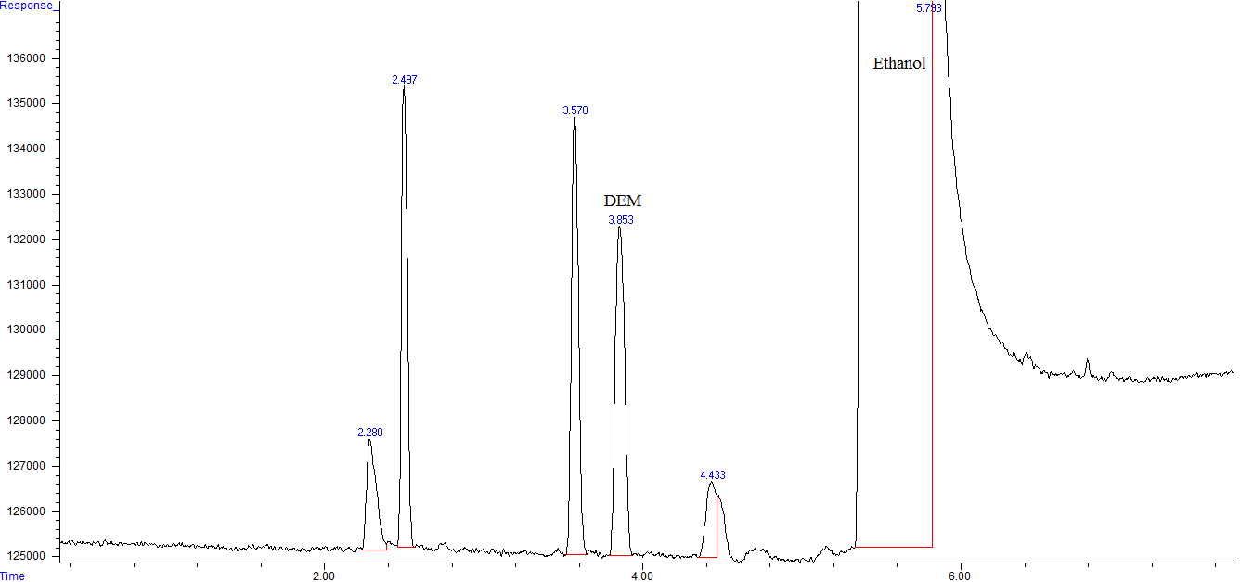

Figure S2. GC-FID chromatogram of PEG 400 sample spiked with formaldehyde. DEM: diethoxymethane.

