Fig. S3 without labels.
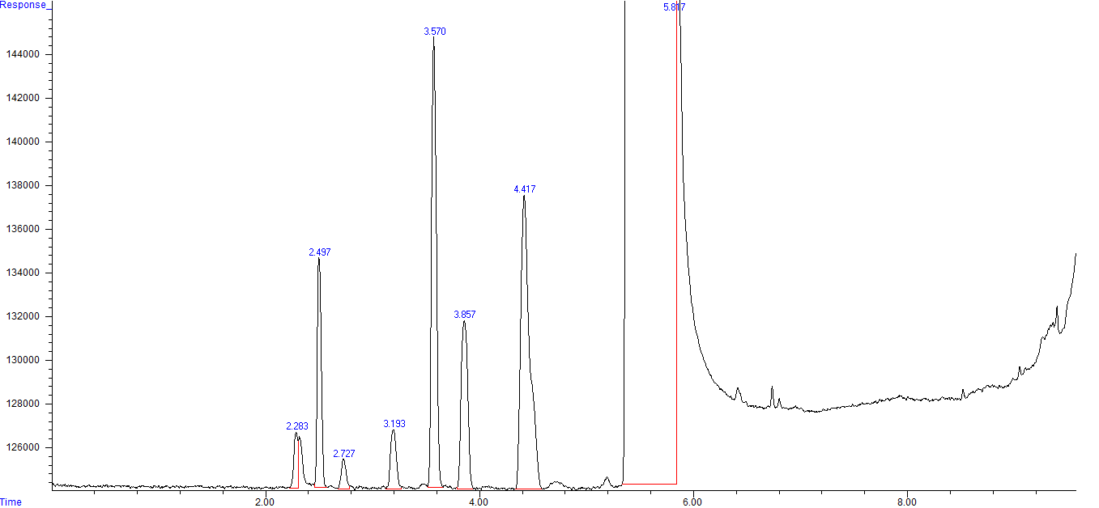

Fig. S3 with labels.
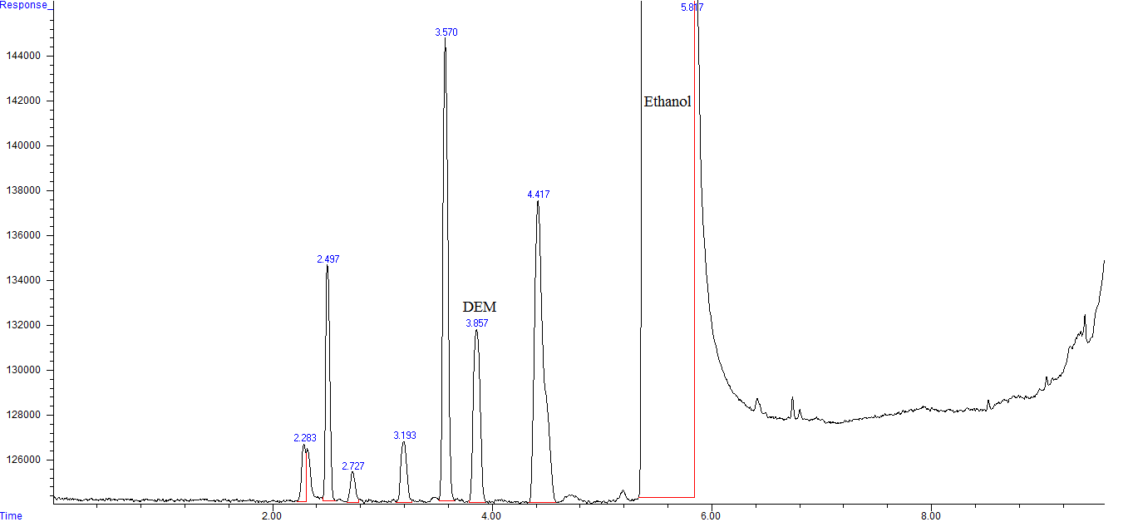

Figure S3. GC-FID chromatogram PVP K-30 sample spiked with formaldehyde. DEM: diethoxymethane.

