Journal of Chemistry
Adsorption characteristics and transport behavior of Cr(VI) in shallow aquifers surrounding a chromium ore processing residue (COPR) dumpsite
Yu Liu,^{1, 2, ∗} Yin Li,² Yucheng Hu,² Khan M. G. Mostofa,¹ Siliang Li,¹ and Zhenying Liu³
¹ Institute of Surface-Earth System Science, Tianjin University, Weijin Road 92, Tianjin 300072, China.
² Tianjin Hydraulic Science Research Institute, Youyi Road 60, Tianjin 300061, China.
³ School of Environmental Science and Safety Engineering, Tianjin University of Technology, Tianjin 300191, China.
Correspondence should be addressed to Dr. Yu Liu; liuyu2017@tju.edu.cn

Number of Pages: 18
Number of Figures: 7
Number of Tables: 5
Journal: Journal of Chemistry
Sampling
Continuous core samples were collected using a drilling rig (SY-1, DPP100) and a triple-tube core barrel. The drilling minimizes mechanical breaks and provides cores that reflect in-situ fracture distributions. Due to site conditions, drillcore samples were collected over an interval of 6 to 20 m below the ground surface. Immediately after obtaining each drill core, a Φ75 × 6000 mm PVC pipe was filled into the drilled hole to construct the groundwater monitoring well. At the same time, ten soils were collected from per metre of core and then mixed into one sample. Core samples were immediately wrapped with aluminum foils and parafilms, and vacuum-sealed to preserve moisture and other physical properties. Top soils (5-10 cm) were collected using a 5-point sampling method and squaring method and then packaged into a polyethylene plastic bag. The collected soil samples were pretreated to remove impurities, naturally air-dried at room temperature, ground to pass through a 100 mesh sieve, and stored in pre-cleaned glass containers for further use. The water depth of each monitoring well was measured using ultrasonic water level monitor (GL-100). Baylor tube samplers were applied to collect the groundwater.
Characteristics of soils and aquifers
Core samples were taken to determine their physical characteristics in terms of in situ bulk density, porosity, and grain size distribution by using the standard for soil test method (National Standards of People's Republic of China, GB/T 50123-1999). Other parameters including pH, organic matter (OM) content, and cation exchange capacity (CEC) were also analyzed [1]. Cr(VI) concentration of groundwater samples were determined by using UV-vis spectrophotometer (TU-1810) at 540 nm wave length by using 1, 5-diphenylcarbazide as a color complexing agent. Total chromium in top soils and shallow aquifers were extracted and measured based on the determination criterion of total chromium in the soil (National environmental protection standards of the People's Republic of China, HJ 491-2009). Firstly, total chromium in top soils and shallow aquifers were extracted by the digestion method with hydrochloric acid, nitric acid, hydrofluoric acid, and perchloric acid. Afterwards, the digestion solution were determined by flame atomic absorption spectrophotometry [2].
Experiments
Firstly, batch adsorption experiments were carried out to determine the adsorption characteristics. Conical flasks were filled with 10 g dried aquifers and Cr(VI) solution for various initial concentrations ranging from 0.1 to 100 mg/L. The conical flasks were shaken at a constant speed of 200 rpm for a period of time till the adsorption reached equilibrium. Total volume of the Cr(VI) solution was kept constant at 100 mL. Samples were withdrawn at regular time intervals. These samples were filtered by filters (0.45μm) coupled to syringes and then analyzed for residual Cr(VI) concentration by UV-vis spectrophotometer. According to the actual in situ condition of the groundwater, the temperature of batch adsorption experiments was fixed at constant 288 K except the adsorption isotherm and thermodynamics studies. Also, the pH was fixed to 7-8 except where the effect of the solution pH on the adsorption of Cr(VI) was investigated. The pH was adjusted by using NaOH and HCl.
Secondly, to reveal the adsorption-desorption behavior of Cr(VI) in aquifers and provide model parameters for Cr(VI) transfer, continuous dynamic column studies were conducted in plexi-glass columns with a diameter of 5.0 cm. A schematic diagram of a column set-up is depicted in Supplementary material (Figure S3). The packing status of columns and operating condition for the adsorption/desorption column study are mentioned in Supplementary material (Table S2). A 5 cm layer of gravels was placed at the bottom of the column in order to provide a uniform outlet flow. After the columns were filled, column beds were saturated by flowing distilled water. One week later, Cr(VI) solution flowed through the filled columns at a desired flow rate by controlling the valve of the Cr(VI) stock tank shown in Figure S3. Based on the Cr(VI) content of shallow groundwater adjacent to the contaminated site, the Cr(VI) solution was prepared to be 550 mg/L. The column experiments were carried out under fixed water head conditions. The samples were collected at regular time intervals. The column saturation was monitored by analyzing the Cr(VI) concentration of inlet and outlet in the column. The adsorption column experiment finished when the Cr(VI) concentration of final effluent in the outlet exceeded 99.9% of the concentration at the inlet. After the adsorption column study, distilled water flowed through the Cr(VI) loaded column to study the desorption behavior of the chromium contaminated aquifers.
According to the physicochemical properties analysis of all aquifers samples, the aquifers used in experiments were collected outside the distance of 1 km from the COPR dumpsite, because they were not polluted by chromium. The Cr(VI) solution was prepared using K₂Cr₂O₇ and distilled water. Cr(VI) concentration of all samples were determined by using UV-vis spectrophotometer (TU-1810). All chemicals used in this study were of analytical grade and without further purification. All experiments were conducted in triplicate and the average values were used for data analysis.

Figure captions:
Figure S1. Photos of Chromium Ore Processing Residue (COPR) dumpsite in Tianjin Former Tongsheng Chemical Factory in 2012.
Figure S2. Photos of core drilling and groundwater sampling.
Figure S3. Schematic of adsorption column packed with aquifers.
Figure S4. The concentrations of total Cr in top soils (5-10 cm) of 11 sampling sites.
Figure S5. The concentrations of total Cr in aquifers at different depths of 1-6 m of 11 sampling sites.
Figure S6. Pseudo-second-order kinetics for adsorption of Cr(VI) onto clay, silty clay and silt. Cr(VI) solution 1.0 mg/L, aquifers 0.1 g/mL, pH 7-8, 288 K.
Figure S7. Effect of temperature on Cr(VI) adsorption by clay, silty clay and silt. Cr(VI) solution 1.0 mg/L, aquifers 0.1 g/mL, pH 7-8.

Table captions:
Table S1 Geographical locations of the drilling sampling sites.
Table S2 Vertical distribution of local geological formations.
Table S3 Packing status of columns and operating condition for the adsorption/desorption column study.
Table S4 The physicochemical properties of different aquifers.
Table S5 The concentration of Cr(VI) and total Cr of groundwater in monitoring wells of 11 sampling sites.

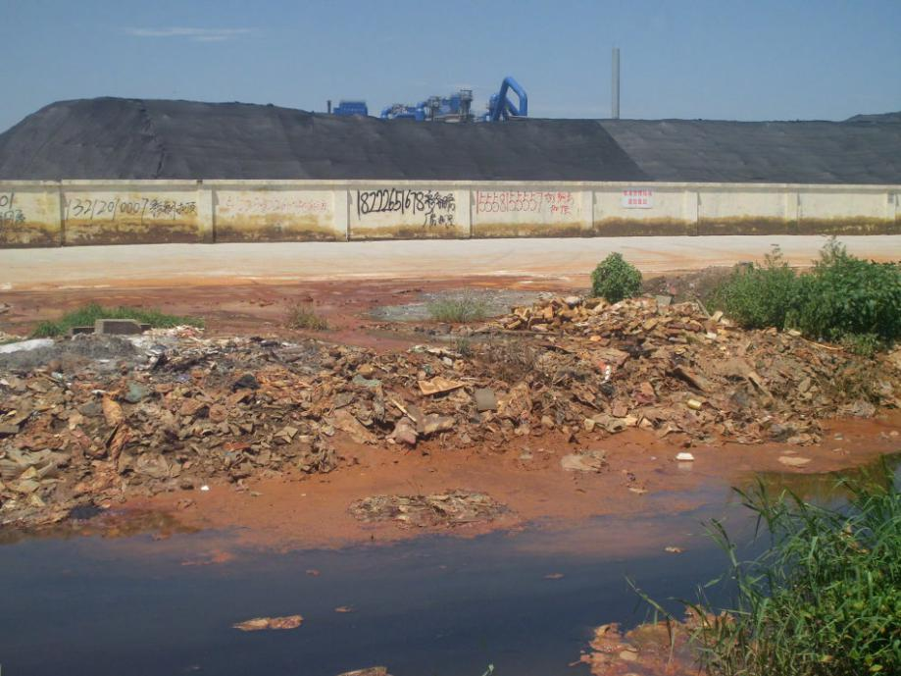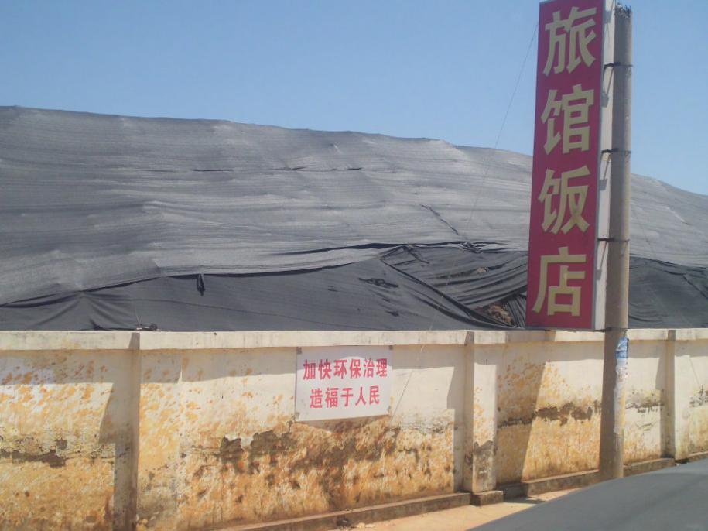
Figure S1. Photos of Chromium Ore Processing Residue (COPR) dumpsite in Tianjin Former Tongsheng Chemical Factory in 2012.

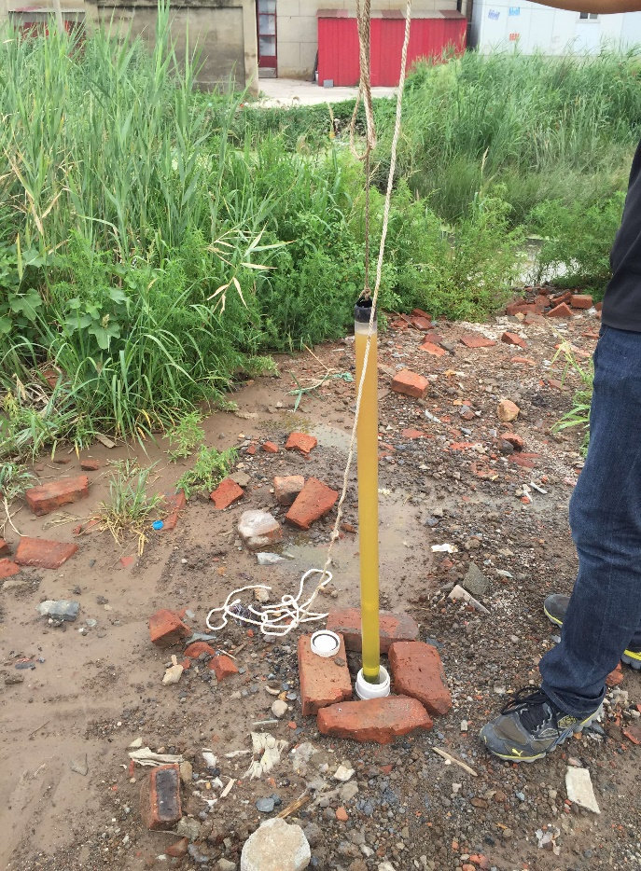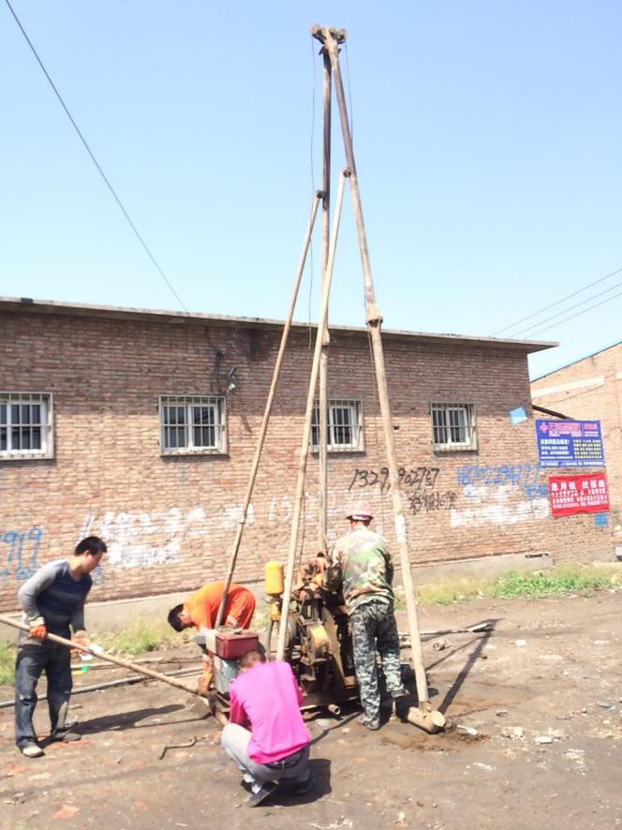
Figure S2. Photos of core drilling and groundwater sampling.
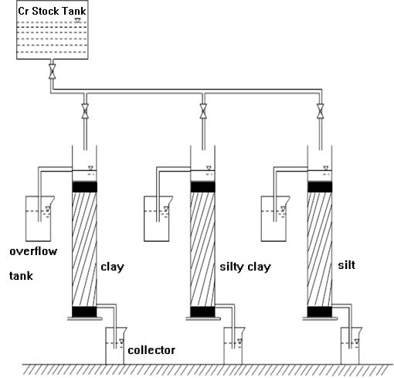
Figure S3. Schematic of adsorption column packed with aquifers.
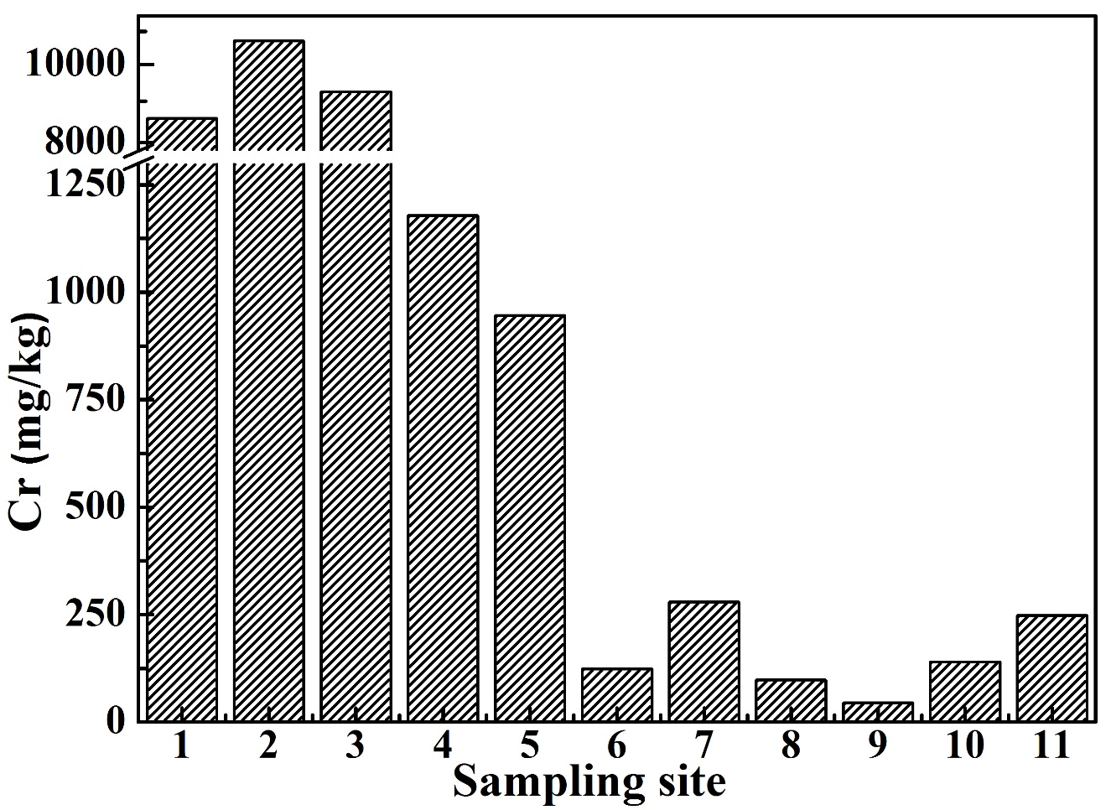
Figure S4. The concentrations of total Cr in top soils (5-10 cm) of 11 sampling sites.
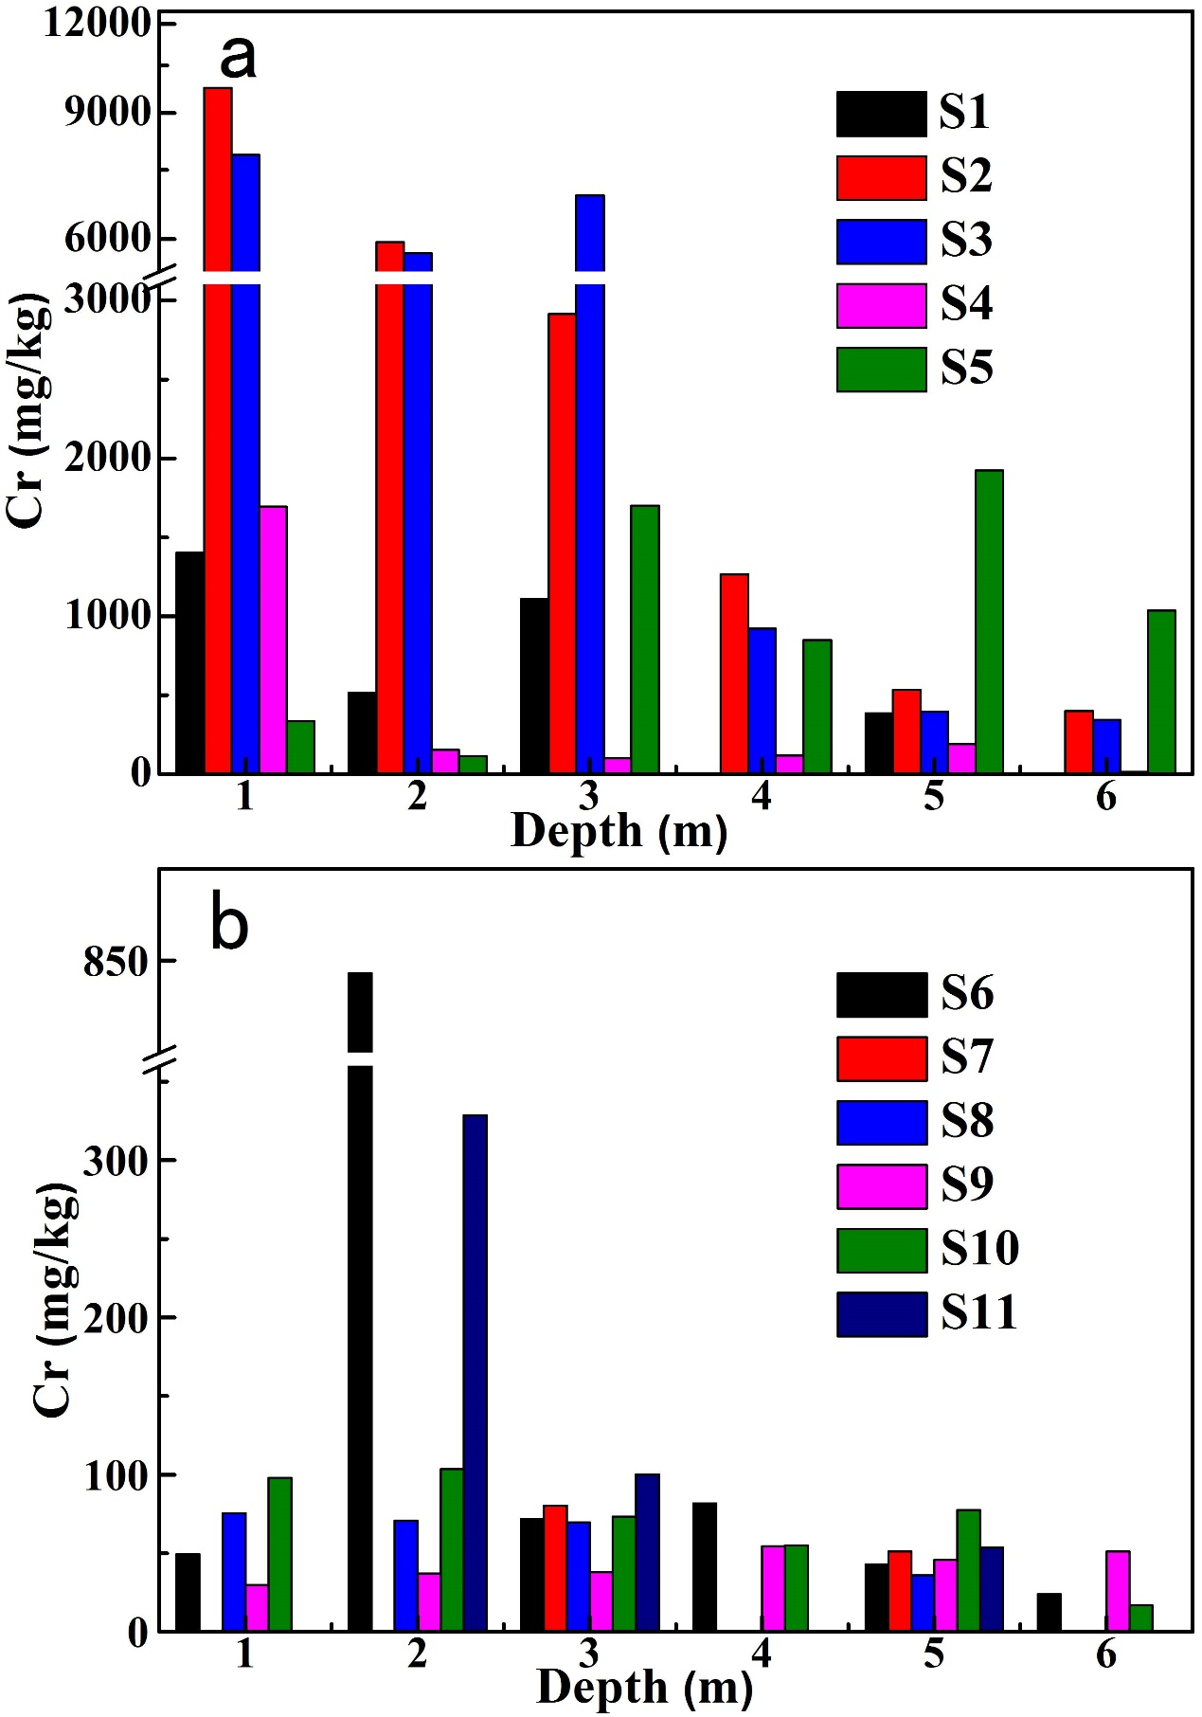
Figure S5. The concentrations of total Cr in aquifers at different depths of 1-6 m of 11 sampling sites.
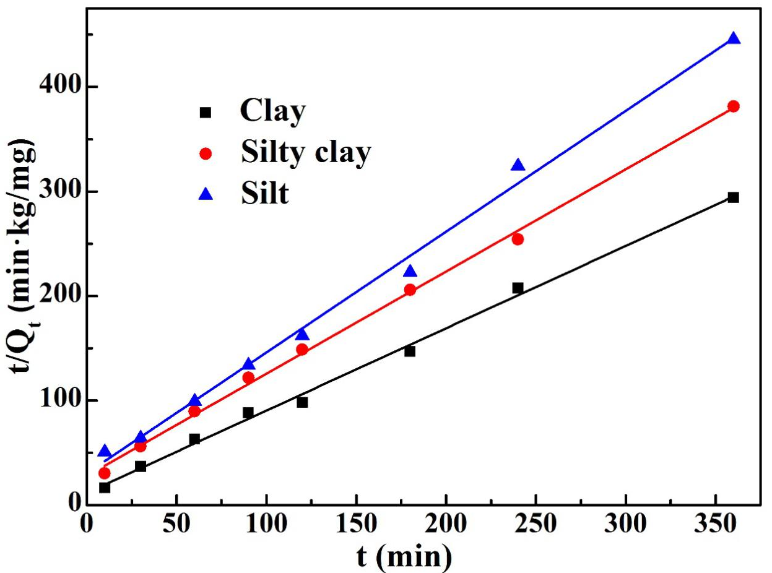
Figure S6. Pseudo-second-order kinetics for adsorption of Cr(VI) onto clay, silty clay and silt. Cr(VI) solution 1.0 mg/L, aquifers 0.1 g/mL, pH 7-8, 288 K.

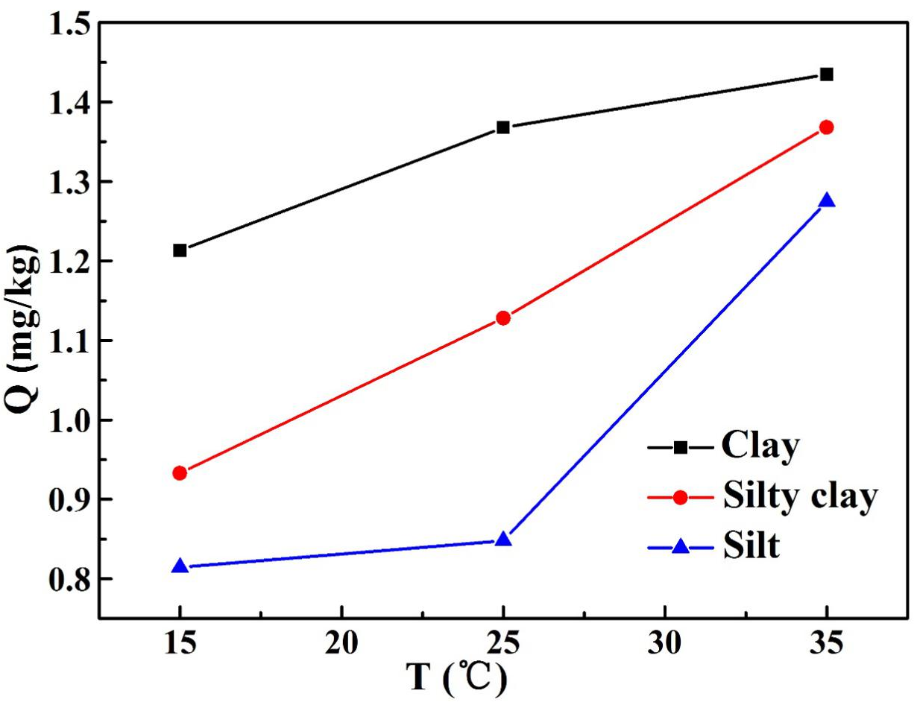
Figure S7. Effect of temperature on Cr(VI) adsorption by clay, silty clay and silt. Cr(VI) solution 1.0 mg/L, aquifers 0.1 g/mL, pH 7-8.
Table S1 Geographical locations of the drilling sampling sites.
Sampling sites | Latitude | Longitude
S1 | 39°14′18.5″N | 117°06′27.2″E
S2 | 39°14′19.0″N | 117°06′28.2″E
S3 | 39°14′19.6″N | 117°06′29.7″E
S4 | 39°14′17.3″N | 117°06′25.3″E
S5 | 39°14′21.9″N | 117°06′23.7″E
S6 | 39°14′11.7″N | 117°06′28.4″E
S7 | 39°14′45.8″N | 117°06′32.4″E
S8 | 39°14′24.4″N | 117°06′45.9″E
S9 | 39°14′7.9″N | 117°06′38.7″E
S10 | 39°14′7.6″N | 117°06′44.2″E
S11 | 39°14′28.3″N | 117°06′56.6″E

Table S2 Vertical distribution of local geological formations.
Stratum formation time | Depth  (m) | Thickness  (m) | Geological symbol | Ground name
Artificial Fill Layer  ( Qml) | 1.40 | 1.40 | 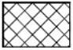 | Plain fill
New Alluvium  ( Q₄^{3N}al) | 2.10 | 1.00 | 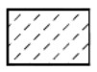 | Silt
Holocene Upper Group lagoon-facies sedimentary layer  (Q₄³l+h) | 4.80 | 2.40 | 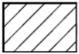 | Clay
Holocene Middle Group marine-facies sedimentary layer  ( Q₄²m) | 11.00 | 6.80 | 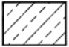 | Silty clay
Holocene Lower Group continental-facies alluvium  ( Q₄¹al) | 20.00 | This layer was not drilled through. |  | Silty clay

Table S3 Packing status of columns and operating condition for the adsorption/desorption column study.
Packing status of columns |  |  |  |  | Operating condition for the adsorption/desorption column study
Aquifers | Density  (g/cm³) | Porosity  (%) | Packing weight  (g) | Packing bed height  (cm) | Parameters | Adsorption condition | Desorption condition
Clay | 1.14 | 59.7 | 690 | 30 | Temperature | Room temperature | Room temperature
Silty clay | 1.28 | 54.0 | 770 | 30 | Solute and solvent | Chromium solution (550 mg/L) | Distilled water
Silt | 1.42 | 47.3 | 850 | 30 | Average flow rate | 1.14×10⁻² mL/min | 9.99×10⁻³ mL/min

Table S4 The physicochemical properties of different aquifers.
Aquifers | Density  (g/cm³) | Porosity  (%) | pH | CEC  (cmol/kg³) | OM  (%) | Particles composition（%）
 |  |  |  |  |  | Sand particles  2-0.075mm | Silt particles 0.075-0.005mm | Clay particles  <0.005mm
Clay | 1.42 | 48.5 | 8.22 | 203.4 | 2.85 | 6.8 | 64.2 | 29.0
Silty clay | 1.46 | 46.4 | 8.39 | 153.7 | 2.21 | 8.8 | 69.9 | 21.3
Silt | 1.48 | 45.0 | 8.01 | 54.0 | 1.96 | 12.1 | 71.6 | 16.3

Table S5 The concentration of Cr(VI) and total Cr of groundwater in monitoring wells of 11 sampling sites.
Groundwater monitoring wells at sampling sites | S1 | S2 | S3 | S4 | S5 | S6 | S7※ | S8 | S9 | S10 | S11
Cr(VI) (mg/L) | 766.9 | 1347.5 | 1063.4 | 0.008 | 0.58 | 0.045 | --- | 0.006 | 0.022 | 0.007 | 0.005
Total Cr (mg/L) | 776.3 | 1369.1 | 1080.4 | 0.031 | 0.59 | 0.048 | --- | 0.009 | 0.025 | 0.008 | 0.009
※ The drilled hole S7 collapsed during the drilling so the PVC pipe was unable to be set up, therefore the groundwater data for sampling site S7 was not obtained.

References
[1] APHA. "Standard Methods for the Examination of Water and Waste Water," American Public Health Association, USA. ISBN: 978-0-87553-287-5, 2017.
[2] X. Zhao, P. A. Sobecky, L. Zhao, P. Crawford, M. Li, "Chromium(VI) transport and fate in unsaturated zone and aquifer: 3D Sandbox results," Journal of Hazardous Materials, vol. 306, pp. 203-209, 2016.

∗ Corresponding author. Tel.: +86 15822711360, E-mail address: liuyu2017@tju.edu.cn

