Supplementary Figure.
Trajectories of fasting (A), 1-hour (B), and 2-hour (C) plasma glucose until the incidence of type 2 diabetes in 28 progressers whose annual consecutive data were available. Error bars show 95% confidence intervals for the estimated levels after adjustments for age and sex.

(A)
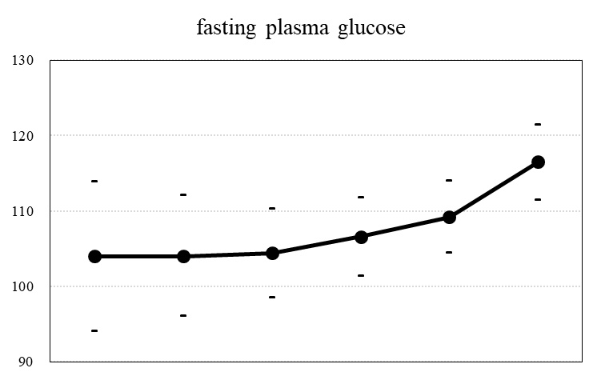
plasma glucose
(mg/dL)

Time until end of follow-up (years) -5 -4 -3 -2 -1 0
Progressors (n) 3 5 12 19 28 28

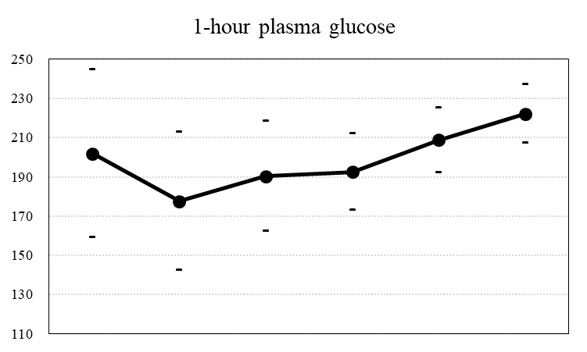
(B)
(mg/dL)

Time until end of follow-up (years) -5 -4 -3 -2 -1 0
Progressors (n) 3 5 12 19 28 28

(C)
Time until end of follow-up (years) -5 -4 -3 -2 -1 0
Progressors (n) 3 5 12 19 28 28

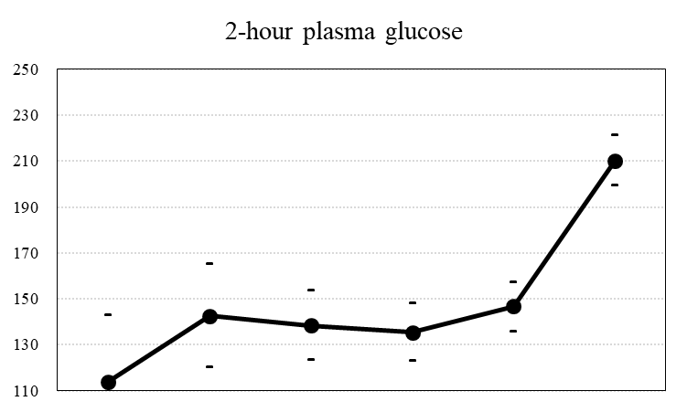
plasma glucose
(mg/dL)

plasma glucose

