Figure S1
Analysed (n=20)

Analysed (n=8)
Assessed for eligibility (n=31)
Lost to follow-up (n=0) at the end study
Allocated to propolis group (n= 20)
Lost to follow-up (n=2) at the end study
- Respiratory complication(n=1)
- Heart surgery (n=1)
Allocated to control group (n=11)
Allocation
Analysis
Follow-Up
Enrollment and Follow up

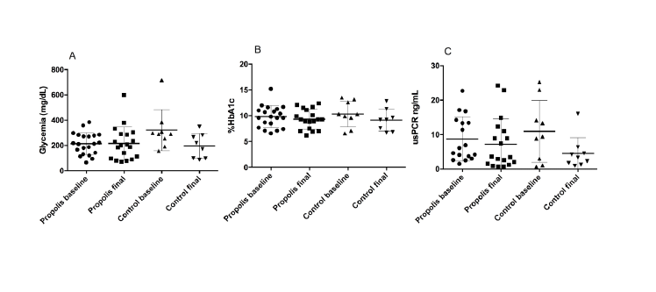
Figure S2

Table S1

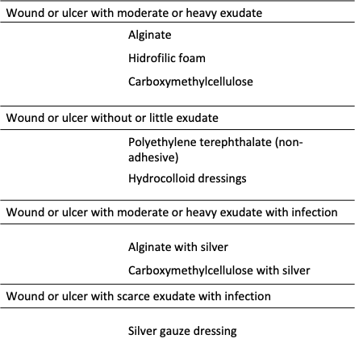

Table S2

Scale | Categorical Description | Percentage of deposit connective tissue
I | Vital (normal tissue) | Less than 5%
II | Fibrosis expansion (+/-) | Among 5 and 20%
III | Fibrosis expansion around vessel areas and connecting some of them | Among 20 and 40%
IV | Fibrosis expansion (marked bringing) | Among 40 and 80%
V | Cicatrized tissue | Over 80% or less tan 5% vital tissue

Table S3

 | Control | Propolis
Concomitant pathologies
Obesity | 100% | 100%
Dyslipidemia | 62.5% (5 subjects) | 40%(8 subjects)
Hypertension | 75% (6 subjects) | 95% (19 subjects)
Coronary disease | 0% | 10% (2 subjects)
Chronicle kidney disease | 37.5 (3 subjects) | 30%(6 subjects)
Anemia | 0% | 5% (1 subject)
Asthma | 0% | 5% (1 subject)
Chronic pharmacological therapies
Insulin (NPH) | 100% | 100%
ASA | 25% (2 subjects) | 35% (7 subjects)
Statins (atorvastatin) | 62.5 (5 subjects) | 40% (8 subjects)
ARBs (losartan) | 75% (6 subjects) | 95%(19 subjects)
Others antihypertensive medications (amlodipine, carvedilol, hydrochlorothiazide, others) | 50% (4 subjects) | 50% (1º subjects)
Others therapies | 0% | 10% (2 subjects)
NPH Neutral protamine Hagedorn insulin.
ASA acetyl salicylic acid
ARBs Angiotensin II receptor blockers

Table S4

 | Control | (%) | Propolis | (%)
Types of bacteria present | S. aureus | 33.4 | S. aureus | 30
 | Streptococcus sp | 22.2 | P. Aeruginosa | 10
 | S. coagulasa negative | 11.1 | Proteus sp | 5
 | E. Coli / K. pneumoniae | 11.1 | Klebsiella sp | 5
 | Negative culture | 22.2 | S. Coagulasa negative | 5
 |  |  | Streptococcus sp | 5
 |  |  | Negative culture | 40
Types of fungi present | Negative culture |  | Negative culture

