- Macrosomia
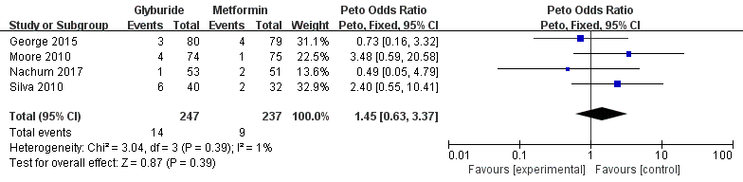
- NICU admission
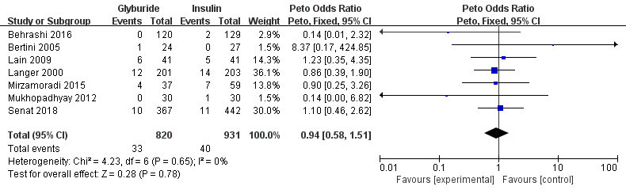
- Respiratory distress syndrome (RDS)
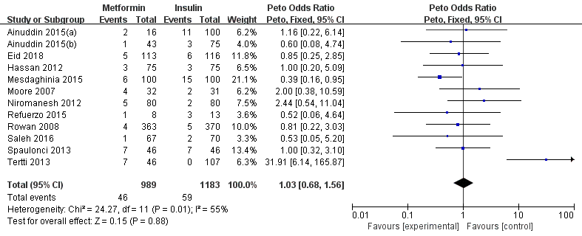
- Birth injury
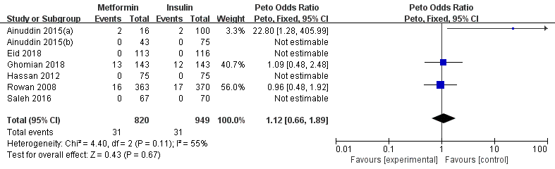
- 5-min Apgar score < 7
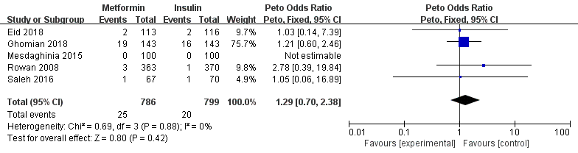
- Congenial anomaly
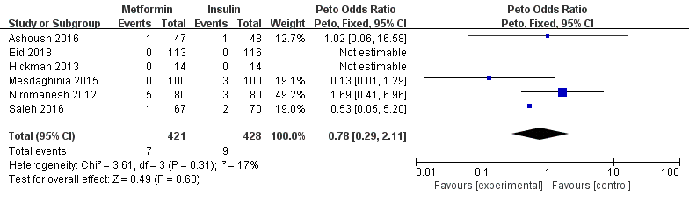
- Neonatal hypocalcemia
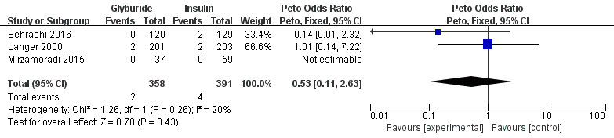
- Sepsis
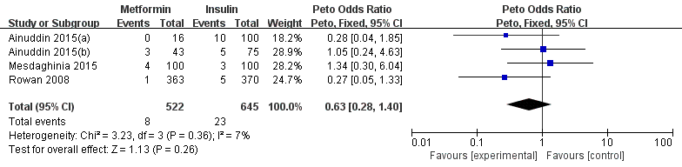
- Shoulder dystocia
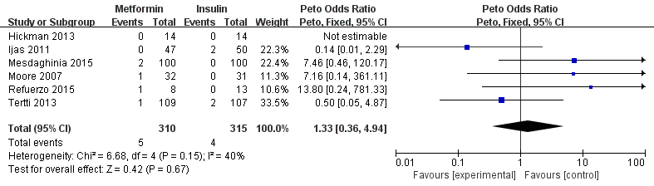
- Transient tachypnea
