Supplementary material
Annexes 1
- Equipment of TV room
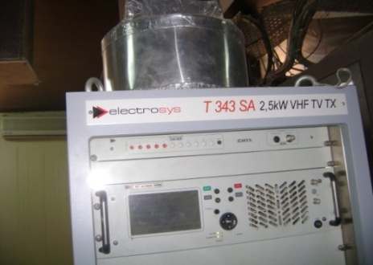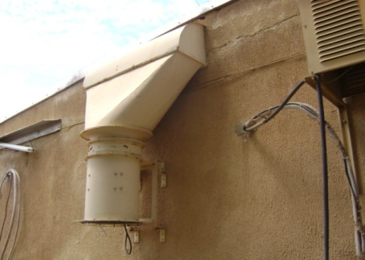
a) Emitter and receiver of TV from CRTV Maroua b) External view of air extractor from TV room

- Equipment of FM room

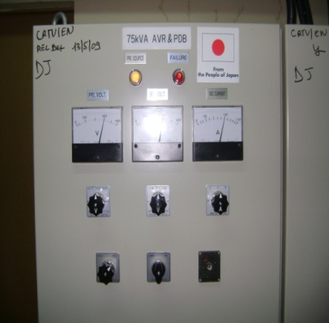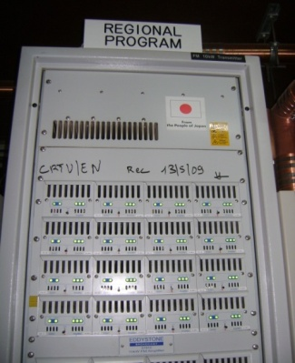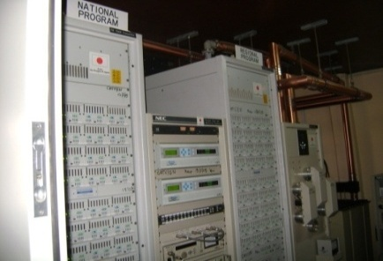
a) On left to right, are represented: voltage regulator, emitter/receiver FM for the far north region, transmitters FM of regional and national signals

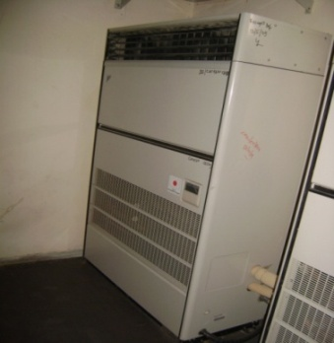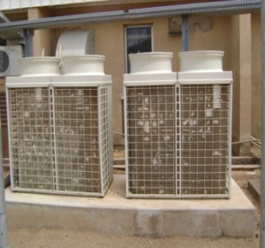
b) Air conditioner system, cooling both transmitters FM of regional and national signals
On the left to the right, evaporator of air conditioner situated in FM room and condensers of air conditioner situated outside the room

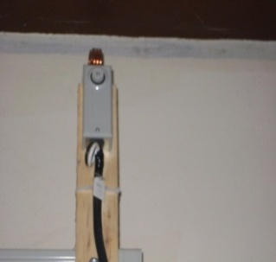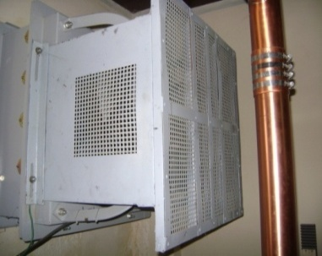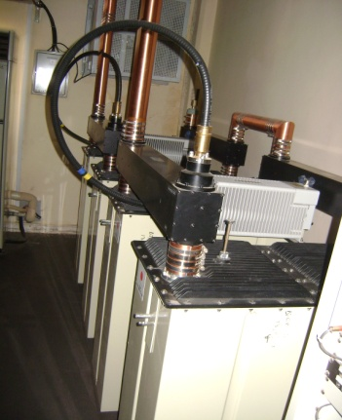
c) On the left to the right: temperature sensor that give information to the dehydrator, the dehydrator, frequencies combiner (dummy load) to be routed to antennas
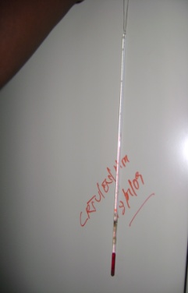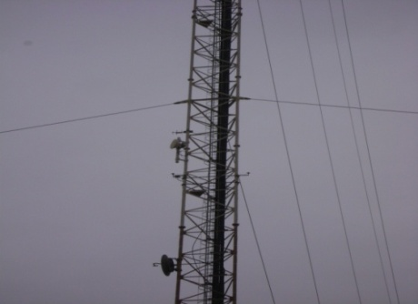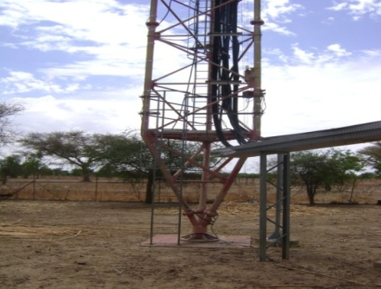
d) On the left to the right: temperature sensor which give FM room's temperature, antennas on the towers, cables of antennas located on tower.

- Equipment of RFI room

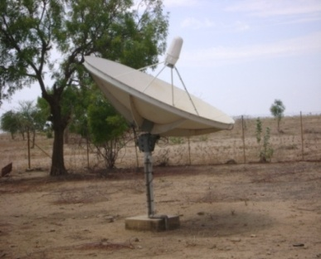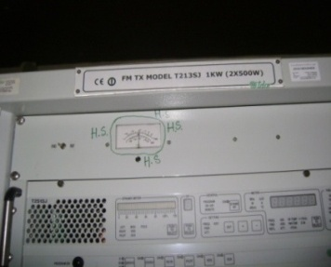
a) Receiver of RFI satellite's waves on the CRTV Maroua site

b) FM RFI Emitter's/receiver's on CRTV Maroua site

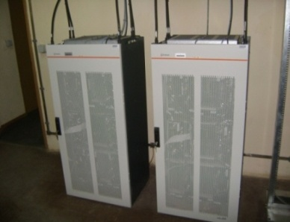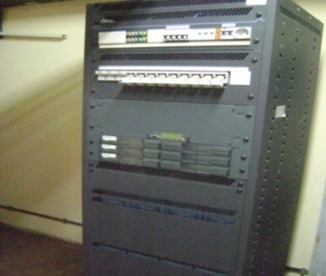
d) Batteries, batteries charger's and controller's
c) TX/RX 900GSM and 1800GSM
in RFI room

Annexes 2
Equipment of MTN sites
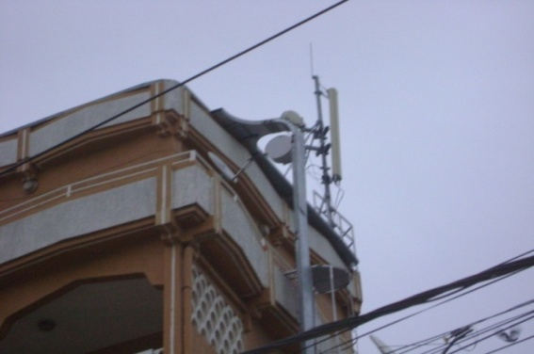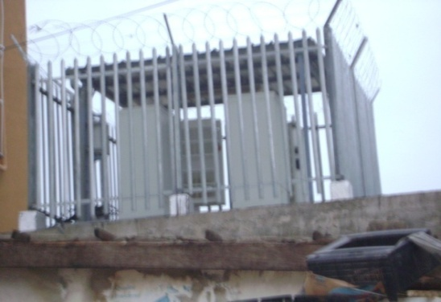

a) Outdoor base station of MTN Maroua Market

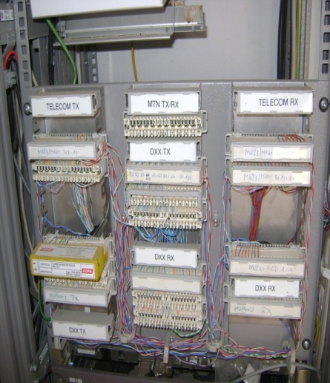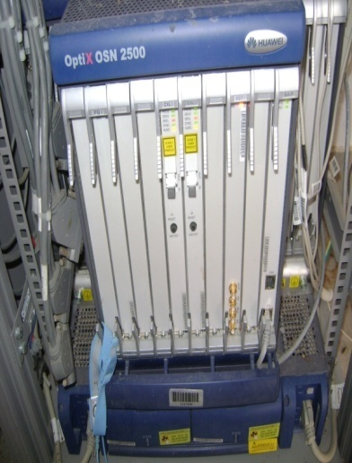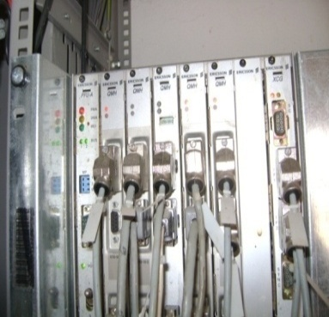
b) MTN Missinguileo base station: on the left to the right TX/RX equipements ,Huawei OSN 2500 multiplexer, radio equipment

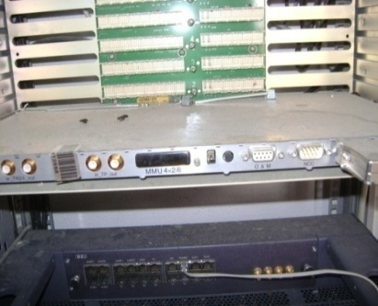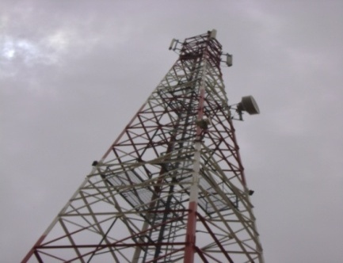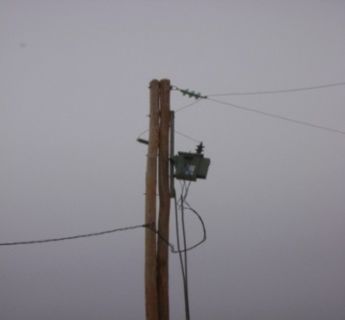
c) MTN Missinguileo base station: on the left to the right ERICSON multiplexer,antennas tower and power supply from AES-sonel

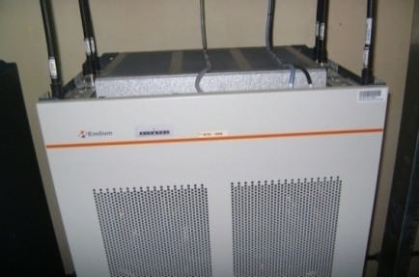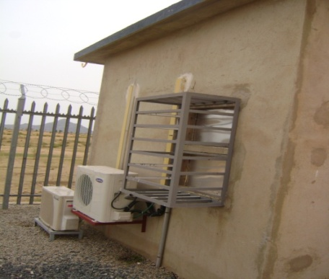
d) MTN Missinguileo base station: on the left to the right BTS GSM 900 equipment located in the room and air conditioner condensers' located outside of the room

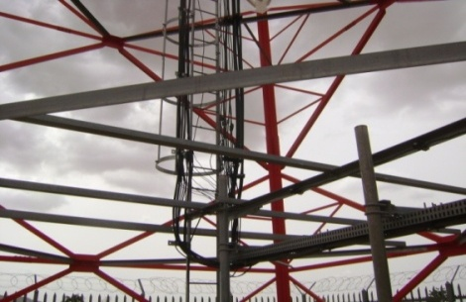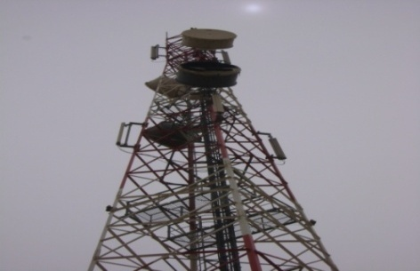
f) MTN Missinguileo base station: Tower with differents directions of radios

e) MTN Missinguileo base station: cables from antennas located on the tower

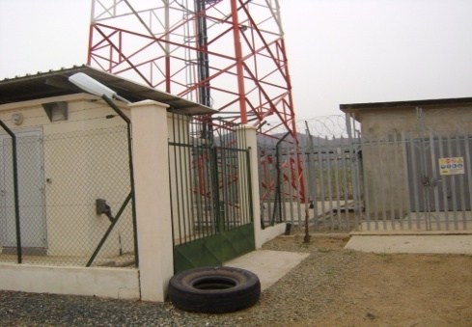
g) MTN Missinguileo base station: An exemple of site which have MTN and ORANGE antennas located on the same tower. The equipments are located on differents rooms

