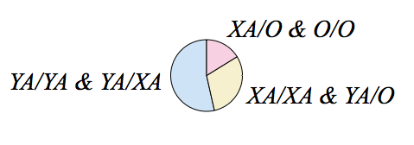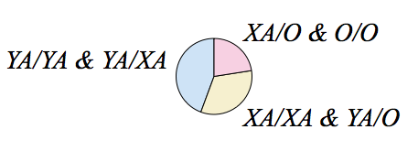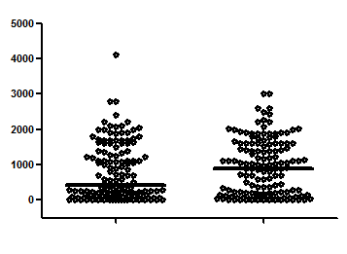

23/142 (16.2%)

43/142 (30.3%)

76/142 (53.5%)

**FEMALE**

47/142 (33.1%)

32/142 (22.5%)

63/142 (44.4%)

**MALE**

**B.**

**MBL concentration (ng/mL)**

**A.**

**Male Female**

***p* = 0.095**