Supplementary files
Table 1. The age and gender of patients and controls
ID | Gender | Age (years)
P1 | female | 50
P2 | female | 44
P3 | female | 36
P4 | female | 65
HC1 | female | 33
HC2 | male | 33
HC3 | male | 37
HC4 | female | 33

Supplementary figures
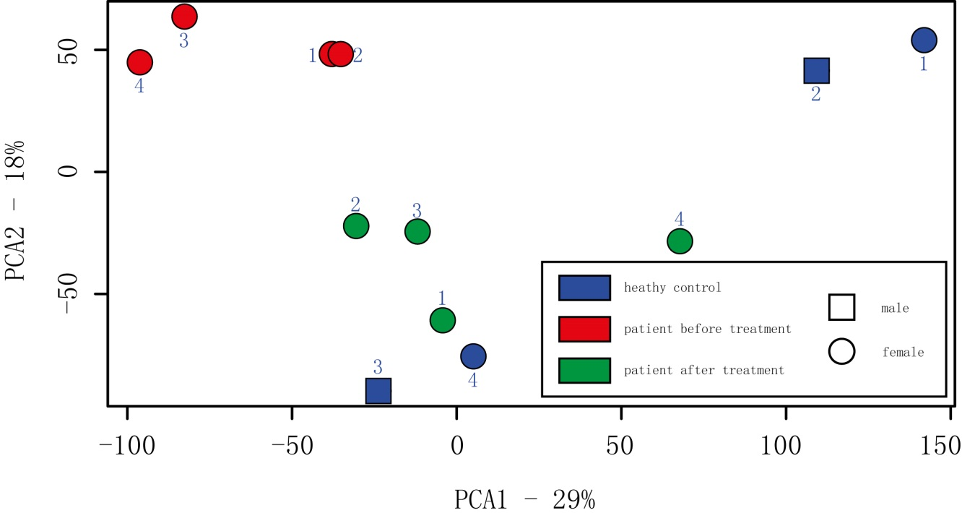
Supplementary Figure 1: The Principal Component Analysis (PCA) plot of the differentially expressed genes in patients before and one year after treatment as well as healthy controls. All male subjects were shown as square and females were round shape. Healthy controls were colored with blue, patients before treatment were colored with red and patients after one year SLIT were colored with green.

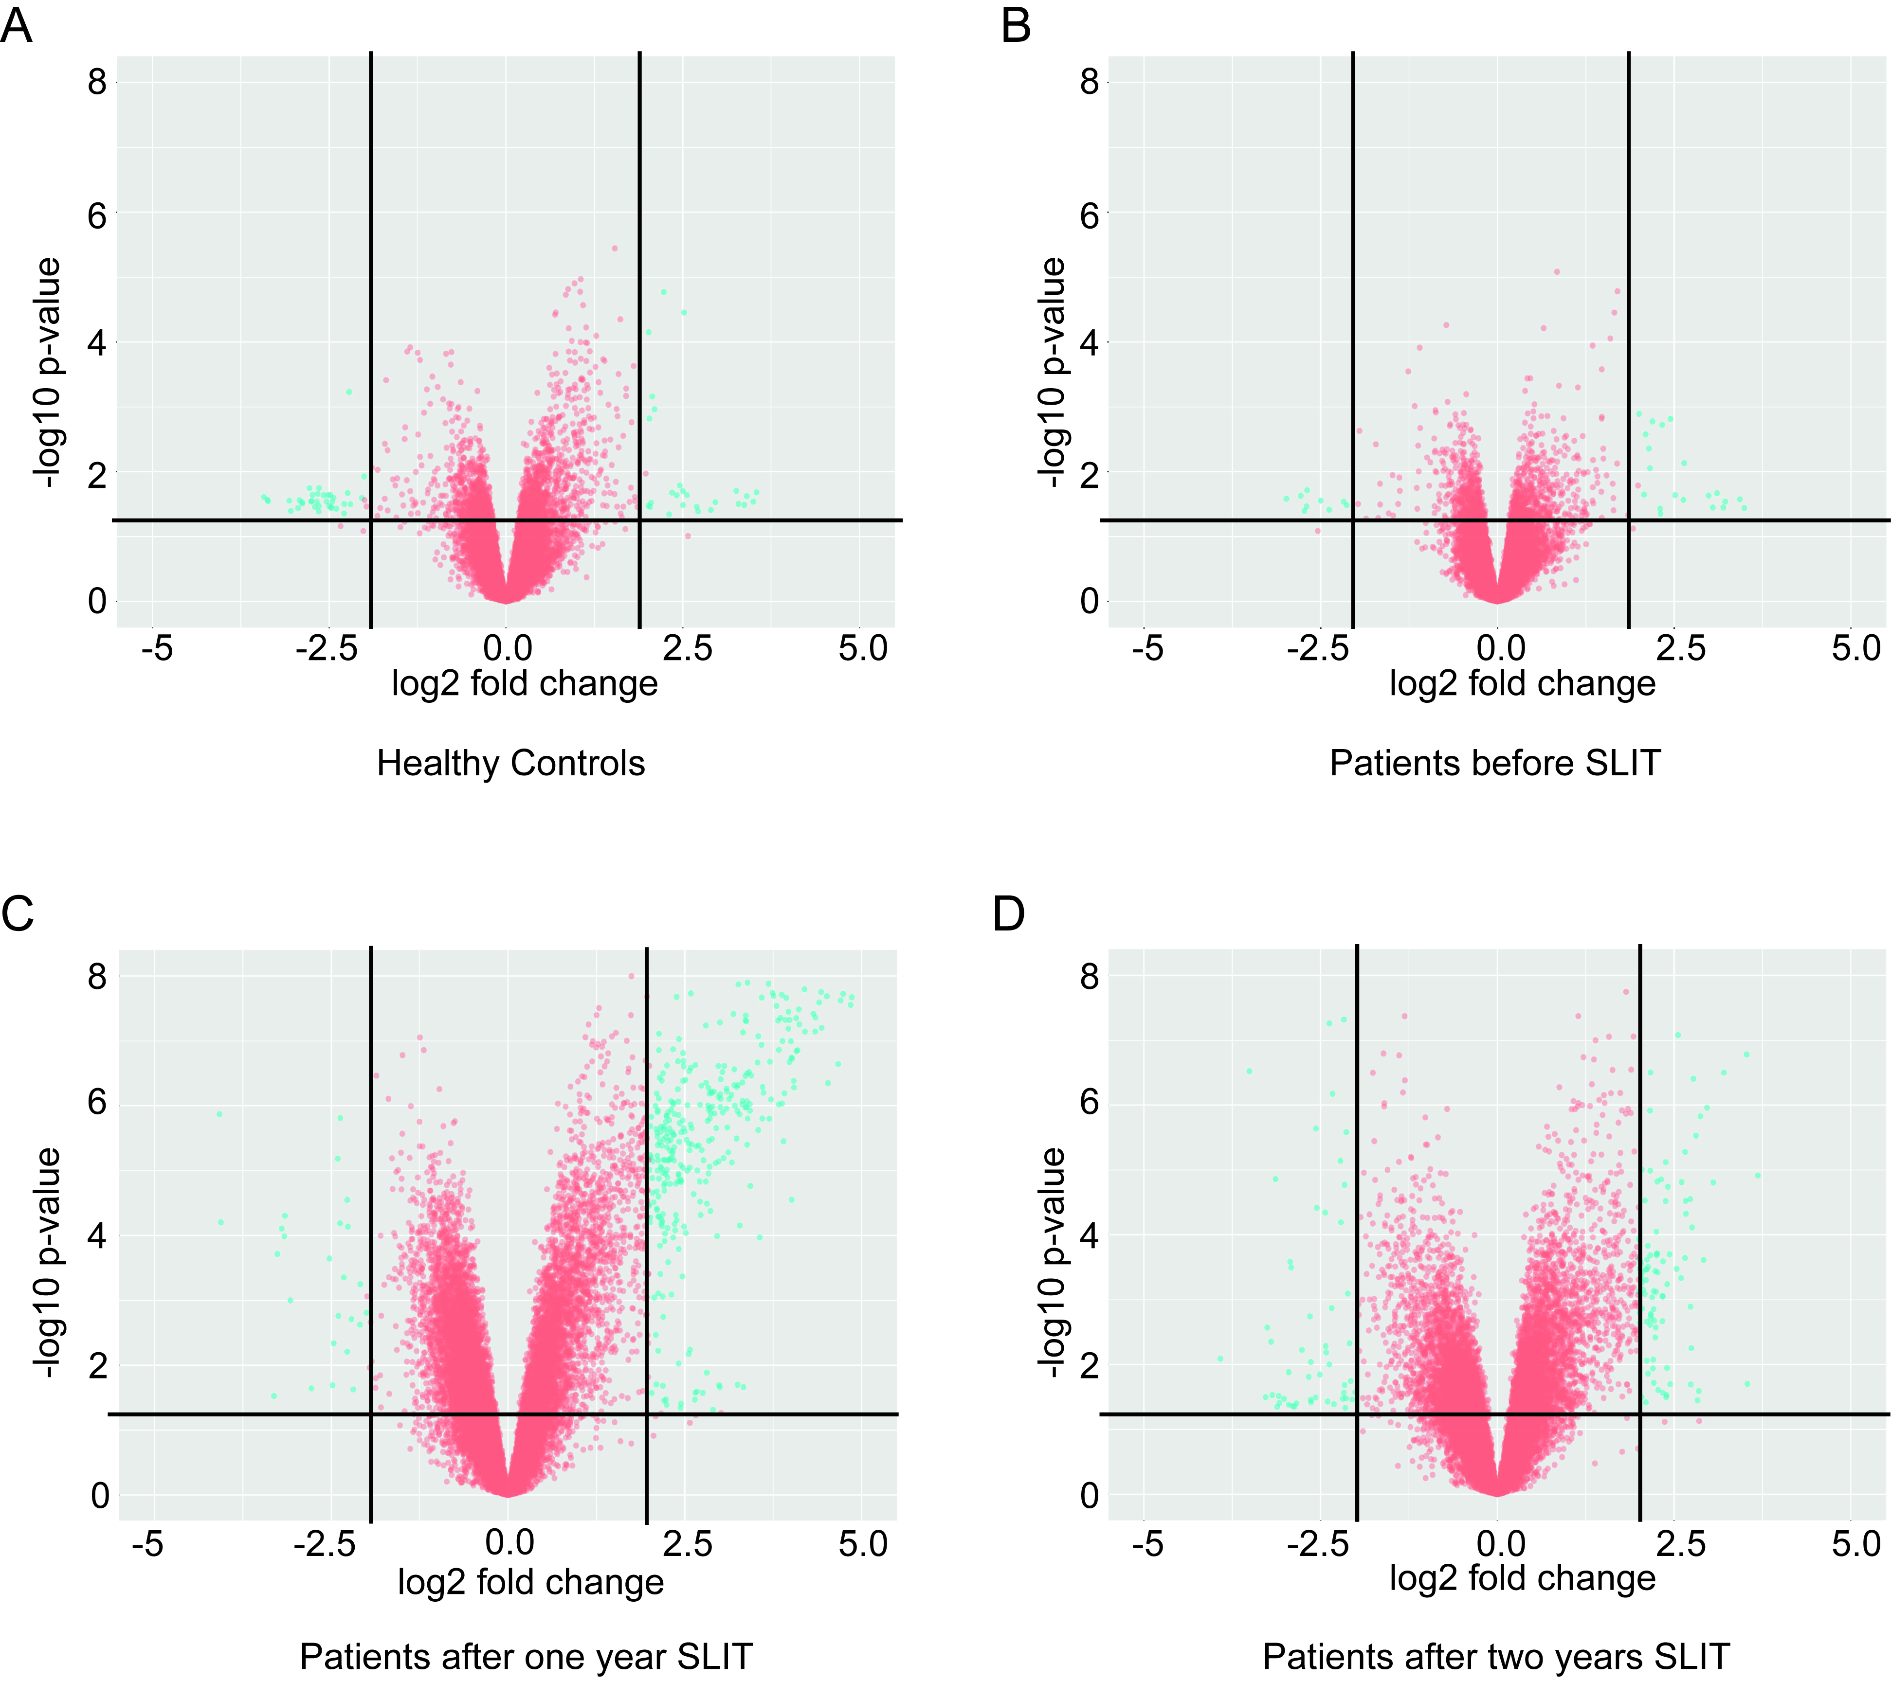
Supplementary figure 2: The Volcano plot of differentially expressed genes in patients before, after one year SLIT and after two years SLIT as well as healthy controls. A. healthy controls; B. patients before SLIT; C. patients after one year SLIT; D. patients after two years SLIT.

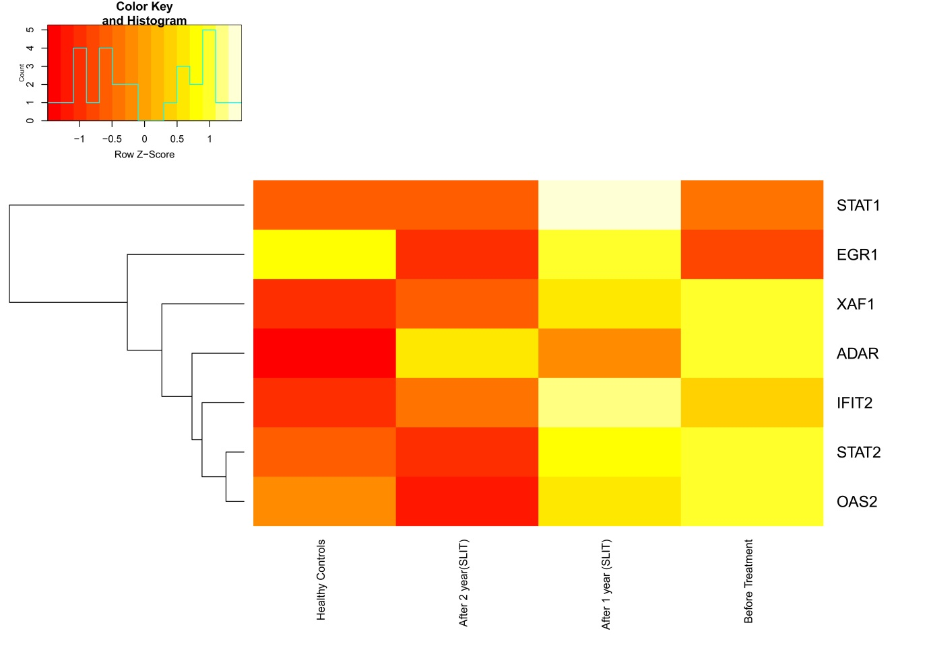
Supplementary figure 3: Heat map of the expression of the seven genes in the interferon pathway. The expression of STAT1, EGR1, XAF1, ADAR, IFIT2, STAT2 and OAS2 in healthy controls, patients before, after one year and after two years SLIT.

