Supplemental Figures.
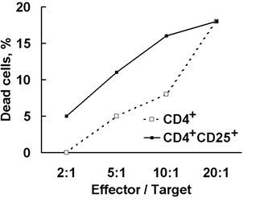
Supplemental figure 1.
Cytolytic activity increases with purification. The CD4+ population was isolated from the 6-day LAK culture with antibody-coated magnetic beads, and the CD4+CD25+subset was similarly isolated from CD4+. Both were incubated with K562 in standard assays at different effector–target cell ratios.
Supplemental figure 2.
Gating strategy for isolating the lymphocytes population from PBMC cells for Figure 1. A. Lymphocytes gating. B. CD3CD4 gating. E2 – double positive cells. C. CD3CD8 gating. E2-double positive cells.
Supplemental figure 3.
Gating strategy for isolating the lymphocytes population from CD4+CD25+ T lymphocytes subpopulation, purified on magnetic beads, for Figure 3. A. Lymphocytes gating. B. Staining by the FITC-conjugated anti-rabbit antibodies.

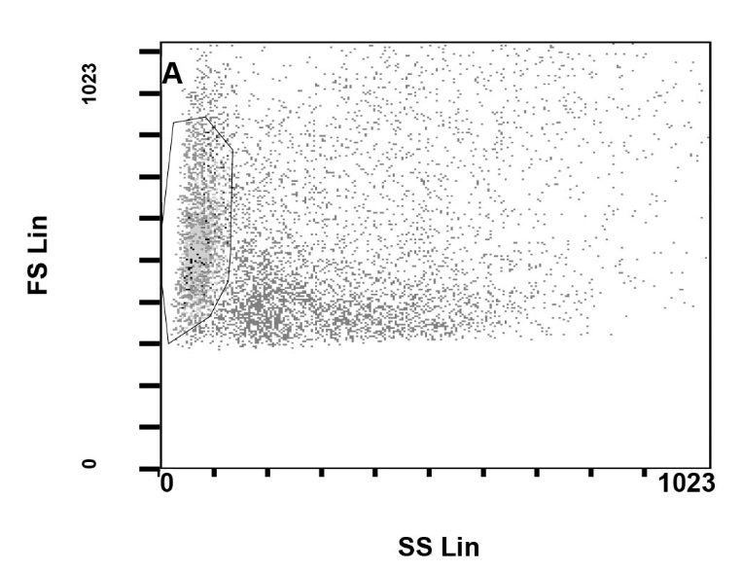
Supplemental figure 4.
Gating strategy for isolating the lymphocytes population from PBMC cells.
Supplemental figure 5.
The CD16+CD56+ population was isolated from the 4-day LAK culture with antibody-coated magnetic beads. Cells were incubated with K562 in standard assays with 1hour preincubation with antibodies to FasL, Fas, Granzyme B.

Supplemental figure 6.
The CD3+CD8+ population was isolated from the 4-day LAK culture with antibody-coated magnetic beads. Cells were incubated with K562 in standard assays with 1hour preincubation with antibodies to FasL, Fas, Granzyme B, Tag7 and Hsp70.
Supplemental figure 7.
Flow cytometry of FoxP3 intracellulary stained with the mouse anti-FoxP3 antibodies following by the PE-conjugated anti-mouse antibodies. A. the CD4+CD25+CD127+ population stained by PE-conjugated anti-mouse antibodies. B. the CD4+CD25+CD127+ population stained with the mouse anti-FoxP3 antibodies following by PE-conjugated anti-mouse antibodies. C. total PBMC population stained with the mouse anti-FoxP3 antibodies following by PE-conjugated anti-mouse antibodies.
Supplemental figure 8.
Gating strategy for isolating the Tag7+ lymphocytes population from PBMC, purified on magnetic beads. A. Lymphocytes gating. B. Staining with the mouse anti-Granzyme B antibodies following by PE-conjugated anti-mouse antibodies.

