Chemical Engineering Journal

ELECTRONIC SUPPLEMENTARY MATERIAL

Microwave Assisted Synthesis of ZnO Nanoparticles: Effect of Precursors, Temperature, Irradiation Time and Additives on Nano-ZnO Morphology Development.

Gastón P. Barreto*, Graciela Morales and Ma. Luisa López Quintanilla
Centro de Investigación en Química Aplicada. Blvd. Enrique Reyna 140, (25253) Saltillo, Coahuila, México.

*Corresponding author e-mail address: gbarreto@fio.unicen.edu.ar

Methods
Characterization technics
Powder X-ray diffraction
ZnO powders were characterized by X-ray diffraction with a Siemens D500 diffractometer. Diffraction patterns were recorded from 10 to 80° 2θ with a step size of 0.06° at 35 kV and 25 mA.
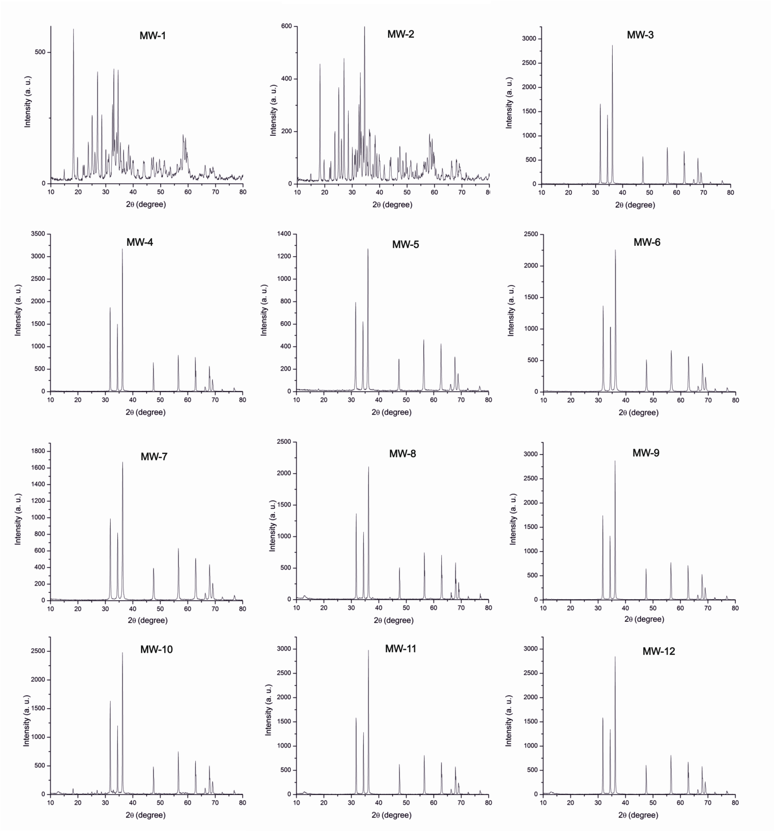

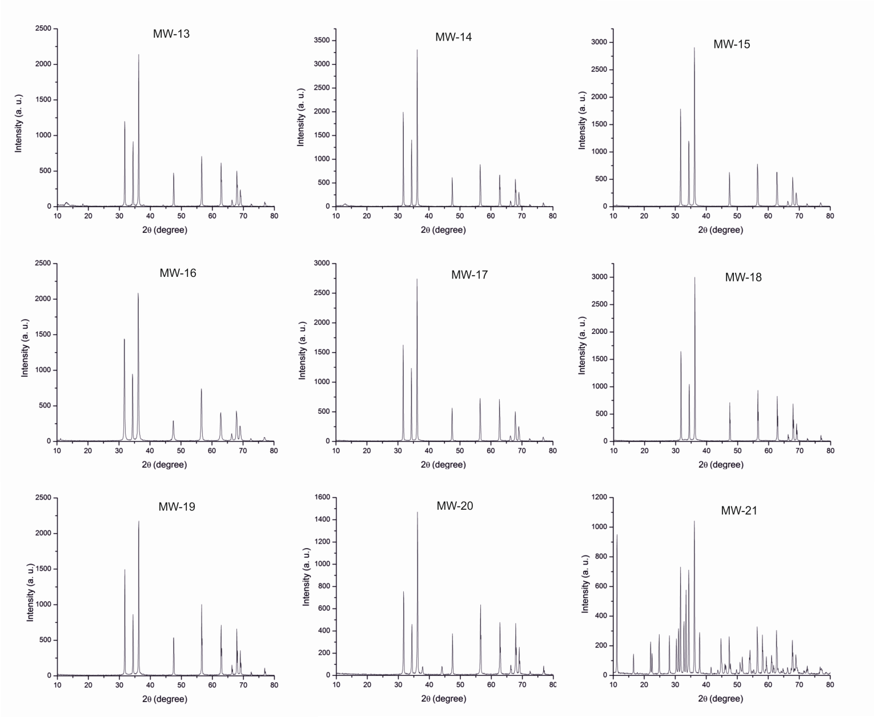
Figure S1. XRD of synthetized ZnO particles using microwave assisted method.

Field Emission Scanning Electron Microscopy

An aliquot of solid state material was placed in a carbon label for analysis by field emission scanning electron microscopy (JSM-7401F). Samples were analyzed using a secondary electron detector.
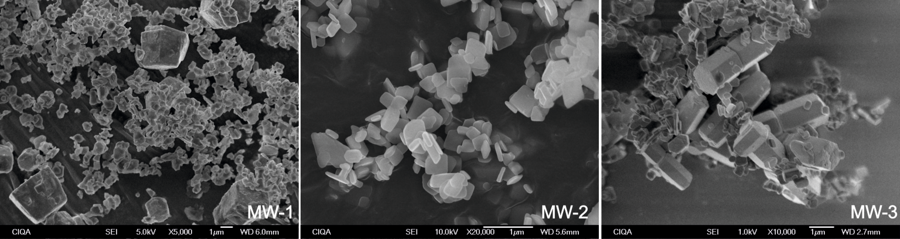

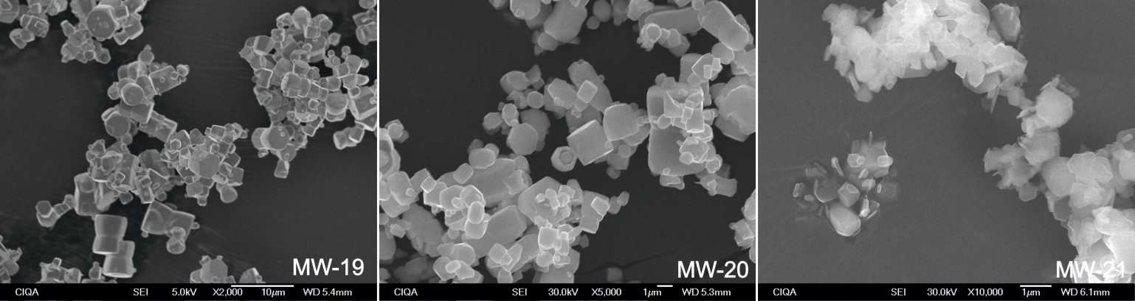
Figure S2. FE-SEM images of synthetized ZnO particles.

Infrared Spectrometry

The infrared spectras of ZnO nanoparticles were taken in a Nicolet spectrophotometer model Nexus 470 Nicolet brand in transmittance mode. The sample preparation was made in tablet way by mixing nano-ZnO and KBr in an agate mortar.
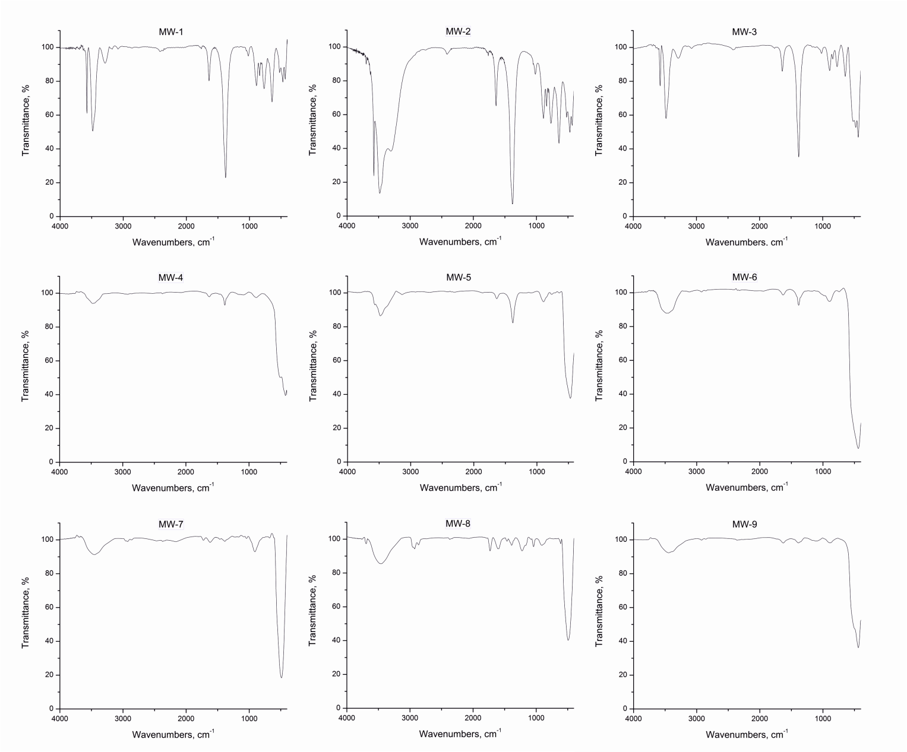

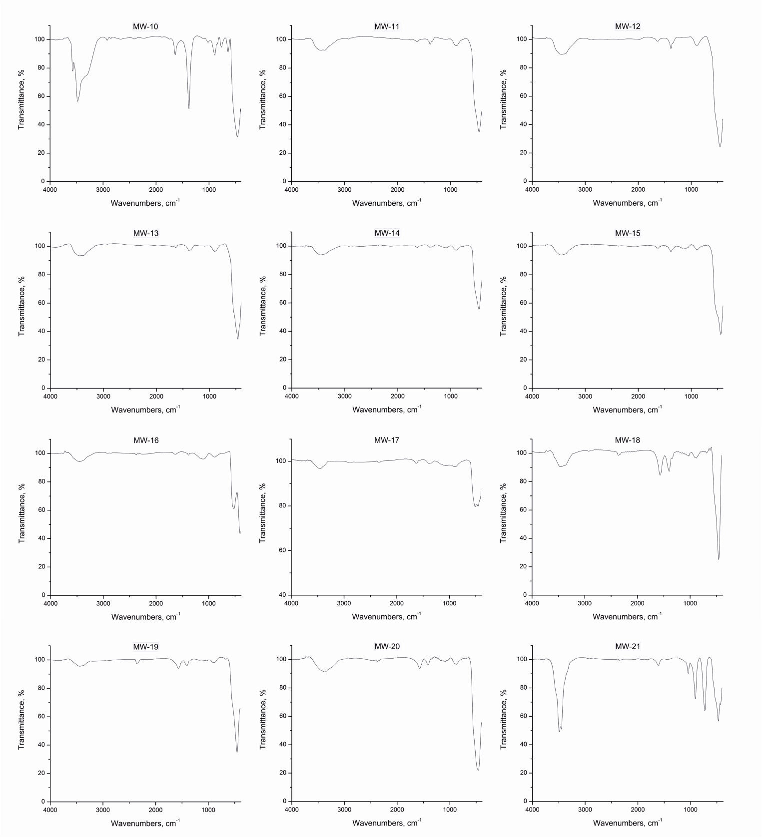
Figure S3. FTIR spectra of synthetized ZnO particles using microwave assisted method.

UV-vis Spectrometry

The solid samples were dispersed in deionized water and ultrasonicated for 10 min. Then UV-vis spectra of colloidal systems were obtained through a Shimadzu double beam spectrophotometer model UV-2401PC.

