Quantitative analysis and efficient surface modification of silica nanoparticles
Hak Sung Jung, Doo-Sik Moon, Jin-Kyu Lee*

Department of Chemistry, Seoul National University, Seoul 151-747, Korea
E-mail: jinklee@snu.ac.kr, Tel: +82-2-879-2923, Fax: +82-2-882-1080

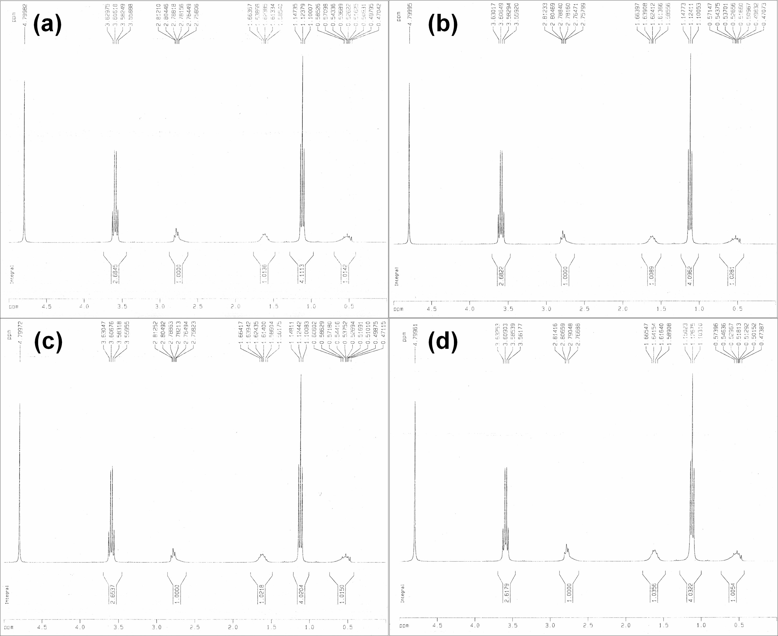
Figure S1. ¹H-NMR spectra of APTES in D₂O after (a) just mixing, (b) 30 min, (c) 1h, and (d) 4h.

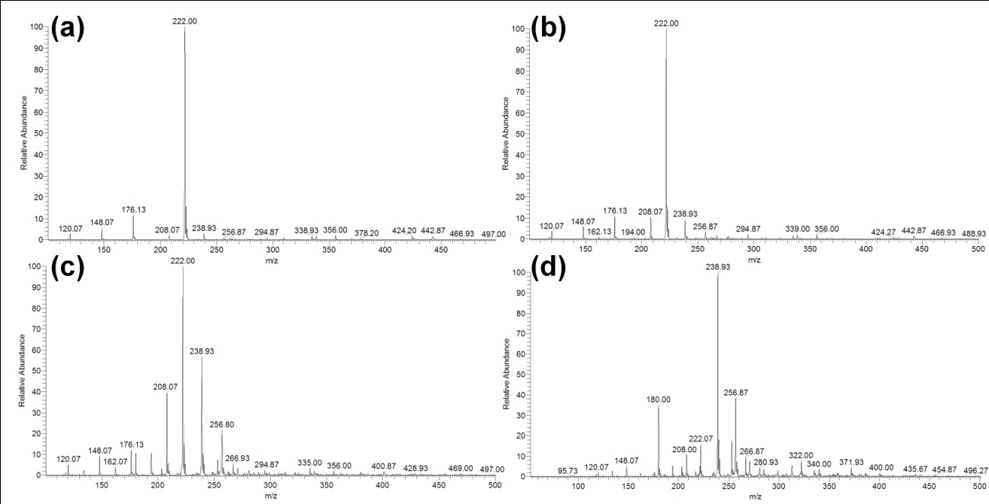
Figure S2. ESI-MS spectra of APTES in methanol: (a) as prepared, (b) after 30min, (c) after 3h, (d) after 6h.

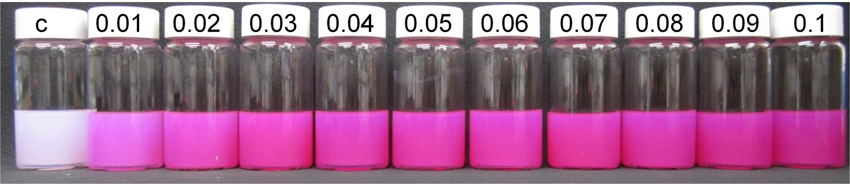
Figure S3. Photograph of SiO₂-DETAS(RITC) nanoparticles prepared from various amounts of DETAS ligand.

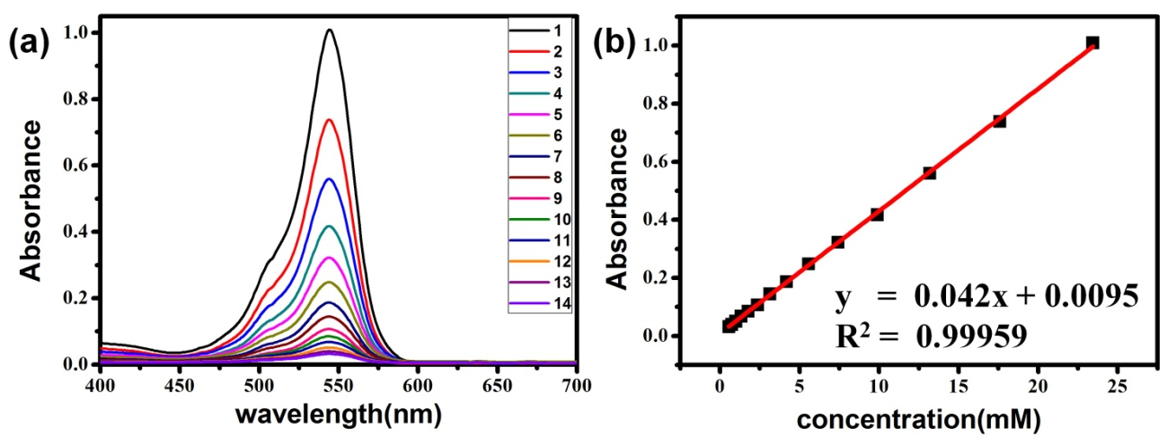
Figure S4. (a) UV-Vis absorption spectra and (b) the calibration curve of Rhodmaine B isothiocyanate (RITC) at various concentrations

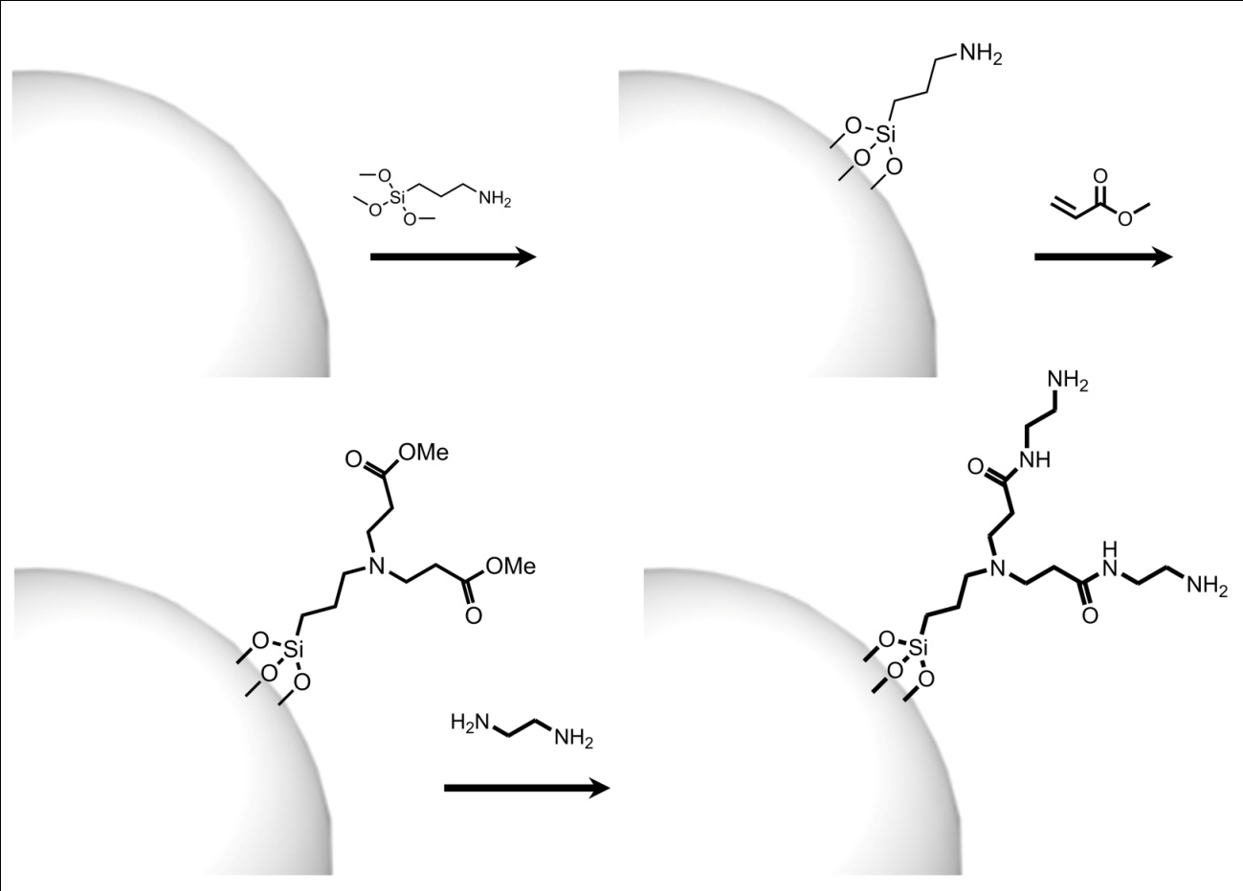
Figure S5. Schematic illustration of the synthesis of SiO₂-EDA in a way analogous to dendrimer synthesis
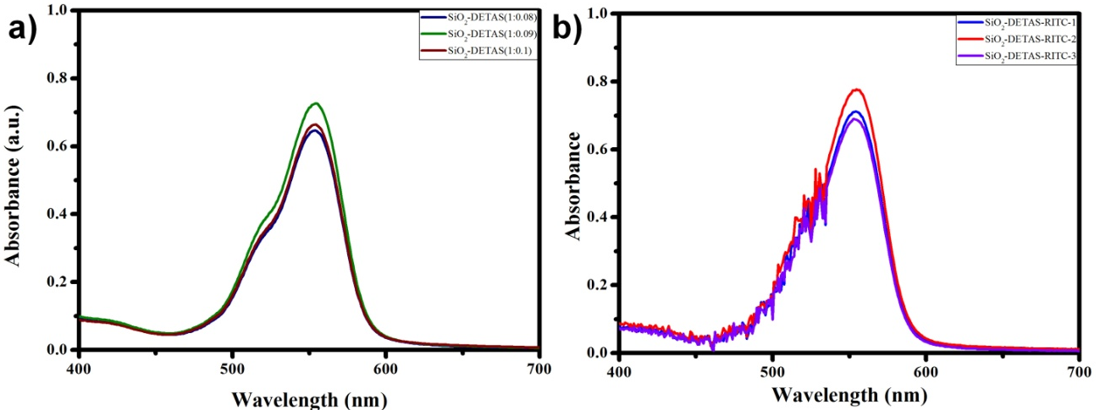
Figure S6. The absorption spectra of a) as prepared SiO₂-DETAS(RITC), b) after 1.5 month of SiO₂-DETAS(RITC).

Table S1. Acid-base back-titration results of surface modified silica nanoparticles.
Concentration of standardized NaOH solution: 0.86 mM
Concentration of HCl solution for back-titration: 1.1 mM
Volume of HCl solution for back-titration: 10.00 mL
Amount of used HCl: 11 μmol
 | Volume of NaOH solution (mL) |  |  |  | Amount of NaOH (μmol) |  |  |  |  | Amount of HCl reacted with surface amine sites (μmol)
SiO₂-APTMS-1 | 11.25 |  |  |  | 9.7 |  |  |  |  | 1.3
SiO₂-APTMS-2 | 11.75 |  |  |  | 10 |  |  |  |  | 1
SiO₂-APTMS-3 | 11.40 |  |  |  | 9.8 |  |  |  |  | 1.2
SiO₂-EDA-1 | 9.95 |  |  |  | 8.6 |  |  |  |  | 2.4
SiO₂-EDA-2 | 10.55 |  |  |  | 8.1 |  |  |  |  | 2.9
SiO₂-EDA-3 | 8.75 |  |  |  | 7.5 |  |  |  |  | 3.5
Concentration of standardized NaOH solution: 3.6 mM
Concentration of HCl solution for back-titration: 1.2 mM
Volume of HCl solution for back-titration: 10.00 mL
Amount of used HCl: 12 μmol
 | Volume of NaOH solution (mL) |  |  |  |  | Amount of NaOH (μmol) |  |  |  | Amount of HCl reacted with surface amine sites (μmol)
SiO₂-DETAS-1 | 2.45 |  |  |  |  | 8.75 |  |  |  | 3.25
SiO₂-DETAS-2 | 2.45 |  |  |  |  | 8.75 |  |  |  | 3.25
SiO₂-DETAS-3 | 2.40 |  |  |  |  | 8.57 |  |  |  | 3.43
Calculated weight of a single SiO₂ NP from the bulk density |  |  |  |  |  |  | 1.2ⅹ10⁻¹² mg/ea
Used amount of SiO₂ NP |  |  |  |  |  |  | 10 mg
Numbers of SiO₂ NPs in 10 mg sample |  |  |  |  |  |  | 8.3ⅹ10¹² ea
Surface area of a single SiO₂ NP |  |  |  |  |  |  | 31000 nm²
Total surface area of 10 mg SiO₂ NPs sample |  |  |  |  |  |  | 2.6ⅹ10¹⁷ ea·nm²
 | Number of amine (ea) |  |  |  |  | ea/nm² |  |  |  |  | Average value (ea/nm²)
SiO₂-APTMS-1 | 7.8ⅹ10¹⁷ |  |  |  |  | 3.0
SiO₂-APTMS-2 | 6.0ⅹ10¹⁷ |  |  |  |  | 2.3 |  |  |  |  | 2.7±0.29
SiO₂-APTMS-3 | 7.3ⅹ10¹⁷ |  |  |  |  | 2.8
SiO₂-EDA-1 | 1.4ⅹ10¹⁸ |  |  |  |  | 5.6
SiO₂-EDA-2 | 1.1ⅹ1018 |  |  |  |  | 6.7 |  |  |  |  | 6.8±1.1
SiO₂-EDA-3 | 2.1ⅹ10¹⁸ |  |  |  |  | 8.2
SiO₂-DETAS-1 | 2.0ⅹ10¹⁸ |  |  |  |  | 7.6
SiO₂-DETAS-2 | 2.0ⅹ10¹⁸ |  |  |  |  | 7.6 |  |  |  |  | 7.7±0.19
SiO₂-DETAS-3 | 2.1ⅹ10¹⁸ |  |  |  |  | 8.0

