The sentence of “The broken F-doped TiO₂ microspheres images of the Figure S1 (a) indicate that the sample prepared sample without adding urea have a hollow structure. While the broken N,F-codoped TiO₂ microspheres images of the Figure S1 (b) show that the codoped samples are composed of solid spheres.” is added in the revised supplementary material.

SI:
Figure S1 The magnified FSEM images of F-doped TiO₂ (a) and F, N codoped TiO₂ (b).

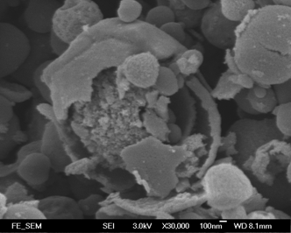
500 nm
500 nm

The broken F-doped TiO₂ microspheres images of the Figure S1 (a) indicate that the sample prepared sample without adding urea have a hollow structure. While the broken N,F-codoped TiO₂ microspheres images of the Figure S1 (b) show that the codoped samples are composed of solid spheres.

