**Supplementary Information**

**Photoluminescence enhancement of titanate nanotubes by insertion of rare earth ions in their interlayer spaces**

Thalles M. F. Marques,a Cleanio Luz-Lima,b Marco Sacilloti,c Kazunori Fujisawa,d Nestor Perea-Lopez,d Mauricio Terrones,d Eder Nascimento Silva,e Odair Pastor Ferreira,f and Bartolomeu Cruz Vianaa,b,d

aLIMAV – Ciências dos Materiais, Universidade Federal do Piauí – UFPI, 64049-550, Teresina-PI, Brazil;

bDepartamento de Física, Universidade Federal do Piauí – UFPI, 64049-550, Teresina-PI, Brazil;

cDepartamento de Física, Universidade Federal de Pernambuco - UFPE, 50670-901, Recife-PE, Brazil;

dDepartment of Physics and Center for 2-Dimensional and Layered Materials, The Pennsylvania State University, 16802, University Park –PA, United States;

eDepartamento de Física, CCET, Universidade Federal do Maranhão, 65085-580 São Luís-MA, Brazil;

fLaMFA – Laboratório de Materiais Funcionais Avançados, Departamento de Física, Universidade Federal do Ceará, Fortaleza–CE, Brazil.

**Table S1.** Interlayer distances calculated using peaks ((200) plane) around 10° (2θ) in X ray diffractograms. These interlayer distances are longer than the distances measured in HRTEM. In TEM, the samples were submitted to a high vacuum (bellow 10-6 Pa) and the water in the nanotubes was released promoting a shortening of the interlayer distance.

|  |  |
| --- | --- |
| **Samples** | **Interlayer distance (nm)** |
| **NaTiNt** | 0.87 |
| **PrTiNt** | 0.89 |
| **NdTiNt** | 0.92 |
| **ErTiNt** | 0.96 |
| **YbTiNt** | 0.98 |

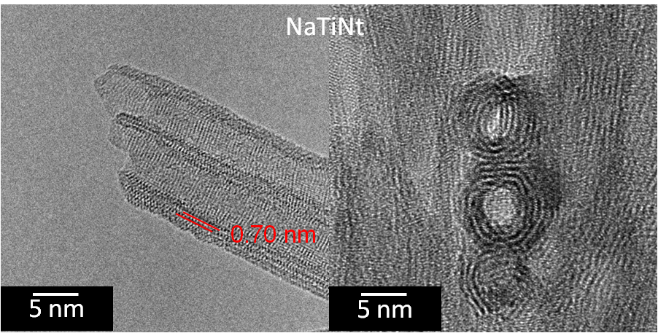

**Fig. S1.** TEM images of the pristine titanate nanotubes (NaTiNt). These images show the characteristic scroll-like morphology of the nanotubes. Also, the NaTiNT interlayer distance is shown (red line in left image).



**Fig. S2.** Schematic diagram of the titanate nanotubes band gap with the possible electronic levels (inserted red lines) generated by modifications into electronic structure of nanotubes due to RE (Pr3+, Nd3+, Er3+ and Yb3+) intercalation.