Sputtered PdO-Doped TiO₂ Sensing Layer for a Hydrogen Gas Sensor

Jeong Hoon Lee,¹ Seungmin Kwak,^{1,2} Jin-Hyung Lee,² Inho Kim,^{3,4} Yong Kyoung Yoo,¹ Kyu Hyoung Lee⁵

¹ Department of Electrical Engineering, Kwangwoon University, Seoul 01897, Republic of Korea
² Korea Institute of Science and Technology (KIST), Seoul 02792, Republic of Korea
³ R&D Center, Maccon IT Inc., Bucheon 14441, Republic of Korea
⁴ Department of Chemical Engineering, Ajou University, Suwon 16499, Republic of Korea
⁵ Department of Nano Applied Engineering, Kangwon National University, Chuncheon 24341, Republic of Korea
Correspondence should be addressed to Kyu Hyoung Lee; khlee2014@kangwon.ac.kr

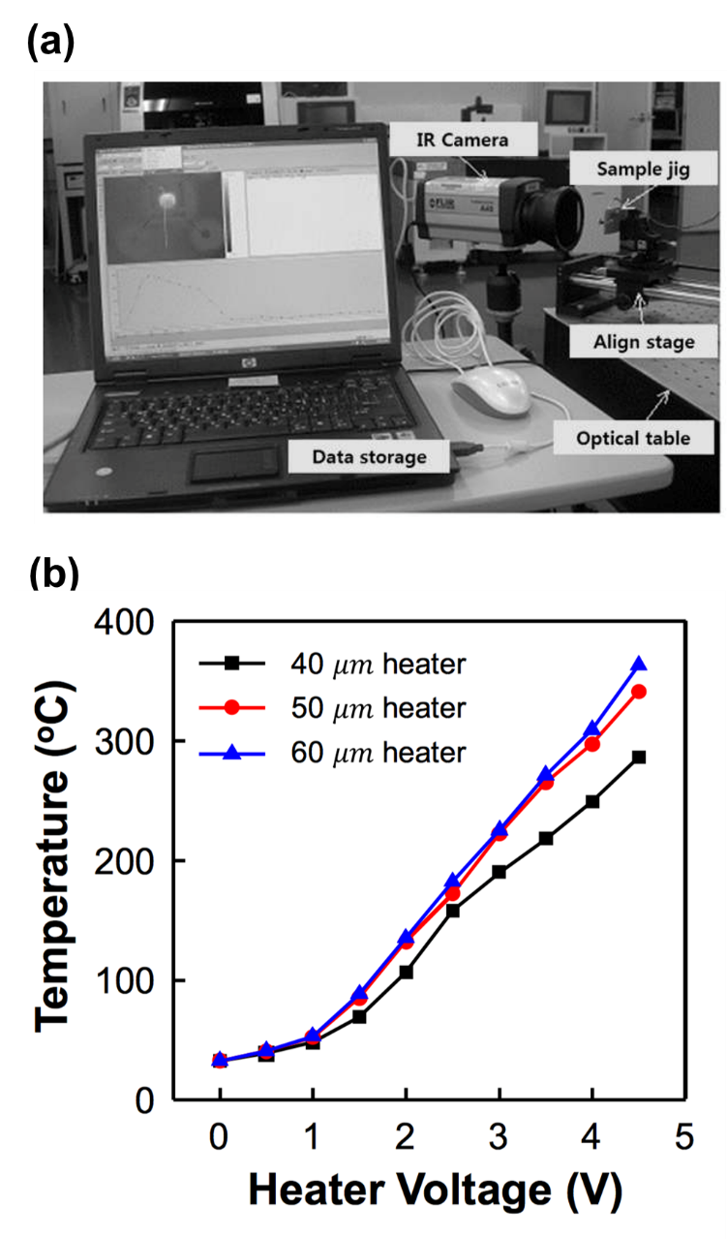
Figure S1. (a) IR measurement set-up and (b) measured temperature by IR camera as function of applied voltage. From three different heater widths data, we used 60 µm width pattern for MEMS H₂ sensor.

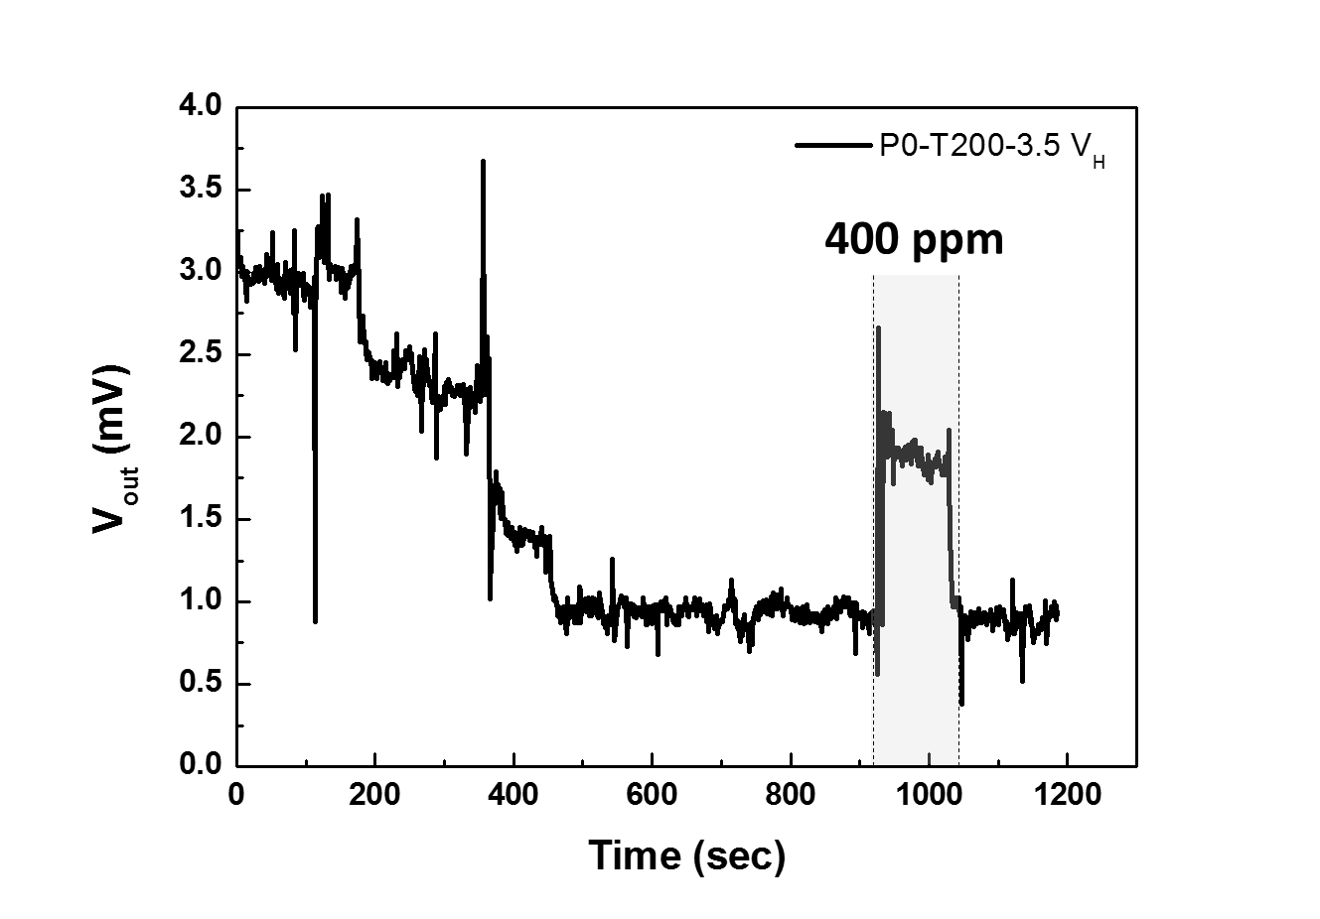
Figure S2. Hydrogen gas detection without PdO layer. The hydrogen sensing had 3.5 V applied.

