Supplementary Figure 1
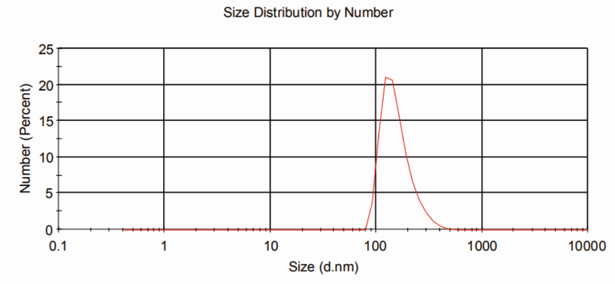
Supplementary Figure 1: The size and size distribution of the Ag@Fe₃O₄ nanoparticles measured by DLS.

Supplementary Figure 2
Supplementary Figure 2: TEM images of the Ag@Fe₃O₄ nanoparticles after irradiatting with an 808 nm light laser for 15 min at 5.0 W /cm².

