Supporting information
Fig. S1 ¹H NMR spectrum of NAG monomer

Calculations of the grafting density of carboxyl groups on PNAG-coated MNP after dispersing in water
The amounts of carboxyl groups presenting on the MNP surface were quantitatively determined by a conductometric titration. The conductometric titration curve of the reaction between NaOH and HCl having a V-shape (Blank) shows (Fig. 1A). During the titration, the reaction that takes place in the titration vessel is following:

In the region I, before the end point, OH⁻ is removed from the solution by reaction with H⁺, and Cl⁻ is added to the solution. The conductance of the solution decreases prior to the end point. After the end point (region II), no OH⁻ is available to react, and the conductance of the solution increases as a result of the additional of H⁺ and Cl⁻.
In the case of the titration of HCl with -COOH groups on the particle surface, the conductrometric titration curve exhibits three regions (Fig. 1B). Before the titration of -COOH groups on the particle surface, the -COOH coated on the particle surface was dispersed in an excess of NaOH solution. Thus, the reaction that takes place in the vessel is following:

In the region I of the titration, because basicity of excess OH⁻ in the solution is stronger than that of -COO⁻, the OH⁻ in the solution was first neutralized when HCl was titrated.

In the region II, when the OH⁻ in the solution was completely neutralized, the H⁺ ions reacted with the -COO⁻ groups on the MNP surface. After the COO⁻ groups on the MNP surface were completely reacted with H⁺ ions, the solution conductivity sharply increase due to the excess of OH⁻ and Na⁺ (region III). The measurement of the amounts of -COOH groups on the surface of the polymer-coated MNP was estimated from the following equation:

$$\text{Carboxylic acid = }\frac{\text{M∆V}}{\text{m}}$$
$$\text{ = }\frac{\text{0.005 mol/L × (1.6 × }{\text{10}}^{\text{-3 }}\text{L) }}{\text{2 × }{\text{10}}^{\text{-3 }}\text{g}}$$
$$\text{ = 4.0 mmol/g}$$

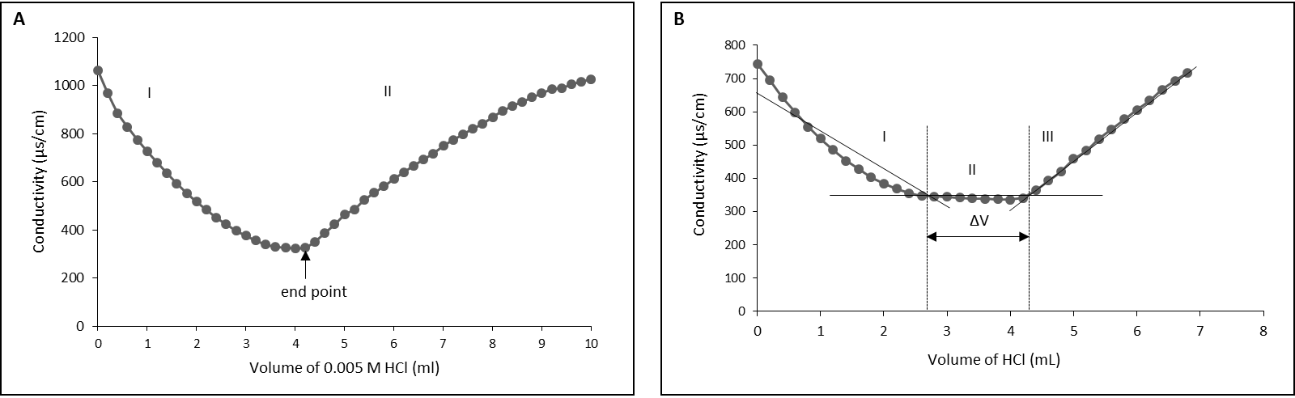

Fig. S2 Examples of the conductometric titration curves, (A) the titration curve of HCl with NaOH and (B) the titration curve of HCl with carboxyl groups on the PNAG-coated MNP surface
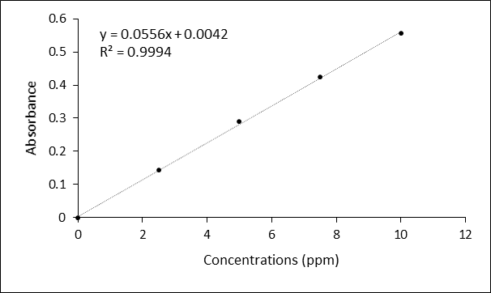

Fig. S3The calibration curve of theophylline standard with various concentration solution at pH 2.0

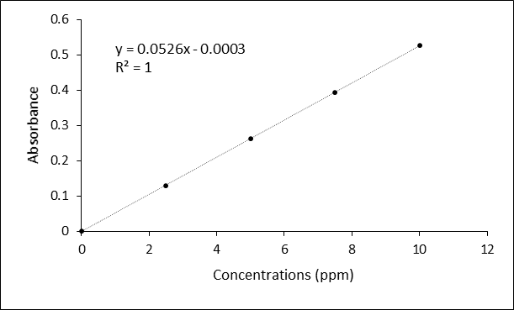

Fig. S4 The calibration curve of theophylline standard with various concentration solution at pH 7.4

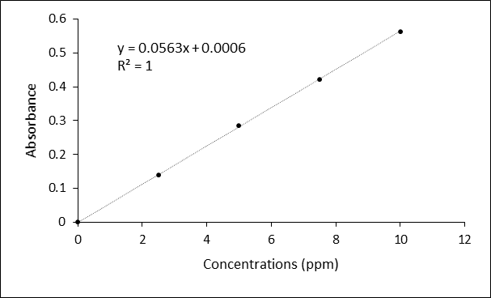

Fig. S5 The calibration curve of theophylline standard with various concentration solution at pH 11.0

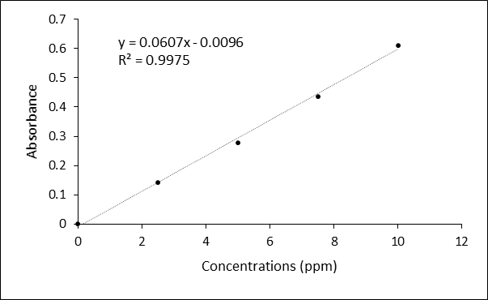

Fig. S6 The calibration curve of theophylline standard with various concentration solution at 0.1 M HCl

