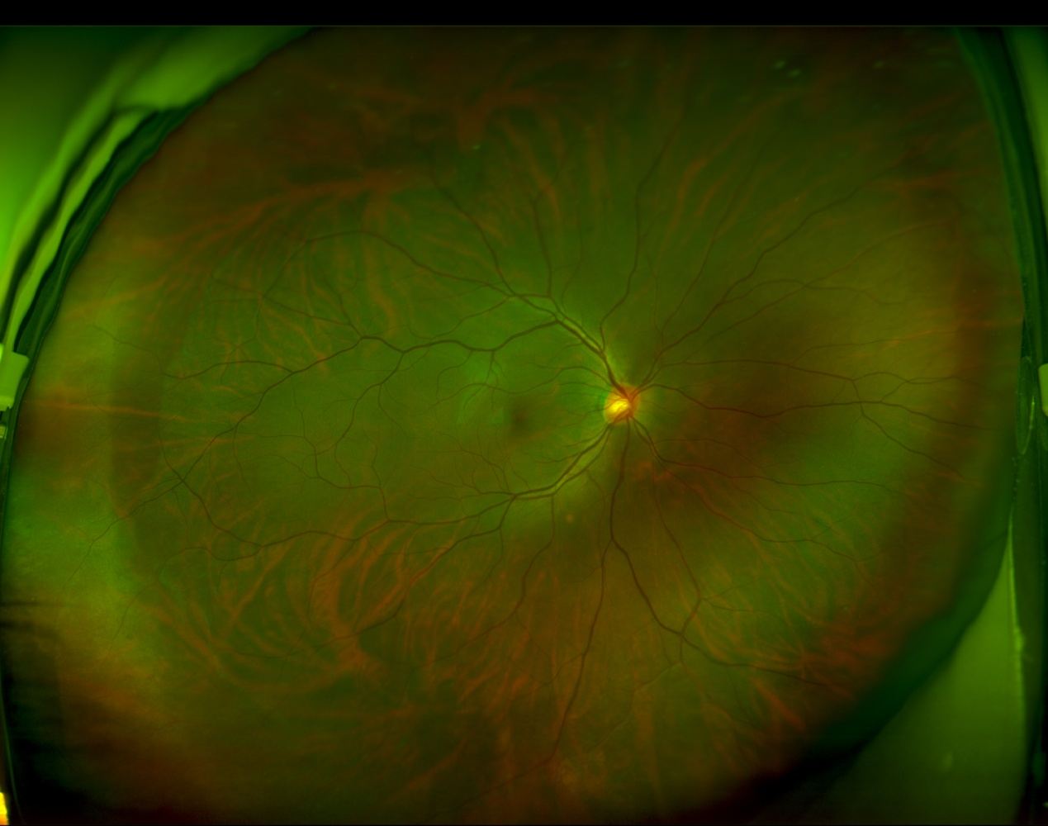

8. White-without-pressure(WWOP)