SUPPLEMENTARY MATERIAL

Detailed personal history and phenotype of individual IV:1 diagnosed with congenital cataracts, facial dysmorphism, and neuropathy syndrome.

The patient underwent bilateral cataract surgery in infancy without artificial lens implantation. When he was 24 years old, an anterior chamber lens was introduced into the right eye. As a sequela he developed secondary glaucoma in the right eye for which he underwent trabeculectomy in the third decade of his life.

At the age of 36 years he was referred to the Department of Ophthalmology, First Faculty of Medicine, Charles University and General University Hospital in Prague because of right corneal decompensation. When first examined, microcornea (corneal diameter 9.75 mm in both eyes) and horizontal nystagmus was documented, with visual acuity counting fingers in the right eye and light perception in the left eye. The right cornea was opaque due to edema, and in the left eye, ring synechia of the iris was present. Examination of the fundus was not possible due to the anterior segment pathology. Penetrating keratoplasty (PK) was performed in the right eye. The postoperative period was however complicated by graft rejection 11 months after PK, and elevated IOP managed by cyclophotocoagulation. At the last ocular examination, when the patient was aged 40 years, visual acuity was bilaterally hand movements. Ultrasound examination excluded microphthalmos (axial length 26.36 mm and 25.02 mm in the right and left eye, respectively) and retinal detachment in both eyes.

The proband was known to have delayed psychomotor development. He also had a history of cryptorchism surgery in childhood. Facial dysmorphism, intellectual disability (IQ 35–49), obesity (body mass index 40 at the age of 36 years), difficulties with walking, back pain, hypertension and hearing impairment were noted during ophthalmic examinations.

Clinical neurological examination performed at the age of 41 years confirmed severe peripheral polyneuropathy, with predominantly motor involvement, distal muscle weakness and in lower and upper limbs. Extensor plantar response, mild ataxia, and postural and kinetic tremor of the upper limbs were also present.

Supplementary Table 1: Primers sequences and conditions used in this study.
 | Forward | Reverse | Product size (bp) | Annealing temperature
CTDP1 c.863+389C>T | TCCTGACCTCGTGATCTTCC | CCTGGGAGACAGTGGGAGTA | 195 | 60°C
PRSS56  c.1509G>C | ACCGCAACCGTTCATTATTC | CCTCGGACCCTCTACCTACC | 301 | 60°C
Reference sequences: NG_007988.1 (CTDP1); NM_001195129.1 (PRSS56)

Supplementary Table 2: In silico analysis of p.(Met503Ile) mutation in PRSS56.
 | PolyPhen2 | SIFT | MutPred2 | SNP&GO | PhD-SNP | CADD
PRSS56  c.1509G>C | 0.883 | NA | 0.272 | NA | NA | 23.5
 | Possibly damaging | Damaging | Neutral | Disease | Disease | Disease causing
Reference sequence: NM_001195129.1 and NP_001356777.1, NA – not available
Overall probability MutPred score >0.5 was considered as probably disease-causing and a score > 0.75 was considered as disease-causing. For CADD score >20 was considered as pathogenic.

Supplementary Figure 1: Evolutionary amino acid conservation of affected residue across 14 species (T-coffee alignments).
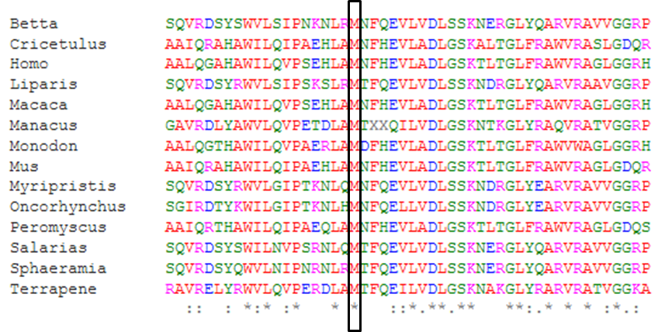

Supplementary Table 3: Rare variants identified in genes associated with disorders affecting ocular development in individual V:1.
Chromo-some | Position | Zygosity | Gene and  RefSeq ID | Variant description | rs ID | gnomAD frequency  # of alleles het/hom/total | Associated phenotype  OMIM number | Inheritance
1 | 150525555 | het | ADAMTSL4  NM_001288607.2 | c.260G>A; p.(Arg87Gln) | rs199599791 | 0.000168  47/ 0 / 278,742 | Lens ectopia  #225200 | AR
2 | 36583511 | het | CRIM1  NM_016441.3 | c.76C>A; p.(Leu26Met) | rs534996132 | 0.003545  861 / 30 / 242,846 | Macrophthalmia, coloboma, microcornea  #602499 | AD
2 | 233389542 | hom | PRSS56  NM_001195129.1 | c.1509G>C; p.(Met503Ile) | 0 | 0 | Microphthalmia  #613517 | AR
3 | 49167182 | hom | LAMB2  NM_002292.3 | c.1406-33T>C; p.? | rs557786607 | 0.000874  246 / 7 / 281,602 | Pierson syndrome  #609049 | AR
4 | 8869701 | het | HMX1  NM_018942.3 | c.765C>T; p.(Arg255Arg) | rs574706311 | 0.000540  101 / 0 / 186,972 | Oculoauricular syndrome  #612109 | AR
4 | 183676354 | het | TENM3  NM_001080477 | c.4834G>A; p.(Gly1612Ser) | rs543733302 | 0.000297  73 / 2 / 245,596 | Microphthalmia with coloboma  #615145 | AR
9 | 100227317 | het | TDRD7  NM_014290.2 | c.1629+7A>G; p.? | rs151288166 | 0.002321  649 / 4 / 279,676 | Cataract  #613887 | AR
14 | 70490008 | het | SMOC1  NM_001034852.2 | c.1135A>C; p.(Ile379Leu) | rs766710070 | 0.000056  14 / 0 / 251,432 | Microphthalmia with limb anomalies  #206920 | AR
14 | 74971592 | het | LTBP2  NM_000428.2 | c.4370-28C>T; p.? | rs143626054 | 0.000880  249 / 1 / 282,762 | Microspherophakia/megalocornea,  with ectopia lentis, with or without secondary glaucoma  #251750 | AR
14 | 75019032 | het |  | c.1257C>T; p.(Pro419Pro) | rs150977144 | 0.000036  9 / 0 / 247,760
14 | 75052587 | het |  | c.800C>T; p.(Ser267Leu) | rs149952751 | 0.000975  274 / 1 / 280,846
16 | 77353778 | het | ADAMTS18  NM_001326358.2 | c.1984C>T; p.(Pro662Ser) | rs139553755 | 0.001966  555 / 5 / 282,356 | Microcornea, myopic chorioretinal atrophy and telecantus  #615458 | AR
17 | 79479366 | het | ACTG1  NM_001199954.2 | c.15C>T; p.(Ile5Ile) | rs199657153 | 0.001287  364 / 7 / 282,748 | Baraitser/Winter syndrome 2  #614583 | AD
20 | 17475569 | het | BFSP1  NM_001161705.2 | c.773A>G; p.(Asn258Ser) | rs150798461 | 0.002419  684 / 16 / 282,738 | Cataract  #611391 | AD, AR
het = heterozygous, hom = homozygous, AR = autosomal recessive, AD = autosomal dominant, rs ID = dbSNP reference SNP number , OMIM = Online Mendelian Inheritance in Man
Web resources:
PolyPhen2 (Polymorphism Phenotyping v2): http://genetics.bwh.harvard.edu/pph2/
SIFT (Sorting Intolerant From Tolerant): http://sift.jcvi.org/
MutPred2: http://mutpred.mutdb.org/
SNPs&GO; PhD-SNP: http://snps.biofold.org/snps-and-go/
CADD https://cadd.gs.washington.edu/snv
T-coffee: http://tcoffee.crg.cat/apps/tcoffee/index.html
gnomAD: https://gnomad.broadinstitute.org/
OMIM: https://www.omim.org/
dbSNP: https://www.ncbi.nlm.nih.gov/snp/

