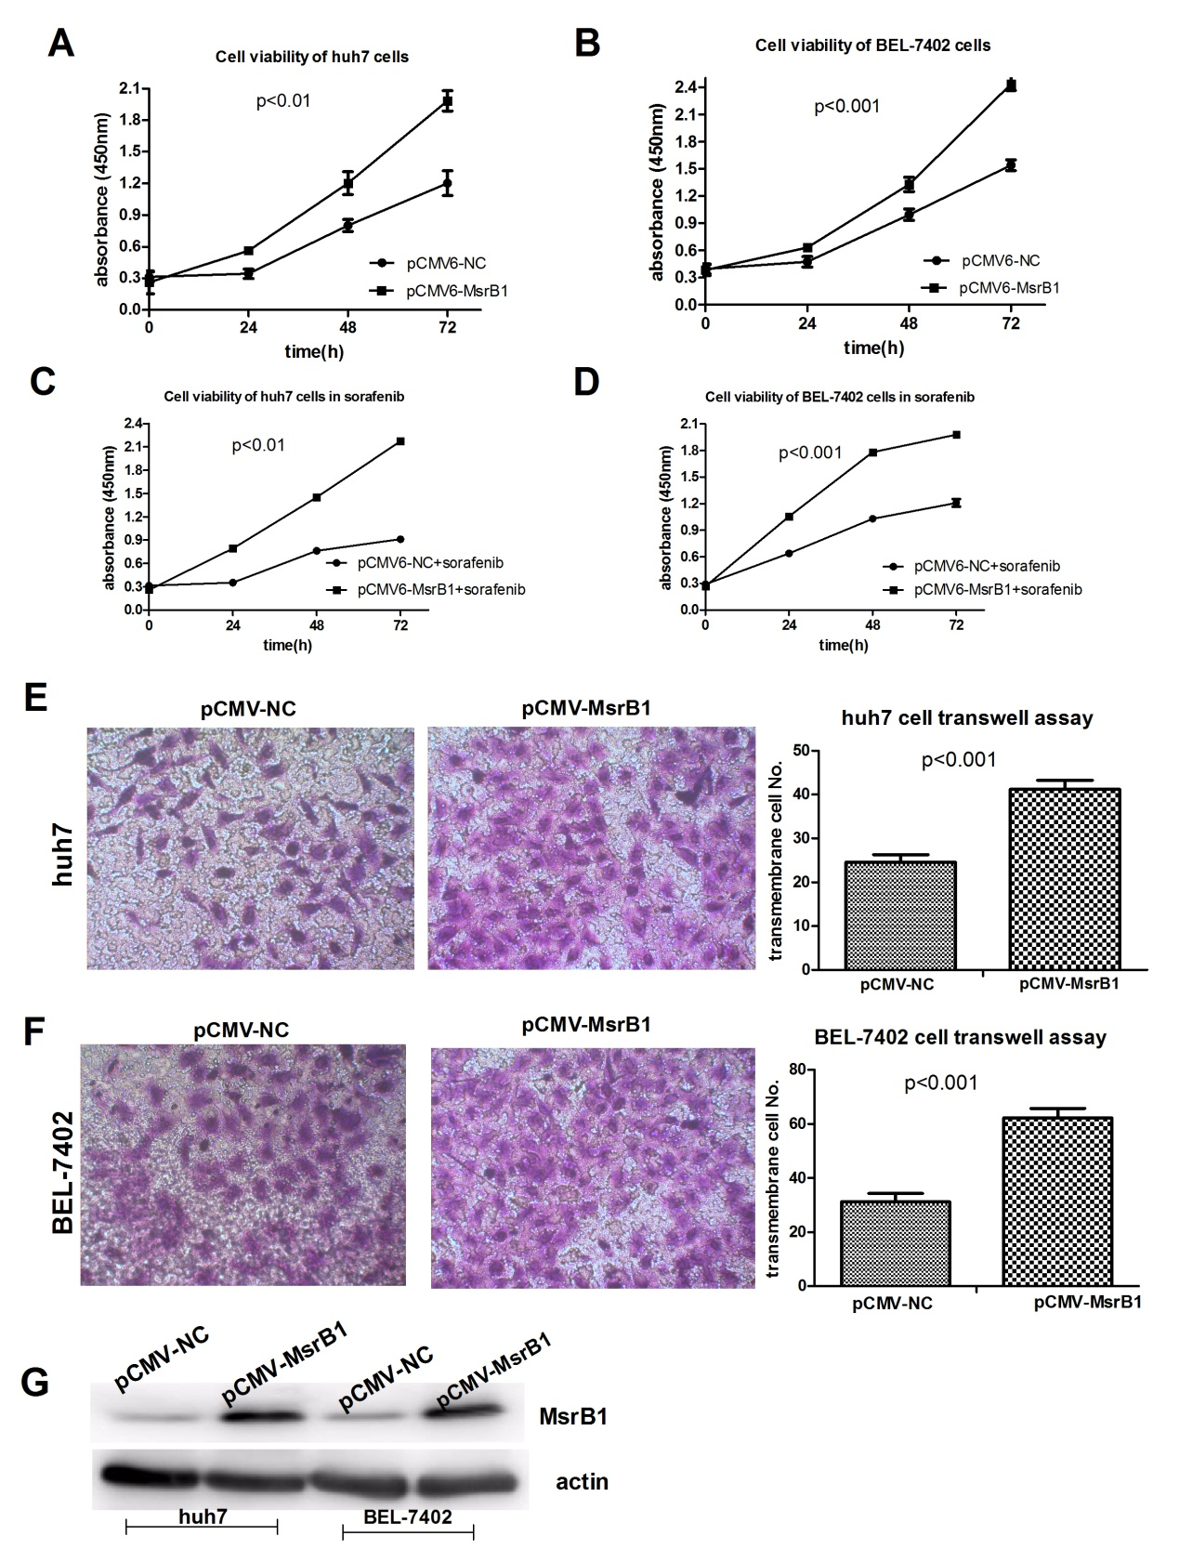
Figure S3. MsrB1 overexpression promotes proliferation and invision in HCC cells. A. MsrB1 overexpression promotes proliferation in huh7 cells through MTS assay. B. MsrB1 overexpression promotes proliferation in BEL7402 cells through MTS assay. C. MsrB1 overexpression promotes proliferation in huh7 cells with sorafenib through MTS assay. D. MsrB1 overexpression promotes proliferation in BEL7402 cells with sorafenib through MTS assay. E.Transwell assaymanifested MsrB1 overexpression promotes invision of huh7 cell. F. Transwell assaymanifested MsrB1 overexpression promotes invision of BEL7402 cell. G. western blot indicated the different expression of MsrB1 in HCC cells with pCMV-MsrB1 vector.

