SUPPORTING INFORMATION

Circulating heme oxygenase-1: not a predictor of preeclampsia, but highly expressed in pregnant women who subsequently develop severe preeclampsia
Valéria C. SANDRIM^{1,2*}, Mayara CALDEIRA-DIAS¹, Heloisa BETTIOL³, Marco Antonio BARBIERI ³, Viviane Cunha CARDOSO ³, Ricardo Carvalho CAVALLI⁴
¹ Departament of Pharmacology, Institute of Biosciences, São Paulo State University (UNESP), Botucatu, São Paulo, Brazil
² CEATOX – Center of Toxicological Assistance - Institute of Biosciences, São Paulo State University (UNESP), Botucatu, São Paulo, Brazil
³ Department of Pediatrics, Faculty of Medicine of Ribeirao Preto, University of Sao Paulo, Ribeirao Preto, Sao Paulo, Brazil.
⁴ Departament Of Obstetric and Gynecology, Faculty of Medicine of Ribeirao Preto, University of Sao Paulo, Ribeirao Preto, Sao Paulo, Brazil
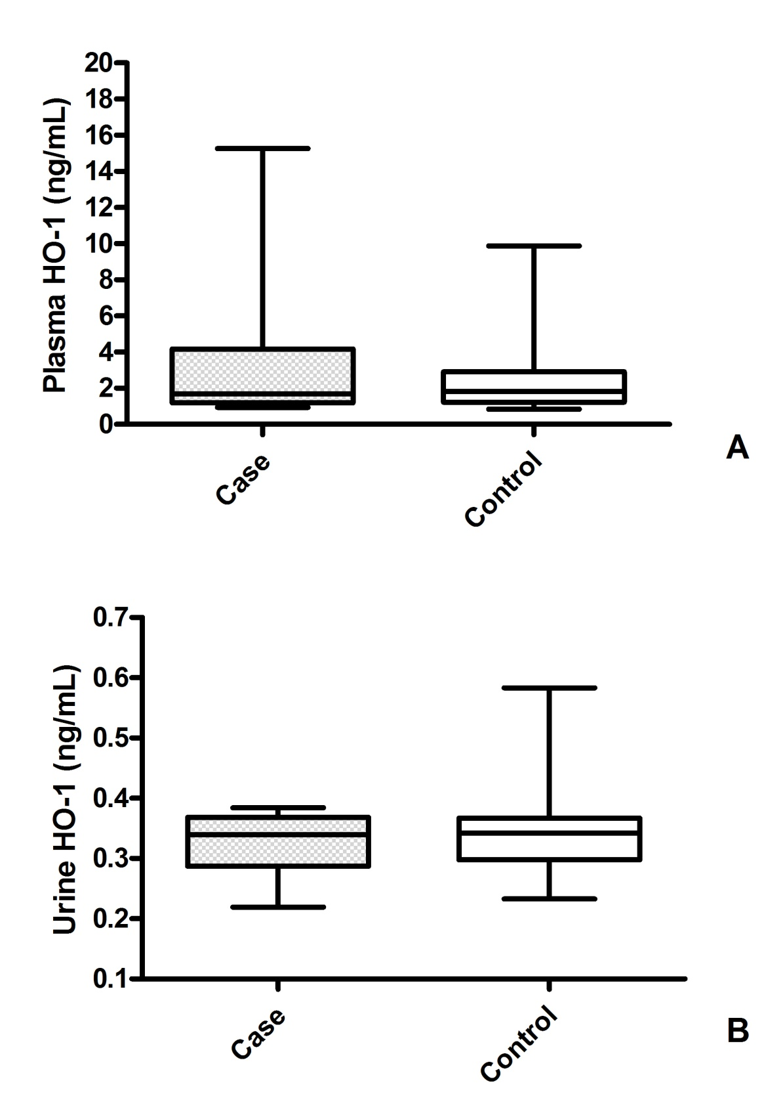

Figure S1 –Plasma (A) and urine (B) HO-1 concentration from pregnant healthy during gestation (control, n=90) and women who subsequently developed preeclampsia (case, n=30). No significant differences were found in plasma between case and control of plasma (medians [25th–75th centiles]: 1.69 ng/mL [1.19-4.17] vs 1.83 [1.22-2.90], respectively; P=0.54) neither urine (0.33±0.05 ng/mL vs 0.34±0.06 ng/mL, respectively P=0.31). Boxplot indicates median [min−max]. Comparison between groups was Student´s T-test.
Table S1. Correlations between general characteristics and HO-1 concentration in plasma samples from controls, mild and severe cases
 | Severe (Case) | Mild (Case) | Control
SBP (mmHg) | -0.24 (0.42) | -0.04 (0.87) | -0.05 (0.62)
DBP (mmHg) | 0.00 (0.97) | 0.13 (0.62) | -0.09 (0.37)
BMI (Kg/m²) | -0.01 (0.95) | -0.31 (0.23) | -0.19 (0.08)
Maternal Age | -0.22 (0.46) | -0.10 (0.70) | -0.12 (0.26)
NBW (g) | 0.35 (0.23) | -0.18 (0.49) | -0.12 (0.24)
Urine levels | -0.02 (0.94) | -0.49 (0.06) | -0.13 (0.23)
Data as correlation coefficient (P value); SBP, systolic blood pressure; DBP, diastolic blood pressure; BMI, body mass index GA, gestational age; NBW, newborn weight.

