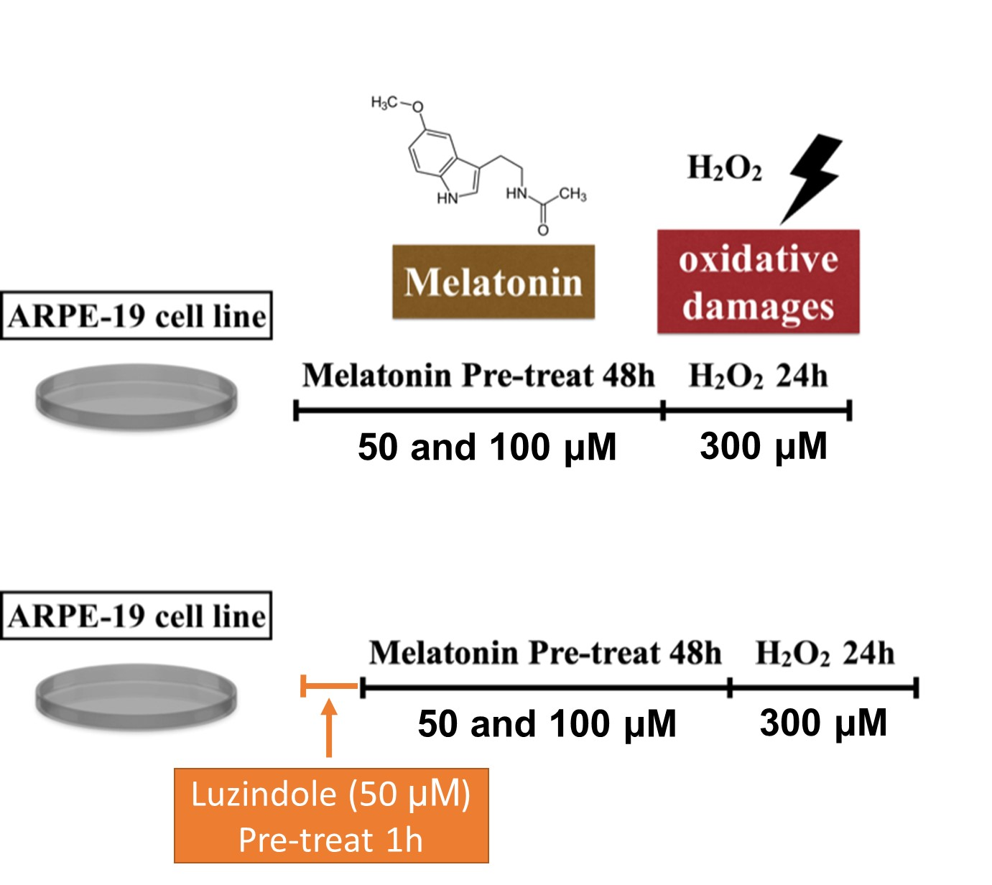

Figure S1. The experimental protocol for ARPE-19 cell. The cells were treated with vehicle (ethanol) or melatonin at indicated concentrations for 48 h, and they were then treated with 300 μM H₂O₂ for 24 h. For the luzindole (melatonin receptor antagonist) test, the RPE cells were seeded as previously detailed. Luzindole was added to the culture medium at a final concentration of 50 μM. One hour later, melatonin was added to the culture medium followed by culturing for 48 h, and H₂O₂ was then added followed by culturing for 24 h.

