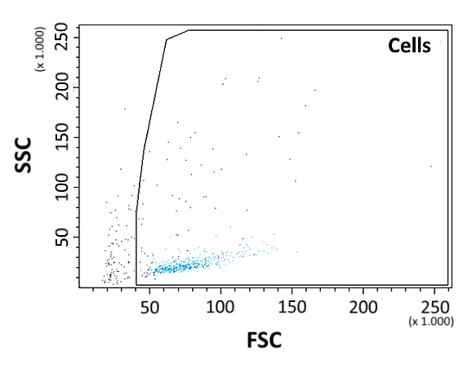
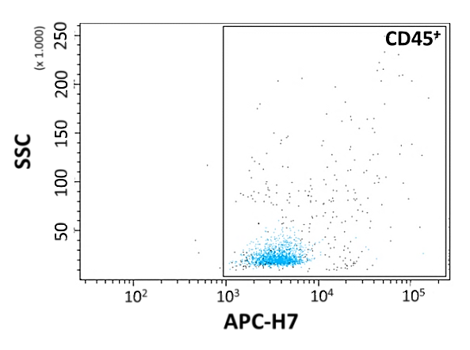
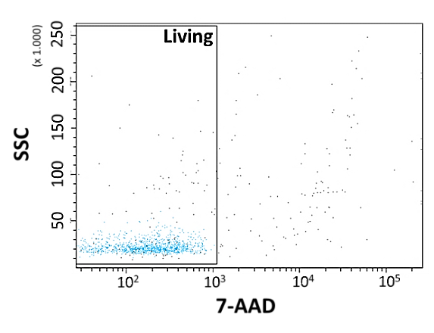
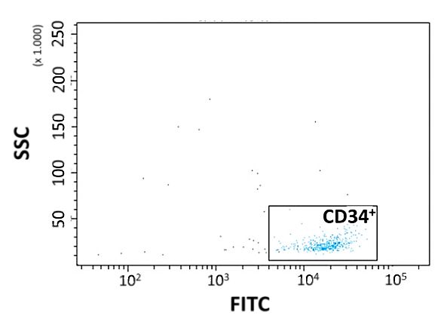
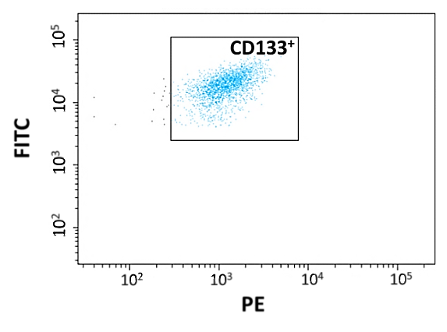
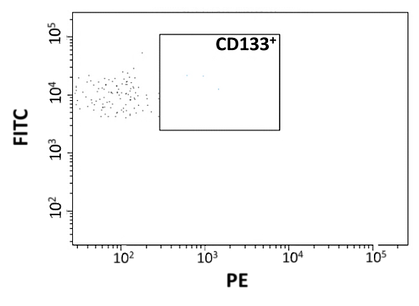
B
A

D
C

F
E

Figure S1: Boolean gating strategy for flow cytometry measurements of cell viability and surface marker pattern. (A) Debris was excluded from the intact cell population; (B) CD45⁺ cells (APC-H7 pos.); (C) Viable cells (7-AAD neg.) out of CD45⁺ population; (D) CD34⁺ cells (FITC pos.) out of viable CD45⁺ population; (E) CD133⁺ cells (PE pos.) out of viable CD45⁺/CD34⁺ population; (F) PE isotype control. Blue: viable CD45⁺/CD34⁺/CD133⁺ cells

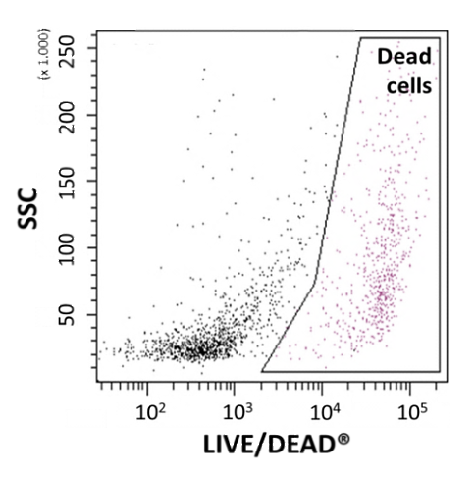
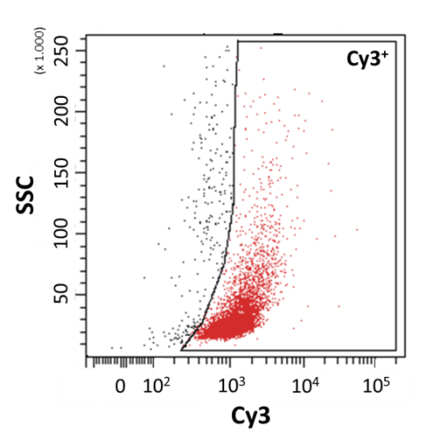
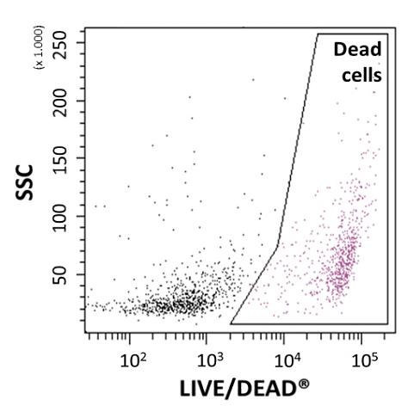
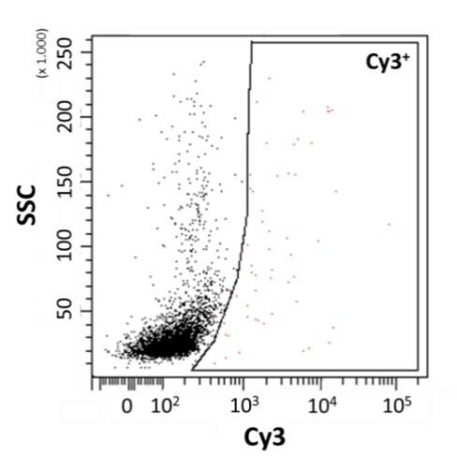
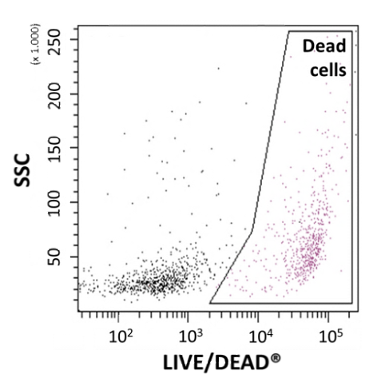
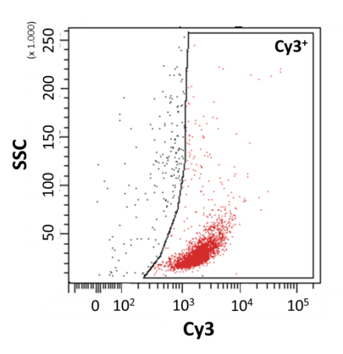
F
E
D
C
B
A

Figure S2: Gating strategy for flow cytometry measurements of uptake efficiency and cytotoxicity of transfection complexes. (A-C) Uptake efficiency analyses of miR/PEI (B) and miR/PEI/MNP (C) complexes were based on Cy3-labeling. Unlabeled miR/PEI complexes (A) were used as control. (D - F) Cytotoxic effects of miR/PEI (E) and miR/PEI/MNP (F) complexes were based on labeling dead cells with LIVE/DEAD® Fixable Near-IR Dead Cell staining solution. Untransfected cells (D) were used as control. Red: Cy3⁺ cells; Purple: dead cells.

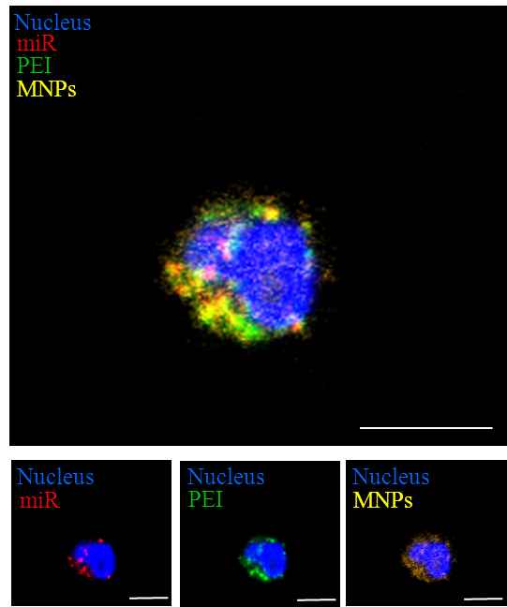

Figure S3: Intracellular visualization of transfection complexes. Cells were transfected with optimized fluorescently labeled miR/PEI/MNP (20 pmol miR; N/P ratio 7.5; 3 µg/ml MNPs) complexes. miR staining was performed with Cy5™ dye (red). PEI was labeled Oregon Green® 488 (green). MNPs were stained with Atto 565 (yellow). Nuclei were counterstained with DAPI (blue). Representative images were taken 18h after transfection using laser scanning confocal microscopy. Scale bar = 5 µm.

