Supplementary information
Therapeutic potential of Dental pulp stem cell secretome for Alzheimer’s disease treatment: an in vitro study.
Nermeen EL-Moataz Bellah Ahmed, Masashi Murakami, Yujiro Hirose & Misako Nakashima
- Supplementary Table 1. Donor information for used dental pulp derived mesenchymal stem cells.
- Supplementary Table 2. Donor information for used bone marrow-derived mesenchymal stem cells.
- Supplementary Table 3. Donor information for used Adipose-derived mesenchymal stem cells.
- Supplementary figure legends :
Fig. S1. DPSC secretome treatment preserves morphology and improves viability of SH-SY5Y cells exposed to Aβ₁₋₄₂. Full size pictures shown of SH-SY5Y cells exposed to Aβ₁₋₄₂ only, Aβ₁₋₄₂ and DPSC secretome or non-exposed as control.
Fig. S2. DPSC secretome stimulates the endogenous survival factor Bcl-2 and decreases the apoptotic regulator Bax. Full length scans of western blot membranes treated with an anti-Bax, anti-Bcl2 or anti-actin antibody.
Fig. S3. DPSC secretome contains higher concentration of Neprilysin/CD10. Full-length scans of western blot membranes treated with anti-NEP antibody.
Fig. S4. DPSC secretome degrade Aβ₁₋₄₂ protein in vitro. Full-length scans of western blot membranes treated with an anti-Aβ antibody.

Fig. S5. DPSC secretome has neuroprotective ability against Aβ₁₋₄₂ induced neurotoxicity. Full size pictures of representative photos demonstrating the morphology of SH-SY5Y cells in different treatment groups; undifferentiated, non-exposed differentiated, differentiated exposed to Aβ₁₋₄₂ and DPSC secretome and differentiated exposed to Aβ₁₋₄₂ only.

Table S1. Donor information for used dental pulp derived mesenchymal stem cells.
ID | #1 | #2 | #3 | #4
Sex | Female | Female | Female | Female
Age | 22 | 25 | 23 | 21
Tooth | Upper right third molar | Upper left third molar | Lower left third molar | Lower right third molar

Table S2. Donor information for used bone marrow-derived mesenchymal stem cells.
ID | #1 | #2
Bank name | Health science research resources | Lonza Walkersville, Inc
Cell name | UE6E7-16 | PT-2501
Sex | Female | Female
Age | 91 | 21-22
Site | Posterior iliac crest of the pelvic bone | Posterior iliac crest of the pelvic bone

Table S3. Donor information for used adipose-derived mesenchymal stem cells.
ID | #1
Bank name | Lonza Walkersvillen, Inc
Cell name | PT-5006
Site | lipoaspirates

Fig. S1
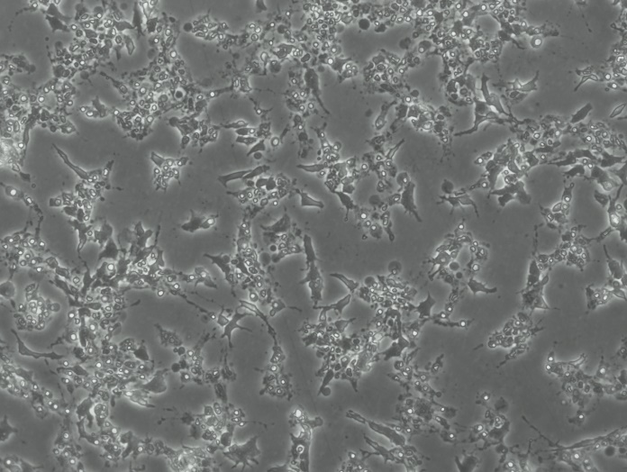
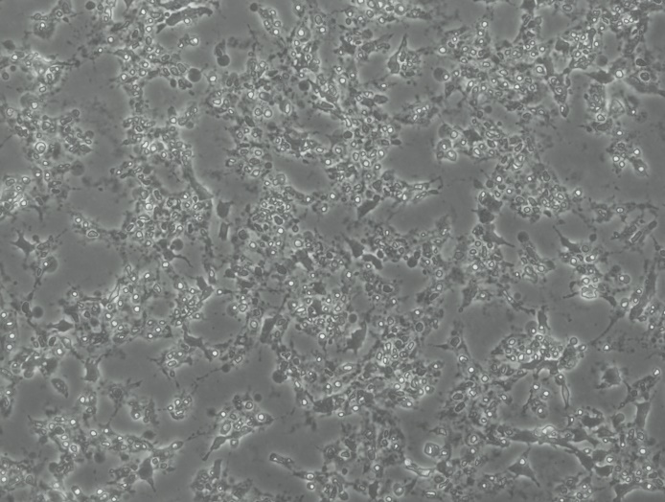
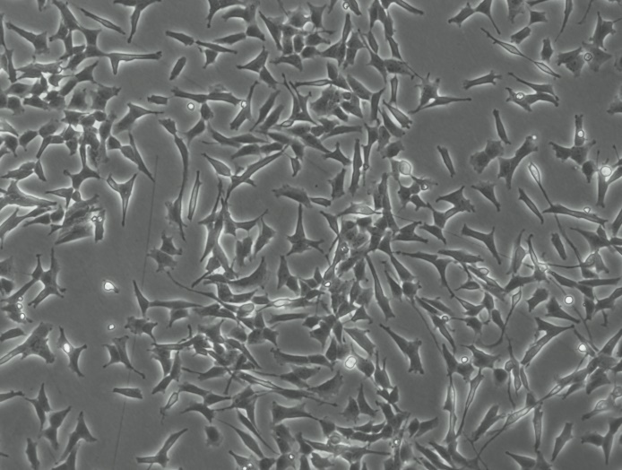
Aβ only
Aβ and DPSC secretome
Non-exposed (control)
200µm
200µm
200µm

Fig. S2
MW(kDa)
25 -
20 -
37 -
50 -
75 -
100 -
150 -
250 -
15 -
10 -
Bcl-2
Bax
β-actin

Fig. S3
100 -
MW(kDa)
Neprilysin/CD10

Fig. S4
MW(kDa)

10 kDa -

Fig. S5
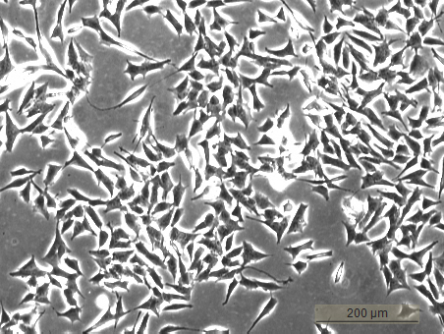
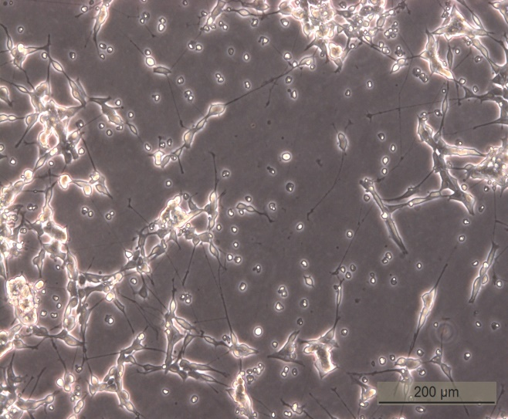
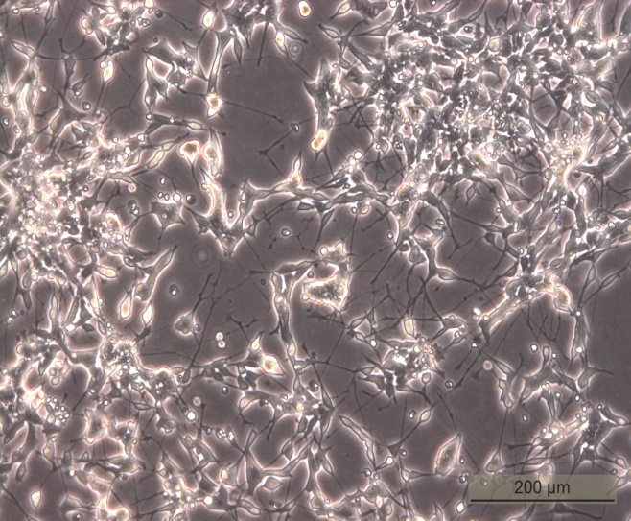
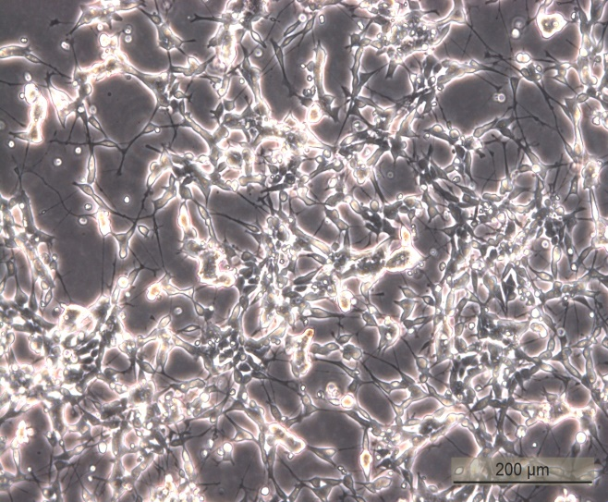
Undifferentiated cells (-ve control)
Differentiated (Aβ+DPSC secretome)
Differentiated cells
Differentiated (Aβ only)

